Samenvatting Netwerken 2

Gilles De Praeter

Inhoud

1. Basic Device Configuration 4

a) Configure a Switch with Initial Settings 4

b) Configure Switch Ports 6

c) Secure Remote Access 9

d) Basic Router Configuration 10

e) Verify Directly Connected Networks 11

2. Switching Concepts 13

a) Frame Forwarding 13

b) Collision and Broadcast Domains 15

3. VLANs 16

a) Overview of VLANs 16

b) VLANs in a Multi-Switched Environment 17

c) VLAN Configuration 20

d) VLAN Trunks 23

e) Dynamic Trunking Protocol 23

4. Inter-VLAN Routing 24

a) Inter-VLAN Routing Operation 24

b) Router-on-a-Stick Inter-VLAN Routing 27

c) Inter-VLAN Routing using Layer 3 Switches 29

d) Troubleshoot Inter-VLAN Routing 31

5. STP Concepts 32

a) Purpose of STP 32

b) STP Operations 34

c) Evolution of STP 39

6. EtherChannel 43

a) EtherChannel Operation 43

b) Configure EtherChannel 46

c) Verify and Troubleshoot EtherChannel 47

7. DHCPv4 49

a) DHCPv4 Concepts 49

b) Configure a Cisco IOS DHCPv4 Server 52

c) Configure a DHCPv4 Client 55

8. SLAAC and DHCPv6 56

a) IPv6 GUA Assignment 56

b) SLAAC 58

c) DHCPv6 61

d) Configure DHCPv6 Server 64

9. FHRP Concepts 69

a) First Hop Redundancy Protocols 69

b) HSRP 71

10. LAN Security Concepts 73

a) Endpoint Security 73

b) Access Control 75

c) Layer 2 Security Threats 78

d) MAC Address Table Attack 79

e) LAN Attacks 80

11. Switch Security Configuration 84

a) Implement Port Security 84

b) Mitigate VLAN Attacks 91

c) Mitigate DHCP Attacks 92

d) Mitigate ARP Attacks 94

e) Mitigate STP Attacks 95

# Basic Device Configuration

## Configure a Switch with Initial Settings

* Switch boot sequence
  1. Power-on self test (POST).
  2. Run boot loader software.
  3. Boot loader performs low-level CPU initialization.
  4. Boot loader initializes the flash file system
  5. Boot loader locates and loads a default IOS operating system software image into memory and passes control of the switch over to the IOS.

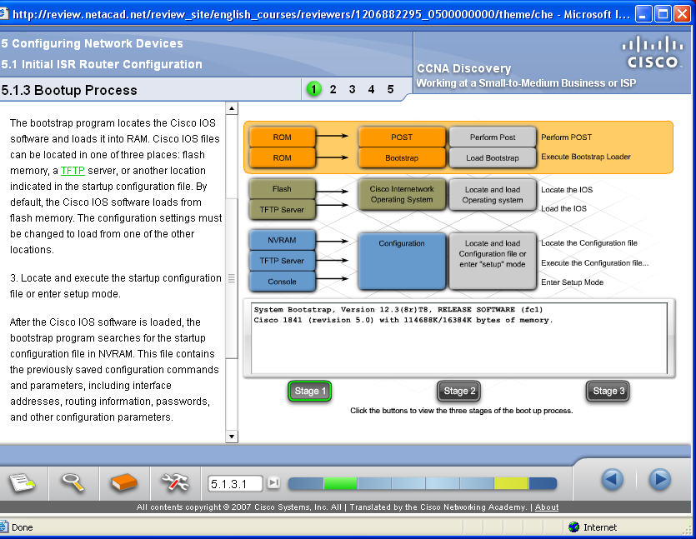

* + Boot system command:
    - **S1(config)# boot system flash:/c2960-lanbasek9-mz.150-2.SE/c2960-lanbasek9-mz.150-2.SE.bin**
* Switch LED indicators:
  + System LED (SYST): Shows whether the system is receiving power and functioning properly.
  + 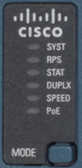Redundant Power Supply LED (RPS): Shows the RPS status.
  + Port Status LED (STAT): When green, indicates port status mode is selected, which is the default. Port status can then be understood by the light associated with each port.
  + Port Duplex LED (DUPLX): When green, indicates port duplex mode is selected. Port duplex can then be understood by the light associated with each port.
  + Port Speed LED (SPEED): When green, indicates port speed mode is selected. Port speed can then be understood by the light associated with each port.
  + Power over Ethernet LED (PoE): Present if the switch supports PoE. Indicates the PoE status of ports on the switch.
  + The Mode button is used to move between the different modes – STAT, DUPLX, SPEED, and PoE

|  |  |  |  |  |  |  |
| --- | --- | --- | --- | --- | --- | --- |
|  | **Off** | **Green** | **Blinking Green** | **Amber** | **Blinking Amber** | **Alternating Green/Amber** |
| RPS | Off/No RPS | RPS ready | RPS up but not available | RPS standby or fault | Internal PS failed, RPS providing power | N/A |
| PoE | Not selected, no issues | Selected | N/A | N/A | Not selected, port issues present | N/A |
| When the named mode is selected, the light associated with each physical port indicates: | | | | | | |
| STAT | No link or shutdown | Link Up | Activity | Port blocked preventing loop | Port blocked preventing loop | Link fault |
| DUPLEX | Half-duplex | Full-duplex | N/A | N/A | N/A | N/A |
| SPEED | 10Mbps | 100Mbps | 1000Mbps | N/A | N/A | N/A |
| PoE | PoE off | PoE on | N/A | PoE disabled | PoE off due to fault | PoE denied (over budget) |

* Recovering from a system crash:
  + The boot loader provides access into the switch if the operating system cannot be used because of missing or damaged system files. The boot loader has a command line that provides access to the files stored in flash memory. The boot loader can be accessed through a console connection following these steps:
    1. Connect a PC by console cable to the switch console port. Configure terminal emulation software to connect to the switch.
    2. Unplug the switch power cord.
    3. Reconnect the power cord to the switch and, within 15 seconds, press and hold down the Mode button while the System LED is still flashing green.
    4. Continue pressing the Mode button until the System LED turns briefly amber and then solid green; then release the Mode button.
    5. The boot loader switch: prompt appears in the terminal emulation software on the PC.
  + The boot loader command line supports commands to format the flash file system, reinstall the operating system software, and recover a lost or forgotten password. There is als the ‘**help**’ or **?** command.
* Switch remote access:
  + Switch needs an SVI configured with an IPv4 and/or an IPv6 address
  + Switch also needs a default gateway

## Configure Switch Ports

* Duplex communication:
  + Full-duplex communication increases bandwidth efficiency by allowing both ends of a connection to transmit and receive data simultaneously. This is also known as bidirectional communication and it requires microsegmentation.
  + A microsegmented LAN is created when a switch port has only one device connected and is operating in full-duplex mode. There is no collision domain associated with a switch port operating in full-duplex mode.
  + Unlike full-duplex communication, half-duplex communication is unidirectional. Half-duplex communication creates performance issues because data can flow in only one direction at a time, often resulting in collisions.
  + Gigabit Ethernet and 10 Gb NICs require full-duplex connections to operate. In full-duplex mode, the collision detection circuit on the NIC is disabled. Full-duplex offers 100 percent efficiency in both directions (transmitting and receiving). This results in a doubling of the potential use of the stated bandwidth.
* Configure switch ports:
  + Switch ports can be manually configured with specific duplex and speed settings. The respective interface configuration commands are **duplex** and **speed**.
  + The default setting for both duplex and speed for switch ports on Cisco Catalyst 2960 and 3560 switches is auto. The 10/100/1000 ports operate in either half- or full-duplex mode when they are set to 10 or 100 Mbps and operate only in full-duplex mode when it is set to 1000 Mbps (1 Gbps).
  + Autonegotiation is useful when the speed and duplex settings of the device connecting to the port are unknown or may change. When connecting to known devices such as servers, dedicated workstations, or network devices, a best practice is to manually set the speed and duplex settings.
  + When troubleshooting switch port issues, it is important that the duplex and speed settings are checked.
  + All fiber-optic ports, such as 1000BASE-SX ports, operate only at one preset speed and are always full-duplex
  + **S1# configure terminal**
  + **S1(config)# interface FastEthernet 0/1**
  + **S1(config-if)# duplex full**
  + **S1(config-if)# speed 100**
  + **S1(config-if)# end**
* Auto-MDIX:
  + When automatic medium-dependent interface crossover (auto-MDIX) is enabled, the switch interface automatically detects the required cable connection type (straight-through or crossover) and configures the connection appropriately.
  + On newer Cisco switches, the **mdix auto** interface configuration mode command enables the feature. When using auto-MDIX on an interface, the interface speed and duplex must be set to **auto** so that the feature operates correctly.
  + When connecting to switches without the auto-MDIX feature, straight-through cables and crossover cables must be used correctly:

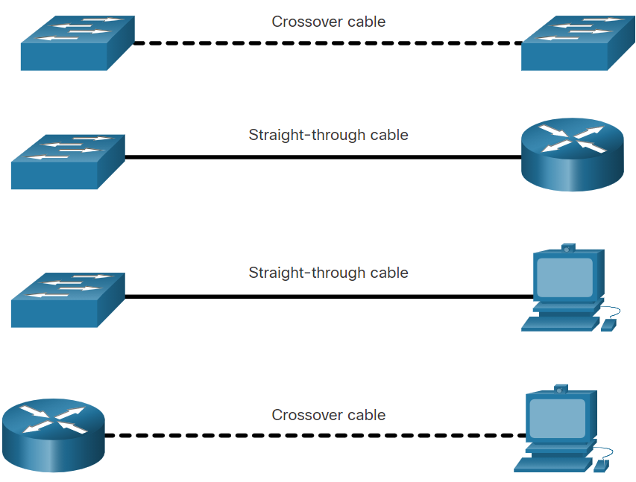

* Switch show commands:

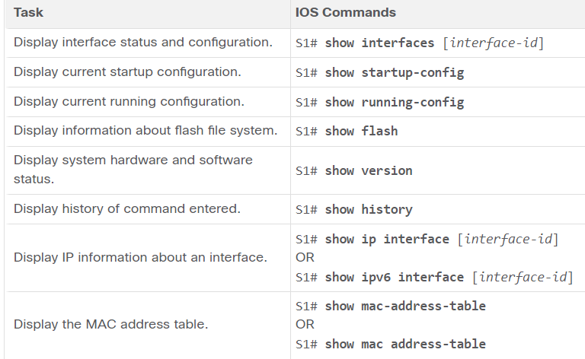

* Show interfaces command:

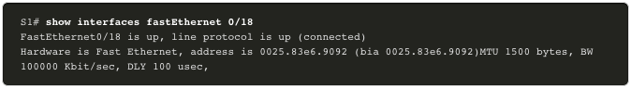

* + The first parameter (FastEthernet0/18 is up) refers to the hardware layer and indicates whether the interface is receiving a carrier detect signal. The second parameter (line protocol is up) refers to the data link layer and indicates whether the data link layer protocol keepalives are being received. Based on the output of the show interfaces command, possible problems can be fixed as follows:
    - If the interface is up and the line protocol is down, a problem exists. There could be an encapsulation type mismatch, the interface on the other end could be error-disabled, or there could be a hardware problem.
    - If the line protocol and the interface are both down, a cable is not attached, or some other interface problem exists. For example, in a back-to-back connection, the other end of the connection may be administratively down.
    - If the interface is administratively down, it has been manually disabled (the shutdown command has been issued) in the active configuration.

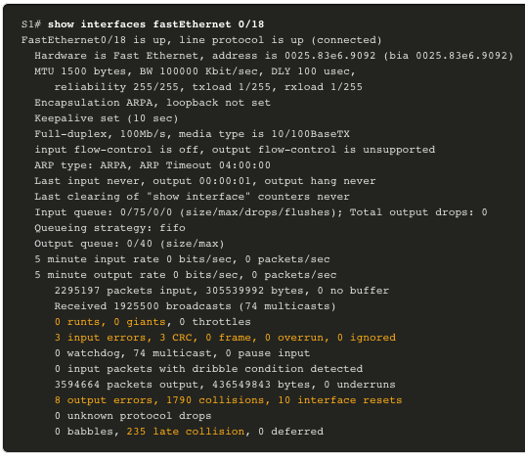

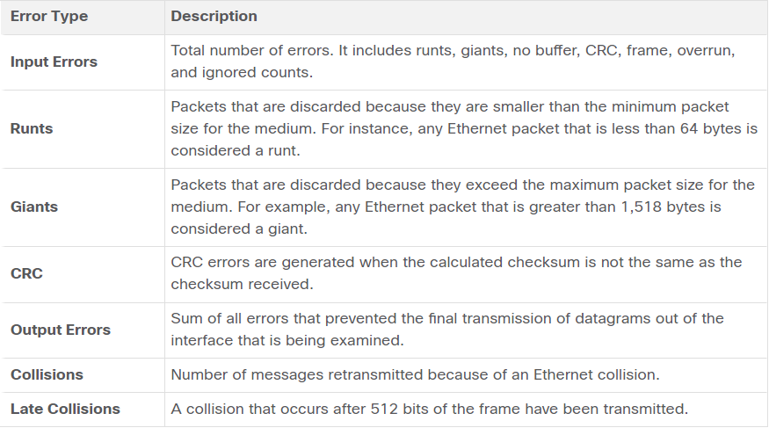

* Troubleshooting Network Access Layer Issues:

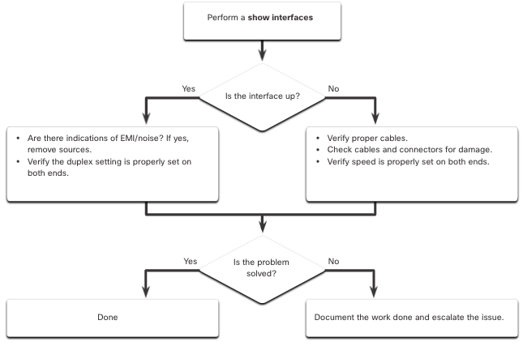

## Secure Remote Access

* Telnet
  + Uses TCP port 23
  + It is an older protocol that uses unsecure plaintext transmission of both the login authentication (username and password) and the data transmitted between the communicating devices.
* Secure Shell (SSH):
  + Uses TCP port 22
  + It provides security for remote connections by providing strong encryption when a device is authenticated (username and password) and also for the transmitted data between the communicating devices.
  + Configuration:
    - Router(config)# hostname R1
    - R1(config)# ip domain name span.com
    - R1(config)# crypto key generate rsa general-keys modulus 1024
    - R1(config)# username Bob secret cisco
    - R1(config)# line vty 0 4
    - R1(config-line)# login local
    - R1(config-line)# transport input ssh
    - R1(config-line)# end
    - R1(config)# ip ssh version 2
  + To display the version and configuration data for SSH on the device that you configured as an SSH server, use the **show ip ssh** command.

## Basic Router Configuration

* Basic configuration:
  + Router: enable
  + Router# configure terminal
  + Router(conf)# hostname R1
  + R1(config)# banner motd ‘Je moet ut mn shuvn bluvn’
  + R1(config)# service password-encryption
  + R1(conf)# enable secret class
  + R1(conf)# line console 0
  + R1(config-line)# password cisco
  + R1(config-line)# login
  + R1(config-line)# line vty 0 4
  + R1(config-line)# transput input ssh
  + R1(config-line)# password cisco
  + R1(config-line)# login
  + R1(config-line)# exit
  + R1# copy running-config startup-config
* Dual stack - Dual stack allows IPv4 and IPv6 to coexist on the same network segment. Dual stack devices run both IPv4 and IPv6 protocol stacks simultaneously. Known as native IPv6, this means the customer network has an IPv6 connection to their ISP and is able to access content found on the internet over IPv6.
* Configure router interfaces:
  + Routers support LANs and WANs and can interconnect different types of networks; therefore, they support many types of interfaces. For example, G2 ISRs have one or two integrated Gigabit Ethernet interfaces and High-Speed WAN Interface Card (HWIC) slots to accommodate other types of network interfaces, including serial, DSL, and cable interfaces.
  + To be available, an interface must be:
    - Configured with at least one IP address - Use the ip address ip-address subnet-mask and the ipv6 address ipv6-address/prefix interface configuration commands.
    - Activated - By default, LAN and WAN interfaces are not activated (shutdown). To enable an interface, it must be activated using the no shutdown command. (This is similar to powering on the interface.) The interface must also be connected to another device (a hub, a switch, or another router) for the physical layer to be active.
    - Description - Optionally, the interface could also be configured with a short description of up to 240 characters. It is good practice to configure a description on each interface. On production networks, the benefits of interface descriptions are quickly realized as they are helpful in troubleshooting and in identifying a third-party connection and contact information.

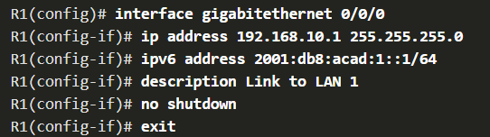

* IPv4 loopback interfaces:
  + The loopback interface is a logical interface that is internal to the router. It is not assigned to a physical port and can never be connected to any other device. It is considered a software interface that is automatically placed in an “up” state, as long as the router is functioning.
  + The loopback interface is useful in testing and managing a Cisco IOS device because it ensures that at least one interface will always be available. For example, it can be used for testing purposes, such as testing internal routing processes, by emulating networks behind the router.
  + Loopback interfaces are also commonly used in lab environments to create additional interfaces. For example, you can create multiple loopback interfaces on a router to simulate more networks for configuration practice and testing purposes. In this curriculum, we often use a loopback interface to simulate a link to the internet.
  + The IPv4 address for each loopback interface must be unique and unused by any other interface

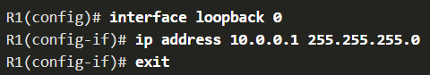

## Verify Directly Connected Networks

* Verify Interface Status and IPv6 Link Local and Multicast Addresses::
  + The output of the **show ip interface brief** and show ipv6 interface brief commands can be used to quickly reveal the status of all interfaces on the router. You can verify that the interfaces are active and operational as indicated by the Status of “up” and Protocol of “up”, as shown in the example. A different output would indicate a problem with either the configuration
  + The output of the **show ipv6 interface brief** command displays two configured IPv6 addresses per interface. One address is the IPv6 global unicast address that was manually entered. The other address, which begins with FE80, is the link-local unicast address for the interface. A link-local address is automatically added to an interface whenever a global unicast address is assigned. An IPv6 network interface is required to have a link-local address, but not necessarily a global unicast address.

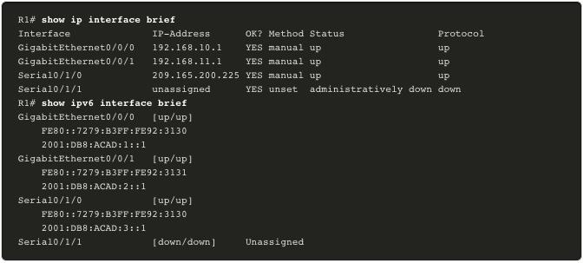

* Verify Interface Configuration:
  + **show interfaces**- Displays interface information and packet flow count for all interfaces on the device.
  + **show ip interface** and **show ipv6 interface** - Displays the IPv4 and IPv6 related information for all interfaces on a router..
* Verify Routes:
  + The output of the **show ip route** and **show ipv6 route** commands reveal the three directly connected network entries and the three local host route interface entries, as shown in the example.
  + The local host route has an administrative distance of 0. It also has a /32 mask for IPv4, and a /128 mask for IPv6. The local host route is for routes on the router that owns the IP address. It is used to allow the router to process packets destined to that IP.
  + A ‘C’ next to a route within the routing table indicates that this is a directly connected network. When the router interface is configured with a global unicast address and is in the “up/up” state, the IPv6 prefix and prefix length are added to the IPv6 routing table as a connected route.
  + A ‘L’ next to a route within the routing table indicates that this is a Local route. The IPv6 global unicast address applied to the interface is also installed in the routing table as a local route. The local route has a /128 prefix. Local routes are used by the routing table to efficiently process packets with the interface address of the router as the destination.

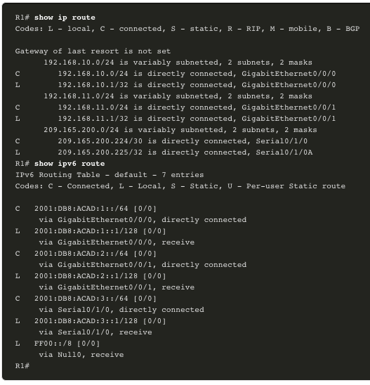

* Another very useful feature that improves the user experience in the CLI is the filtering of **show** output. Filtering commands can be used to display specific sections of output. To enable the filtering command, enter a pipe (**|**) character after the **show** command and then enter a filtering parameter and a filtering expression.
  + There are four filtering parameters that can be configured after the pipe:
    - section - Shows the entire section that starts with the filtering expression.
    - include - Includes all output lines that match the filtering expression.
    - exclude - Excludes all output lines that match the filtering expression.
    - begin - Shows all the output lines from a certain point, starting with the line that matches the filtering expression

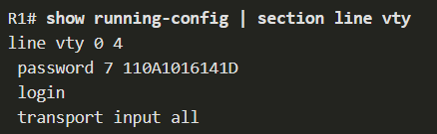

* Command history feature:
  + The command history feature is useful because it temporarily stores the list of executed commands to be recalled.
    - To recall commands in the history buffer, press **Ctrl**+**P** or the **Up Arrow** key. The command output begins with the most recent command. Repeat the key sequence to recall successively older commands. To return to more recent commands in the history buffer, press **Ctrl**+**N** or the **Down Arrow** key. Repeat the key sequence to recall successively more recent commands.
    - By default, command history is enabled and the system captures the last 10 command lines in its history buffer. Use the **show history** privileged EXEC command to display the contents of the buffer.
    - It is also practical to increase the number of command lines that the history buffer records during the current terminal session only. Use the **terminal history size** user EXEC command to increase or decrease the size of the buffer.

# Switching Concepts

## Frame Forwarding

* There are two terms associated with frames entering and leaving an interface:
  + Ingress - This is used to describe the port where a frame enters the device.
  + Egress - This is used to describe the port that frames will use when leaving the device.
* A switch uses its MAC address table to make forwarding decisions.
  + stored in content addressable memory (CAM)
  + sometimes called CAM table
* Switch learn and forward method:
  + Step 1. Learn - Examining the Source MAC Address
    - Every frame that enters a switch is checked for new information to learn. It does this by examining the source MAC address of the frame and port number where the frame entered the switch:
    - If the source MAC address does not exist in the MAC address table, the MAC address and incoming port (ingress) number are added to the table.
    - If the source MAC address does exist, the switch updates the refresh timer for that entry. By default, most Ethernet switches keep an entry in the table for five minutes. If the source MAC address does exist in the table but on a different port, the switch treats this as a new entry. The entry is replaced using the same MAC address, but with the more current port number.
  + Step 2. Forward - Examining the Destination MAC Address
    - If the destination MAC address is a unicast address, the switch will look for a match between the destination MAC address of the frame and an entry in its MAC address table:
    - If the destination MAC address is in the table, it will forward the frame out of the specified port.
    - If the destination MAC address is not in the table, the switch will forward the frame out all ports except the incoming port. This is called an unknown unicast. If the destination MAC address is a broadcast or a multicast, the frame is also flooded out all ports except the incoming port.
* Switches use software on application-specific-integrated circuits (ASICs) to make very quick decisions.
* A switch will use one of two methods to make forwarding decisions after it receives a frame:
  + Store-and-forward switching - This method makes a forwarding decision on a frame after it has received the entire frame and checked the frame for errors using a mathematical error-checking mechanism known as a cyclic redundancy check (CRC). Store-and-forward switching is Cisco’s primary LAN switching method.
  + Cut-through switching - At a minimum, the destination address of the frame must be read before the frame can be forwarded. The switch looks up the destination MAC address in its switching table, determines the outgoing interface port (egress), and forwards the frame onto its destination through the designated switch port. The switch does not perform any error checking on the frame.
* Two primary characteristics of Store-and-Forward Switching:
  + Error checking - The switch will check the Frame Check Sequence (FCS) for CRC errors. Bad frames will be discarded.
  + Automatic buffering - The ingress port buffering process used by store-and-forward switches provides the flexibility to support any mix of Ethernet speeds. For example, handling an incoming frame traveling into a 100 Mbps Ethernet port that must be sent out a 1 Gbps interface would require using the store-and-forward method. With any mismatch in speeds between the ingress and egress ports, the switch stores the entire frame in a buffer, computes the FCS check, forwards it to the egress port buffer and then sends it.
* There are two variants of cut-through switching:
  + Fast-forward switching - forwards the frame immediately after determining the destination MAC.
  + Fragment-free switching - will check the destination and ensure that the frame is at least 64 Bytes. This will eliminate runts.
* Concepts of Cut-Through switching:
  + Is appropriate for switches needing latency to be under 10 microseconds
  + Does not check the FCS, so it can propagate errors
  + May lead to bandwidth issues if the switch propagates too many errors
  + Cannot support ports with differing speeds going from ingress to egress

## Collision and Broadcast Domains

* Collision domains:
  + Part of the network where collisions can occur
  + Switches eliminate collision domains and reduce congestion.
  + When there is full duplex on the link the collision domains are eliminated.
  + When there is one or more devices in half-duplex there will now be a collision domain.
    - There will now be contention for the bandwidth.
    - Collisions are now possible.
  + Most devices, including Cisco and Microsoft use auto-negotiation as the default setting for duplex and speed.

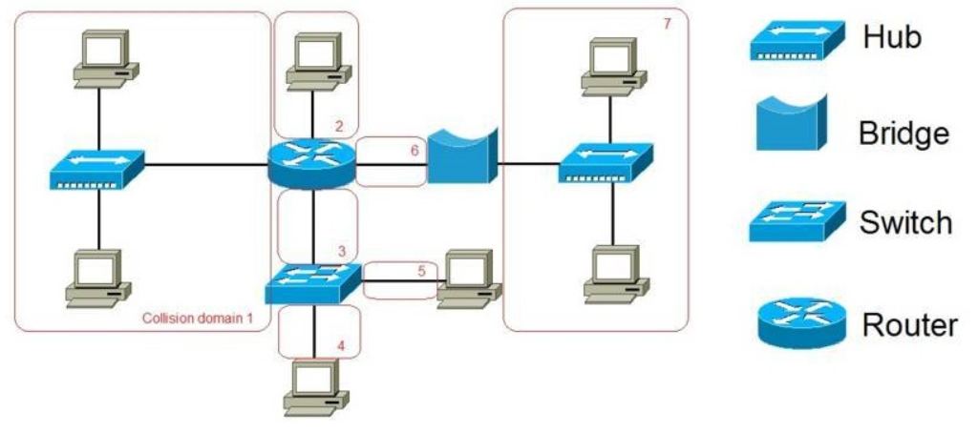

* Broadcast domain:
  + A broadcast domain extends across all Layer 1 or Layer 2 devices on a LAN.
    - Only a layer 3 device (router) will break the broadcast domain, also called a MAC broadcast domain.
    - The broadcast domain consists of all devices on the LAN that receive the broadcast traffic.
  + When the layer 2 switch receives the broadcast it will flood it out all interfaces except for the ingress interface.
  + Too many broadcasts may cause congestion and poor network performance.
  + Increasing devices at Layer 1 or layer 2 will cause the broadcast domain to expand.
* Alleviate (reduce, relieve) network congestion:
  + LAN switches have special characteristics that help them alleviate network congestion. By default, interconnected switch ports attempt to establish a link in full-duplex, therefore eliminating collision domains. Switches interconnect LAN segments, use a MAC address table to determine egress ports, and can lessen or eliminate collisions entirely.
* Characteristics of switches that alleviate network congestion include the following:
  + Fast port speeds - Ethernet switch port speeds vary by model and purpose. They may have up to 100 Gbps port speeds.
  + Fast internal switching - Switches use a fast internal bus or shared memory to provide high performance.
  + Large frame buffers - Switches use large memory buffers to temporarily store more received frames before having to start dropping them. This enables ingress traffic from a faster port (e.g., 1 Gbps) to be forwarded to a slower (e.g., 100 Mbps) egress port without losing frames.
  + High port density - A high port density switch lowers overall costs because it reduces the number of switches required. For instance, if 96 access ports were required, it would be less expensive to buy two 48-port switches instead of four 24-port switches. High port density switches also help keep traffic local, which helps alleviate congestion.

# VLANs

## Overview of VLANs

* VLANs are logical connections with other similar devices.
  + A group of devices within a VLAN communicate as if each device was attached to the same cable.
  + VLANs are based on logical connections, instead of physical connections.
* Placing devices into various VLANs have the following characteristics:
  + Provides segmentation of the various groups of devices on the same switches
  + Provide organization that is more manageable
  + Broadcasts, multicasts and unicasts are isolated in the individual VLAN
  + Each VLAN will have its own unique range of IP addressing
  + VLANs improve network performance by separating large broadcast domains into smaller ones. If a device in one VLAN sends a broadcast Ethernet frame, all devices in the VLAN receive the frame, but devices in other VLANs do not.
* Benefits of using VLANs:

|  |  |
| --- | --- |
| **Benefits** | **Description** |
| Smaller Broadcast Domains | Dividing the LAN reduces the number of devices in broadcast domains |
| Improved Security | Only users in the same VLAN can communicate together |
| Improved IT Efficiency | VLANs can group devices with similar requirements, e.g. faculty vs. students |
| Reduced Cost | One switch can support multiple groups or VLANs |
| Better Performance | Small broadcast domains reduce traffic, improving bandwidth |
| Simpler Management | Similar groups will need similar applications and other network resources |

* Types of VLANs:
  + Default VLAN:
    - VLAN 1
    - All ports are assigned to VLAN 1 by default.
    - The native VLAN is VLAN 1 by default.
    - The management VLAN is VLAN 1 by default.
    - VLAN 1 cannot be renamed or deleted.
  + Data VLAN:
    - Data VLANs are VLANs configured to separate user-generated traffic.
    - They are referred to as user VLANs because they separate the network into groups of users or devices.
    - A modern network would have many data VLANs depending on organizational requirements.
    - Note that voice and network management traffic should not be permitted on data VLANs.
  + Native VLAN:
    - User traffic from a VLAN must be tagged with its VLAN ID when it is sent to another switch. Trunk ports are used between switches to support the transmission of tagged traffic. Specifically, an 802.1Q trunk port inserts a 4-byte tag in the Ethernet frame header to identify the VLAN to which the frame belongs.
    - A switch may also have to send untagged traffic across a trunk link. Untagged traffic is generated by a switch and may also come from legacy devices. The 802.1Q trunk port places untagged traffic on the native VLAN. The native VLAN on a Cisco switch is VLAN 1 (i.e., default VLAN).
    - It is a best practice to configure the native VLAN as an unused VLAN, distinct from VLAN 1 and other VLANs. In fact, it is not unusual to dedicate a fixed VLAN to serve the role of the native VLAN for all trunk ports in the switched domain.
  + Management VLAN:
    - A management VLAN is a data VLAN configured specifically for network management traffic including SSH, Telnet, HTTPS, HTTP, and SNMP.
  + Voice VLAN:
    - A separate VLAN is needed to support Voice over IP (VoIP). VoIP traffic requires the following:
      * Assured bandwidth to ensure voice quality
      * Transmission priority over other types of network traffic
      * Ability to be routed around congested areas on the network
      * Delay of less than 150 ms across the network

## VLANs in a Multi-Switched Environment

* VLAN trunks allow all VLAN traffic to propagate between switches.
* A trunk is a point-to-point link between two network devices
  + Cisco supports IEEE 802.1Q for coordinating trunks on Fast Ethernet, Gigabit Ethernet, and 10-Gigabit Ethernet interfaces.
  + A VLAN trunk does not belong to a specific VLAN. Instead, it is a conduit for multiple VLANs between switches and routers. A trunk could also be used between a network device and server or another device that is equipped with an appropriate 802.1Q-capable NIC.
  + By default, supports all VLANs
* Networks without VLANs:
  + Without VLANs, all devices connected to the switches will receive all unicast, multicast, and broadcast traffic

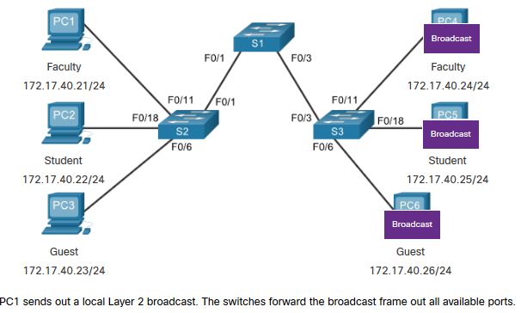

* Network with VLAN’s:
  + With VLANs, unicast, multicast, and broadcast traffic is confined to a VLAN. Without a Layer 3 device to connect the VLANs, devices in different VLANs cannot communicate
  + A VLAN is the equivalent to an IP network (or subnet). VLANs are configured on the switch, whereas IP addressing is configured on the device.

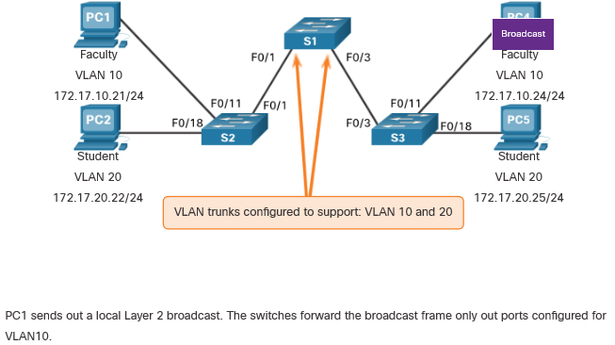

* Tagging:
  + The standard Ethernet frame header does not contain information about the VLAN to which the frame belongs. Therefore, when Ethernet frames are placed on a trunk, information about the VLANs to which they belong must be added. This process, called tagging, is accomplished by using the IEEE 802.1Q header, specified in the IEEE 802.1Q standard. The 802.1Q header includes a 4-byte tag inserted within the original Ethernet frame header, specifying the VLAN to which the frame belongs.
  + When the switch receives a frame on a port configured in access mode and assigned a VLAN, the switch inserts a VLAN tag in the frame header, recalculates the Frame Check Sequence (FCS), and sends the tagged frame out of a trunk port.
  + When sent to end devices, this tag must be removed and the FCS recalculated back to its original number.

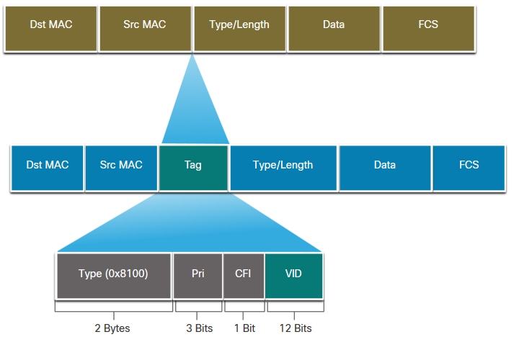

|  |  |
| --- | --- |
| **802.1Q VLAN Tag Field** | **Function** |
| **Type** | * 2-Byte field with hexadecimal 0x8100 * This is referred to as Tag Protocol ID (TPID) |
| **User Priority** | * 3-bit value that supports level or service implementation |
| **Canonical Format Identifier (CFI)** | * 1-bit value that can support token ring frames on Ethernet |
| **VLAN ID (VID)** | * 12-bit VLAN identifier that can support up to 4096 VLANs |

* Native VLANs:
  + When an untagged frame arrives on a trunk port it is assigned to the native VLAN. For example, management frames are typically untagged
  + If the link between two switches is a trunk, the switch sends the untagged traffic on the native VLAN.
  + Control traffic sent on the native VLAN should not be tagged. If an 802.1Q trunk port receives a tagged frame with the VLAN ID that is the same as the native VLAN, it drops the frame. Consequently, when configuring a switch port on a Cisco switch, configure devices so that they do not send tagged frames on the native VLAN.
  + If there are no devices associated with the native VLAN (which is not unusual) and there are no other trunk ports (which is not unusual), then the frame is dropped.
  + Unless changed, VLAN1 is the native VLAN.
  + Both ends of a trunk link must be configured with the same native VLAN.
  + Each trunk is configured separately, so it is possible to have a different native VLANs on separate trunks.
* Voice VLAN tagging:
  + The VoIP phone is a three port switch:
    - The switch will use CDP (Cisco Discovery Protocol) to inform the phone of the Voice VLAN.
    - The phone will tag its own traffic (Voice) and can set Cost of Service (CoS). CoS is QoS for layer 2.
    - The phone may or may not tag frames from the PC.

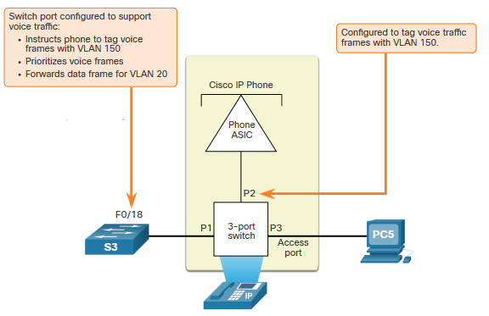

* + Voice VLAN Verification:
    - The **show interfaces fa0/18 switchport** command can show us both data and voice VLANs assigned to the interface.

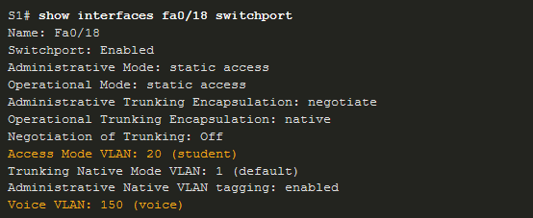

## VLAN Configuration

* VLAN Ranges on Catalyst Switches:
  + Catalyst switches 2960 and 3650 support over 4000 VLANs.
  + Normal range VLANs on these switches are numbered 1 to 1,005 and extended range VLANs are numbered 1,006 to 4,094.
* Normal Range VLANs characteristics:
  + They are used in all small- and medium-sized business and enterprise networks.
  + They are identified by a VLAN ID between 1 and 1005.
  + IDs 1002 through 1005 are reserved for legacy network technologies (i.e., Token Ring and Fiber Distributed Data Interface).
  + IDs 1 and 1002 to 1005 are automatically created and cannot be removed.
  + Configurations are stored in the switch flash memory in a VLAN database file called vlan.dat.
  + When configured, VLAN trunking protocol (VTP), helps synchronize the VLAN database between switches.
* Extended Range VLANs characteristics:
  + They are used by service providers to service multiple customers and by global enterprises large enough to need extended range VLAN IDs.
  + They are identified by a VLAN ID between 1006 and 4094.
  + Configurations are saved, by default, in the running configuration.
  + They support fewer VLAN features than normal range VLANs.
  + Requires VTP transparent mode configuration to support extended range VLANs.
  + Note: 4096 is the upper boundary for the number of VLANs available on Catalyst switches, because there are 12 bits in the VLAN ID field of the IEEE 802.1Q header.
* VLAN Creation Commands:

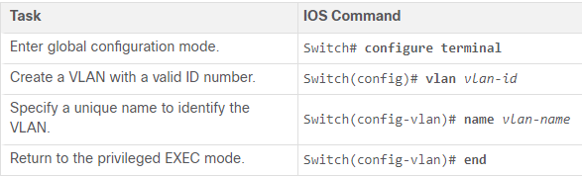

* + VLAN details are stored in the vlan.dat file
* VLAN Port Assignment Commands:

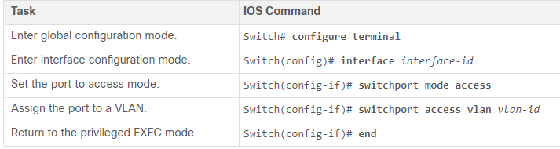

* + Once the VLAN is created, we can then assign it to the correct interfaces.
* Data and Voice VLANs
  + An access port may only be assigned to one data VLAN. However it may also be assigned to one Voice VLAN for when a phone and an end device are off of the same switchport.

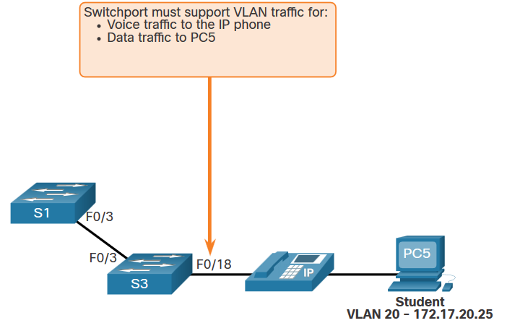

* + Example:
    - We will want to create and name both Voice and Data VLANs.
    - In addition to assigning the data VLAN, we will also assign the Voice VLAN and turn on QoS for the voice traffic to the interface.
    - The newer catalyst switch will automatically create the VLAN, if it does not already exist, when it is assigned to an interface.

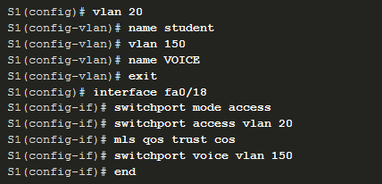

* The **switchport access vlan** command forces the creation of a VLAN if it does not already exist on the switch.
  + For example, VLAN 30 is not present in the show vlan brief output of the switch. If the switchport access vlan 30 command is entered on any interface with no previous configuration, then the switch displays the following:



* Verify VLAN Information
  + Use the **show vlan** command. The complete syntax is:
    - **show vlan [brief** | **id** *vlan-id* | **name** *vlan-name* | **summary**]

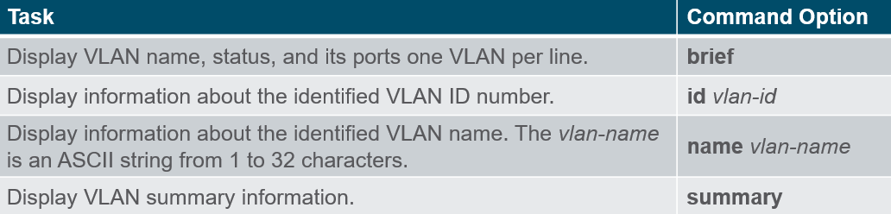

* + Other useful commands are the **show interfaces *interface-id* switchport** and the **show interfaces vlan *vlan-id*** command.

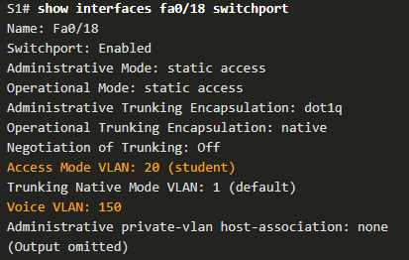

* Change VLAN Port Membership:
  + There are several ways to change VLAN membership:
    - re-enter **switchport access vlan** *vlan-id* interface configuration command
    - use the **no switchport access vlan** to place the interface back in VLAN 1
* Delete VLANs:
  + Delete VLANs with the no vlan vlan-id command.
    - Before deleting a VLAN, reassign all member ports to a different VLAN. Any ports that are not moved to an active VLAN are unable to communicate with other hosts after the VLAN is deleted and until they are assigned to an active VLAN.
  + Delete all VLANs with the delete flash:vlan.dat or delete vlan.dat commands.
    - Reload the switch when deleting all VLANs.
  + Note: To restore to factory default – unplug all data cables, erase the startup-configuration, and delete the vlan.dat file, then reload the device.

## VLAN Trunks

* A VLAN trunk is a Layer 2 link between two switches that carries traffic for all VLANs (unless the allowed VLAN list is restricted manually or dynamically).
  + Configuration commands:

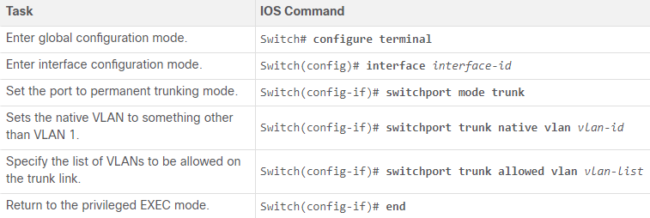

* Verify Trunk Configuration:
  + The configuration is verified with the **show interfaces *interface-ID* switchport** command.
* Reset the Trunk to the Default State:
  + Use the **no switchport trunk allowed vlan** and the **no switchport trunk native vlan** commands to remove the allowed VLANs and reset the native VLAN of the trunk.

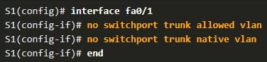

* + Reset the trunk to an access mode with the **switchport mode access** command

## Dynamic Trunking Protocol

* Dynamic Trunking Protocol (DTP):
  + Some Cisco switches have a proprietary protocol that lets them automatically negotiate trunking with a neighboring device.
  + Is a proprietary Cisco protocol.
  + Operates on a point-to-point basis only, between network devices.
  + DTP manages trunk negotiation only if the port on the neighbor switch is configured in a trunk mode that supports DTP.
  + Switches from other vendors do not support DTP.
  + Characteristics:
    - On by default on Catalyst 2960 and 2950 switches
    - Dynamic-auto is default on the 2960 and 2950 switches
    - May be turned off with the nonegotiate command
    - To enable trunking from a Cisco switch to a device that does not support DTP, use the switchport mode trunk and switchport nonegotiate interface configuration mode commands. This causes the interface to become a trunk, but it will not generate DTP frames.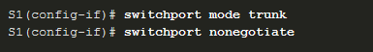
    - To re-enable dynamic trunking protocol use the switchport mode dynamic auto command.



* Negotiated Interface Modes:
  + The switchport mode command full syntax is the following:



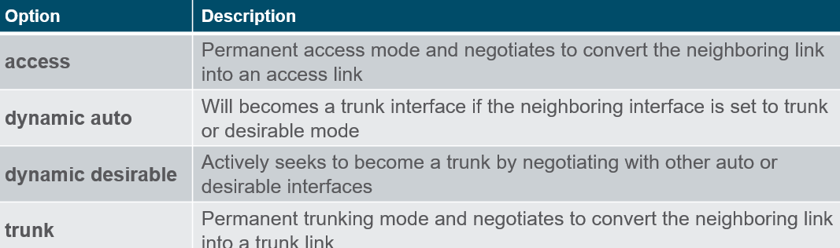

* Results of a DTP configuration:

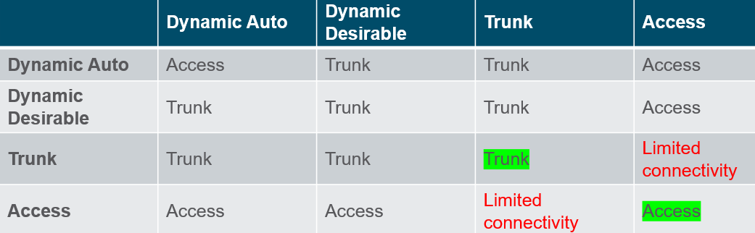

* Verify DTP mode:
  + The default DTP configuration is dependent on the Cisco IOS version and platform.
  + Use the **show dtp interface** command to determine the current DTP mode.
  + Best practice recommends that the interfaces be set to access or trunk and to turnoff DTP

# Inter-VLAN Routing

## Inter-VLAN Routing Operation

* VLANs are used to segment switched Layer 2 networks for a variety of reasons. Regardless of the reason, hosts in one VLAN cannot communicate with hosts in another VLAN unless there is a router or a Layer 3 switch to provide routing services.
* Inter-VLAN routing is the process of forwarding network traffic from one VLAN to another VLAN.
* There are three inter-VLAN routing options:
  + Legacy Inter-VLAN routing - This is a legacy solution. It does not scale well.
  + Router-on-a-Stick - This is an acceptable solution for a small to medium-sized network.
  + Layer 3 switch using switched virtual interfaces (SVIs) - This is the most scalable solution for medium to large organizations.
* Legacy Inter-VLAN Routing:
  + The first inter-VLAN routing solution relied on using a router with multiple Ethernet interfaces. Each router interface was connected to a switch port in different VLANs. The router interfaces served as the default gateways to the local hosts on the VLAN subnet.
  + Legacy inter-VLAN routing using physical interfaces works, but it has a significant limitation. It is not reasonably scalable because routers have a limited number of physical interfaces. Requiring one physical router interface per VLAN quickly exhausts the physical interface capacity of a router.
  + Note: This method of inter-VLAN routing is no longer implemented in switched networks and is included for explanation purposes only.

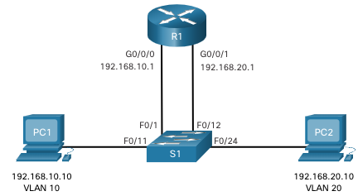

* Router-on-a-Stick Inter-VLAN Routing:
  + The ‘router-on-a-stick’ inter-VLAN routing method overcomes the limitation of the legacy inter-VLAN routing method. It only requires one physical Ethernet interface to route traffic between multiple VLANs on a network.
  + A Cisco IOS router Ethernet interface is configured as an 802.1Q trunk and connected to a trunk port on a Layer 2 switch. Specifically, the router interface is configured using subinterfaces to identify routable VLANs.
  + The configured subinterfaces are software-based virtual interfaces. Each is associated with a single physical Ethernet interface. Subinterfaces are configured in software on a router. Each subinterface is independently configured with an IP address and VLAN assignment. Subinterfaces are configured for different subnets that correspond to their VLAN assignment. This facilitates logical routing.
  + When VLAN-tagged traffic enters the router interface, it is forwarded to the VLAN subinterface. After a routing decision is made based on the destination IP network address, the router determines the exit interface for the traffic. If the exit interface is configured as an 802.Q subinterface, the data frames are VLAN-tagged with the new VLAN and sent back out the physical interface.
  + Note: The router-on-a-stick method of inter-VLAN routing does not scale beyond 50 VLANs.

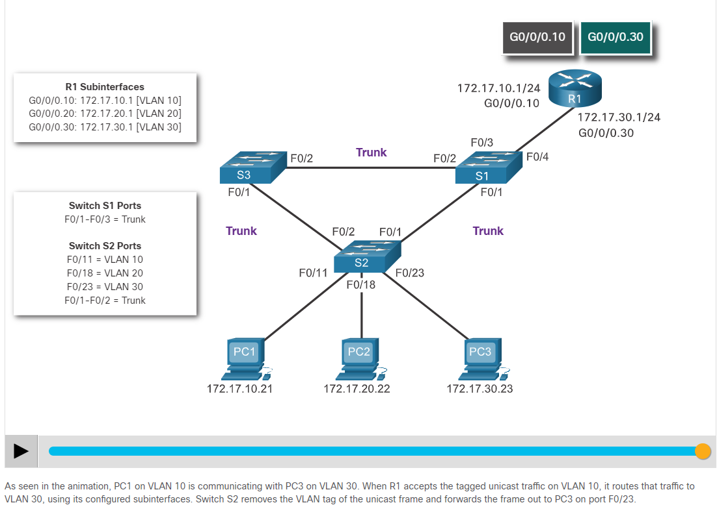

Also Trunk

* Inter-VLAN Routing on a Layer 3 Switch:
  + The modern method of performing inter-VLAN routing is to use Layer 3 switches and switched virtual interfaces (SVI). An SVI is a virtual interface that is configured on a Layer 3 switch

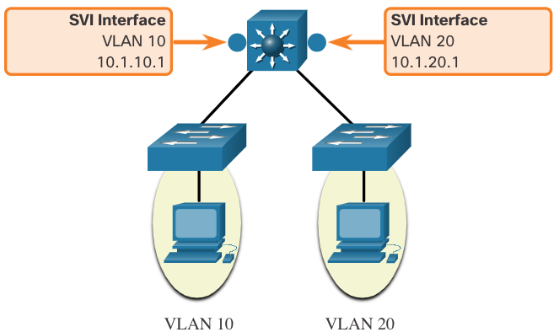

* Inter-VLAN SVIs are created the same way that the management VLAN interface is configured. The SVI is created for a VLAN that exists on the switch. Although virtual, the SVI performs the same functions for the VLAN as a router interface would. Specifically, it provides Layer 3 processing for packets that are sent to or from all switch ports associated with that VLAN.
* The following are advantages of using Layer 3 switches for inter-VLAN routing:
  + They are much faster than router-on-a-stick because everything is hardware switched and routed.
  + There is no need for external links from the switch to the router for routing.
  + They are not limited to one link because Layer 2 EtherChannels can be used as trunk links between the switches to increase bandwidth.
  + Latency is much lower because data does not need to leave the switch in order to be routed to a different network.
  + They more commonly deployed in a campus LAN than routers.
* The only disadvantage is that Layer 3 switches are more expensive.

## Router-on-a-Stick Inter-VLAN Routing

* The scenario:

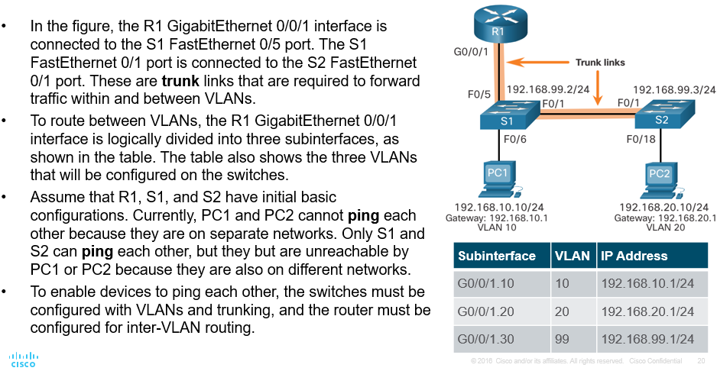

* The configuration for the switches:
  1. Create and name the VLANs
  2. Create the management interface
  3. Configure access ports
  4. 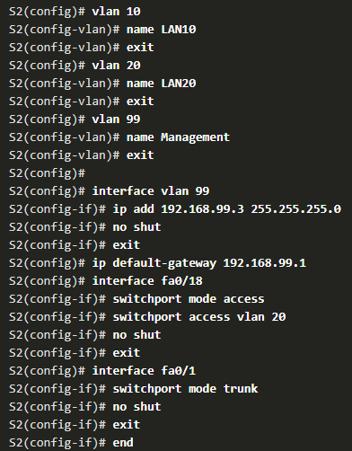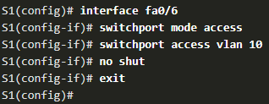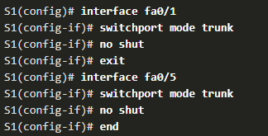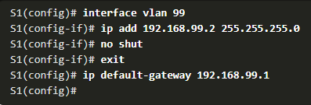Configure trunking ports

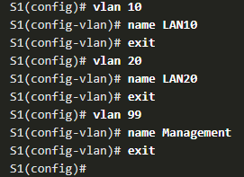

* Router configuration:
  + The router-on-a-stick method requires you to create a subinterface for each VLAN to be routed. A subinterface is created using the interface interface_id subinterface_id global configuration mode command. The subinterface syntax is the physical interface followed by a period and a subinterface number. Although not required, it is customary to match the subinterface number with the VLAN number.
  + Each subinterface is then configured with the following two commands:
    - encapsulation dot1q vlan_id [native] - This command configures the subinterface to respond to 802.1Q encapsulated traffic from the specified vlan-id. The native keyword option is only appended to set the native VLAN to something other than VLAN 1.
    - ip address ip-address subnet-mask - This command configures the IPv4 address of the subinterface. This address typically serves as the default gateway for the identified VLAN.
  + Repeat the process for each VLAN to be routed. Each router subinterface must be assigned an IP address on a unique subnet for routing to occur. When all subinterfaces have been created, enable the physical interface using the no shutdown interface configuration command. If the physical interface is disabled, all subinterfaces are disabled.

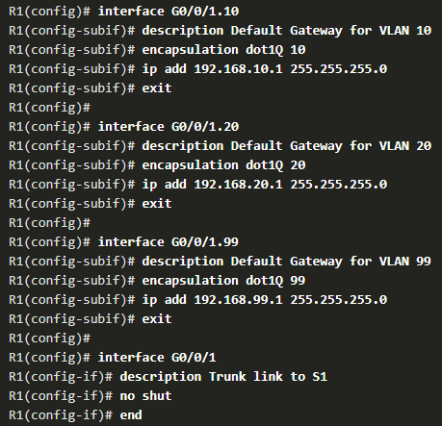

* Verify connectivity:
  + The router-on-a-stick configuration is complete after the switch trunk and the router subinterfaces have been configured. The configuration can be verified from the hosts, router, and switch.
  + From a host, verify connectivity to a host in another VLAN using the **ping** command. It is a good idea to first verify the current host IP configuration using the **ipconfig** Windows host command.
  + Next, use **ping** to verify connectivity with PC2 and S1, as shown in the figure. The ping output successfully confirms inter-VLAN routing is operating.
* In addition to using ping between devices, the following show commands can be used to verify and troubleshoot the router-on-a-stick configuration:
  + show ip route
  + show ip interface brief
  + show interfaces
  + show interfaces trunk

## Inter-VLAN Routing using Layer 3 Switches

* Enterprise campus LANs use Layer 3 switches to provide inter-VLAN routing. Layer 3 switches use hardware-based switching to achieve higher-packet processing rates than routers. Layer 3 switches are also commonly implemented in enterprise distribution layer wiring closets.
* Capabilities of a Layer 3 switch include the ability to do the following:
  + Route from one VLAN to another using multiple switched virtual interfaces (SVIs).
  + Convert a Layer 2 switchport to a Layer 3 interface (i.e., a routed port). A routed port is similar to a physical interface on a Cisco IOS router.
* To provide inter-VLAN routing, Layer 3 switches use SVIs. SVIs are configured using the same interface vlan vlan-id command used to create the management SVI on a Layer 2 switch. A Layer 3 SVI must be created for each of the routable VLANs.
* Scenario:

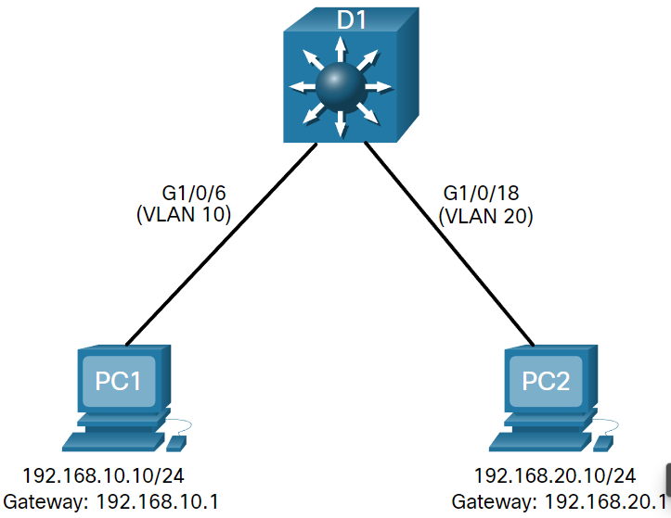

* Layer 3 switch configuration:
  1. Create the VLANs.
  2. Create the SVI VLAN interfaces.
  3. Configure access ports.
  4. Enable IP routing.

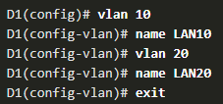

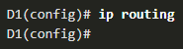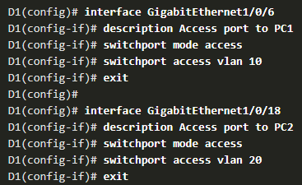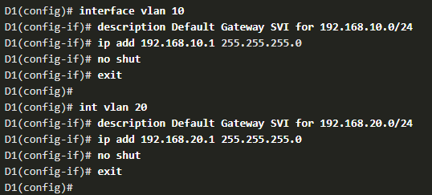

* Layer 3 Switch Inter-VLAN Routing Verification:
  + Inter-VLAN routing using a Layer 3 switch is simpler to configure than the router-on-a-stick method. After the configuration is complete, the configuration can be verified by testing connectivity between the hosts.
  + From a host, verify connectivity to a host in another VLAN using the **ping** command. It is a good idea to first verify the current host IP configuration using the **ipconfig** Windows host command.
  + Next, verify connectivity with PC2 using the **ping** Windows host command. The successful **ping** output confirms inter-VLAN routing is operating.
* Routing on a Layer 3 Switch:
  + If VLANs are to be reachable by other Layer 3 devices, then they must be advertised using static or dynamic routing. To enable routing on a Layer 3 switch, a routed port must be configured.
  + A routed port is created on a Layer 3 switch by disabling the switchport feature on a Layer 2 port that is connected to another Layer 3 device. Specifically, configuring the no switchport interface configuration command on a Layer 2 port converts it into a Layer 3 interface. Then the interface can be configured with an IPv4 configuration to connect to a router or another Layer 3 switch.
* 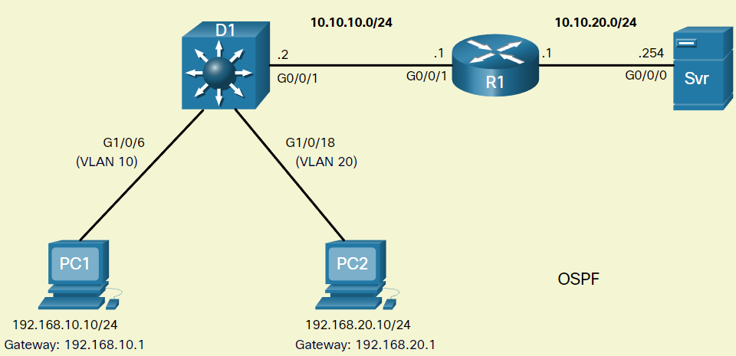Routing scenario:
* Routing configuration:
  1. Configure the routed port.
  2. Enable routing.
  3. Configure routing
  4. Verify routing.
  5. Verify connectivity.

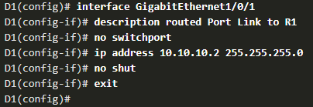

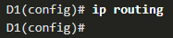

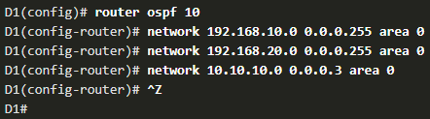

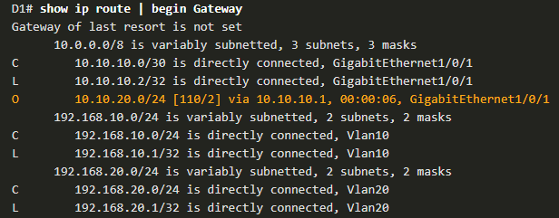

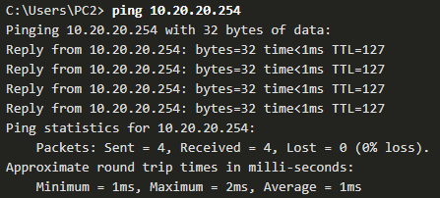

## Troubleshoot Inter-VLAN Routing

* Common inter-VLAN issues:
  + There are a number of reasons why an inter-VLAN configuration may not work. All are related to **connectivity issues**. **First**, check the **physical** layer to resolve any issues where a cable might be connected to the wrong port. If the connections are correct, then use the list in the table for other common reasons why inter-VLAN connectivity may fail.

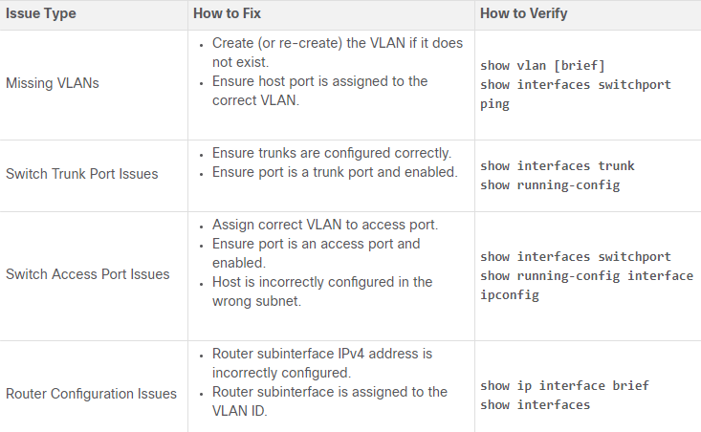

Zie cisco zelf voor een vb op troubleshooting

# STP Concepts

## Purpose of STP

* This topic covers the causes of loops in a Layer 2 network and briefly explains how spanning tree protocol works. Redundancy is an important part of the hierarchical design for eliminating single points of failure and preventing disruption of network services to users. Redundant networks require the addition of physical paths, but logical redundancy must also be part of the design. Having alternate physical paths for data to traverse the network makes it possible for users to access network resources, despite path disruption. However, redundant paths in a switched Ethernet network may cause both physical and logical Layer 2 loops.
* Ethernet LANs require a loop-free topology with a single path between any two devices. A loop in an Ethernet LAN can cause continued propagation of Ethernet frames until a link is disrupted and breaks the loop.
* Spanning Tree Protocol (STP) is a loop-prevention network protocol that allows for redundancy while creating a loop-free Layer 2 topology. IEEE 802.1D is the original IEEE MAC Bridging standard for STP.
* STP logically blocks physical loops in a Layer 2 network, preventing frames from circling the network forever.

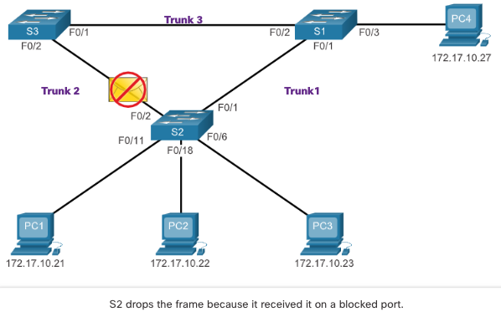

* STP compensates for a failure in the network by recalculating and opening up previously blocked ports.
* Issues with redundant switch links:
  + Path redundancy provides multiple network services by eliminating the possibility of a single point of failure. When multiple paths exist between two devices on an Ethernet network, and there is no spanning tree implementation on the switches, a Layer 2 loop occurs. A Layer 2 loop can result in MAC address table instability, link saturation, and high CPU utilization on switches and end-devices, resulting in the network becoming unusable.
  + Unlike the Layer 3 protocols, IPv4 and IPv6, Layer 2 Ethernet does not include a mechanism to recognize and eliminate endlessly looping frames. Both IPv4 and IPv6 include a mechanism that limits the number of times a Layer 3 networking device can retransmit a packet. A router will decrement the TTL (Time to Live) in every IPv4 packet, and the Hop Limit field in every IPv6 packet. When these fields are decremented to 0, a router will drop the packet. Ethernet and Ethernet switches have no comparable mechanism for limiting the number of times a switch retransmits a Layer 2 frame. STP was developed specifically as a loop prevention mechanism for Layer 2 Ethernet.
* Layer 2 Loops:
  + Without STP enabled, Layer 2 loops can form, causing broadcast, multicast and unknown unicast frames to loop endlessly. This can bring down a network quickly.
  + When a loop occurs, the MAC address table on a switch will constantly change with the updates from the broadcast frames, which results in MAC database instability. This can cause high CPU utilization, which makes the switch unable to forward frames.
  + An unknown unicast frame is when the switch does not have the destination MAC address in its MAC address table and must forward the frame out all ports, except the ingress port. These can also cause loops.
* Broadcast storm:
  + A broadcast storm is an abnormally high number of broadcasts overwhelming the network during a specific amount of time. Broadcast storms can disable a network within seconds by overwhelming switches and end devices. Broadcast storms can be caused by a hardware problem such as a faulty NIC or from a Layer 2 loop in the network.
  + Layer 2 broadcasts in a network, such as ARP Requests are very common. Layer 2 multicasts are typically forwarded the same way as a broadcast by the switch. IPv6 packets are never forwarded as a Layer 2 broadcast, ICMPv6 Neighbor Discovery uses Layer 2 multicasts.
  + A host caught in a Layer 2 loop is not accessible to other hosts on the network. Additionally, due to the constant changes in its MAC address table, the switch does not know out of which port to forward unicast frames.
  + To prevent these issues from occurring in a redundant network, some type of spanning tree must be enabled on the switches. Spanning tree is enabled, by default, on Cisco switches to prevent Layer 2 loops from occurring.
* The spanning tree algorithm:
  + STP is based on an algorithm invented by Radia Perlman while working for Digital Equipment Corporation, and published in the 1985 paper "An Algorithm for Distributed Computation of a Spanning Tree in an Extended LAN.” Her spanning tree algorithm (STA) creates a loop-free topology by selecting a single root bridge where all other switches determine a single least-cost path.
  + STP prevents loops from occurring by configuring a loop-free path through the network using strategically placed "blocking-state" ports. The switches running STP are able to compensate for failures by dynamically unblocking the previously blocked ports and permitting traffic to traverse the alternate paths.
* How does the STA create a loop-free topology?
  1. Selecting a Root Bridge: This bridge (switch) is the reference point for the entire network to build a spanning tree around. Each switch will determine a single, least cost path from itself to the root bridge.
  2. Block Redundant Paths: STP ensures that there is only one logical path between all destinations on the network by intentionally blocking redundant paths that could cause a loop. When a port is blocked, user data is prevented from entering or leaving that port.
  3. Create a Loop-Free Topology: A blocked port has the effect of making that link a non-forwarding link between the two switches. This creates a topology where each switch has only a single path to the root bridge, similar to branches on a tree that connect to the root of the tree.
  4. Recalculate in case of Link Failure: The physical paths still exist to provide redundancy, but these paths are disabled to prevent the loops from occurring. If the path is ever needed to compensate for a network cable or switch failure, STP recalculates the paths and unblocks the necessary ports to allow the redundant path to become active. STP recalculations can also occur any time a new switch or new inter-switch link is added to the network.

## STP Operations

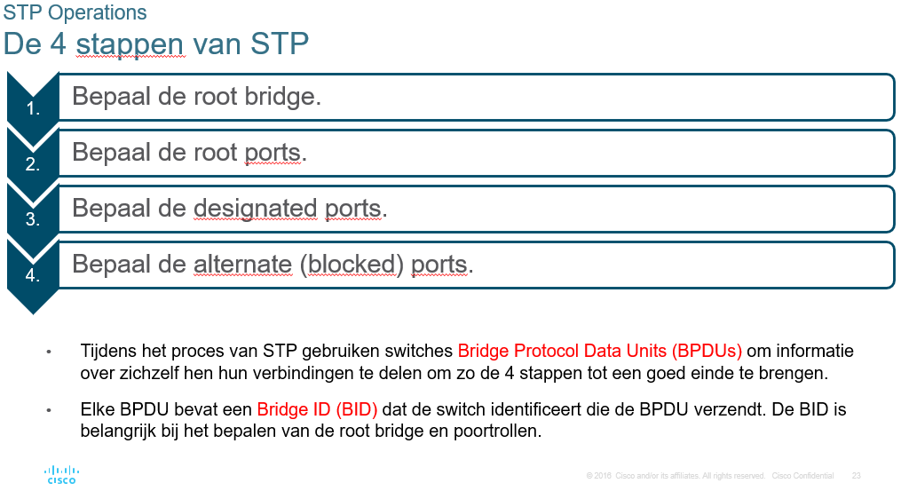

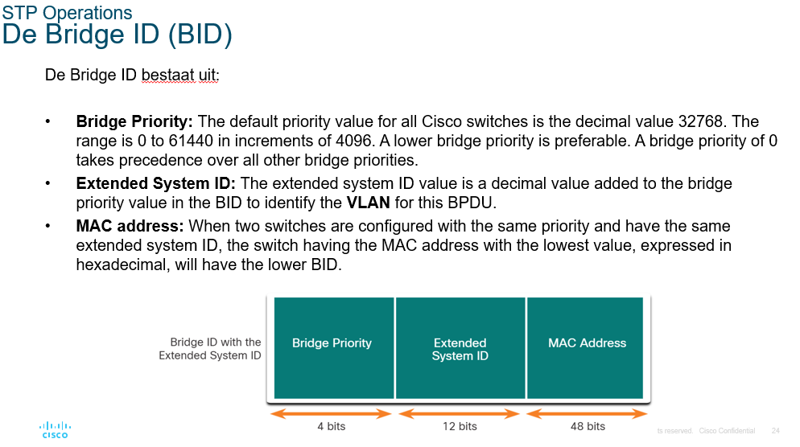

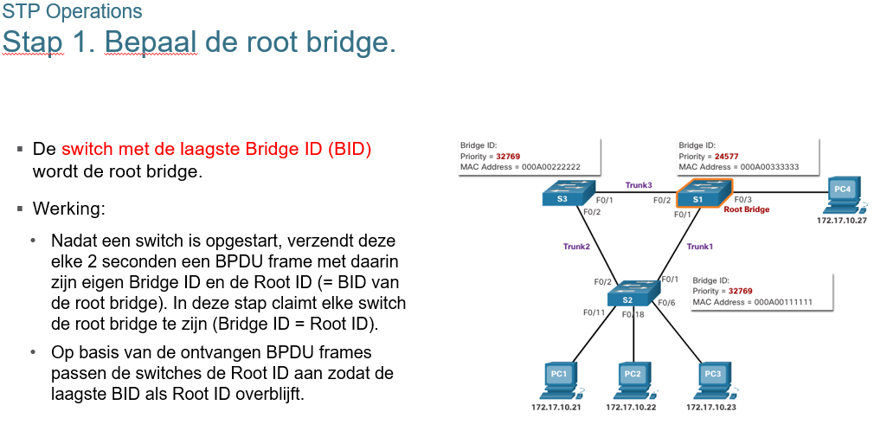

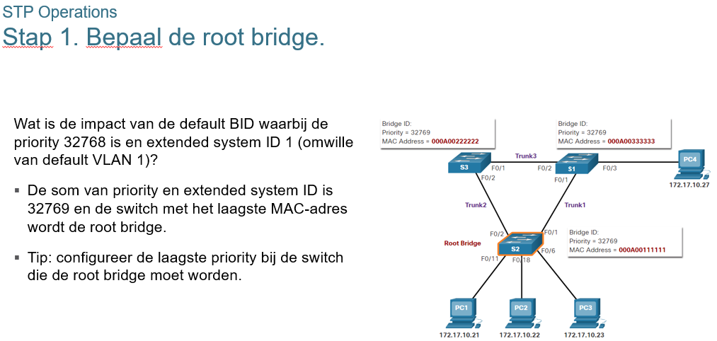

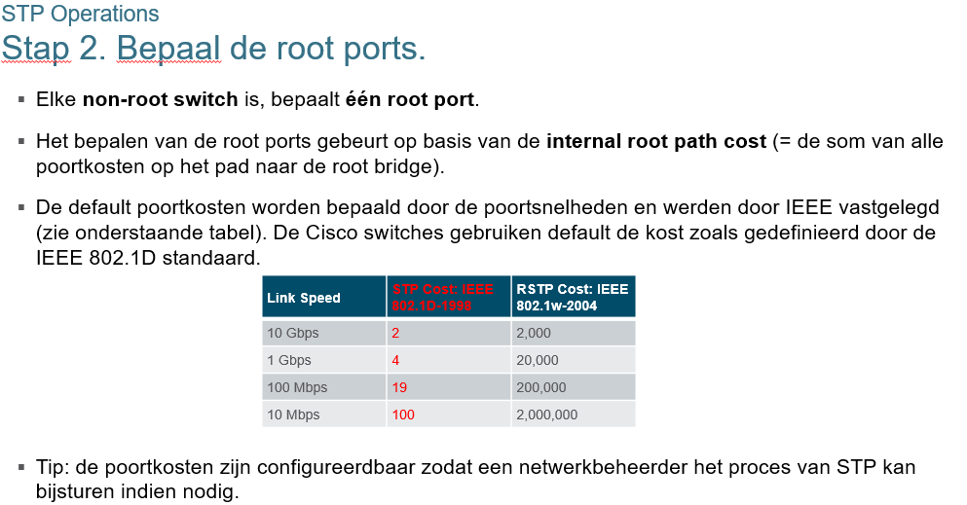 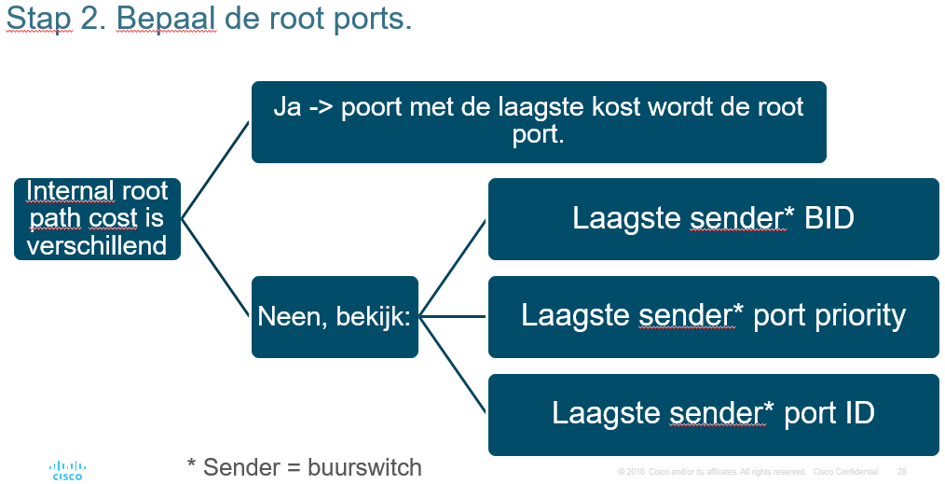 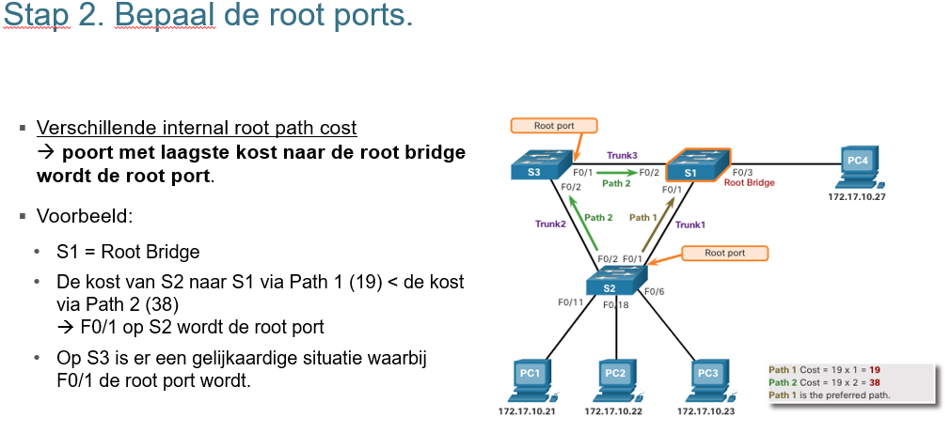

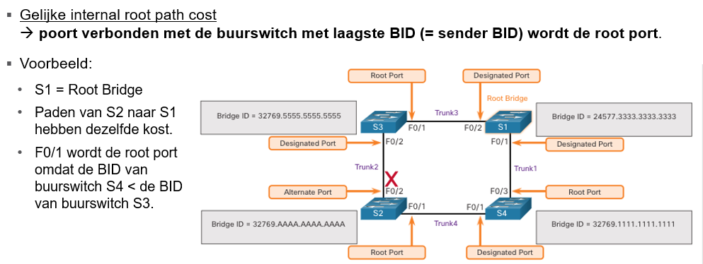

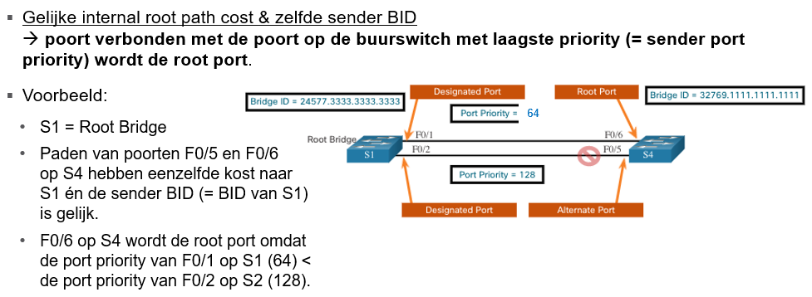 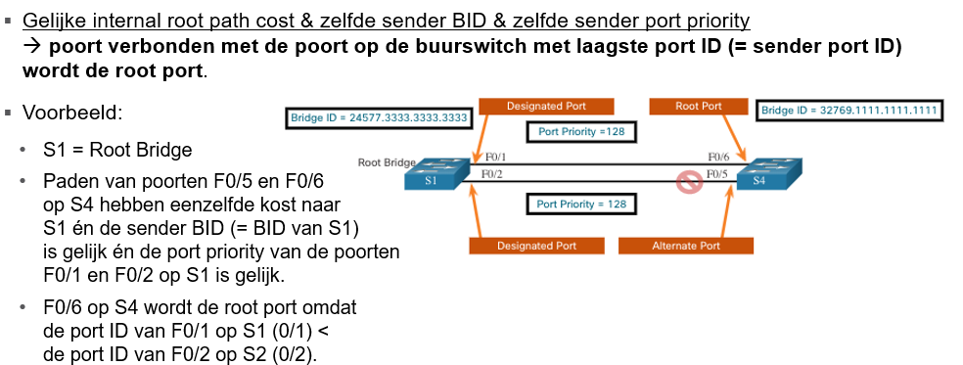 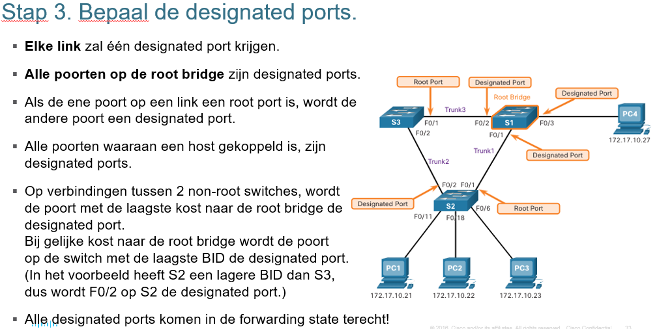

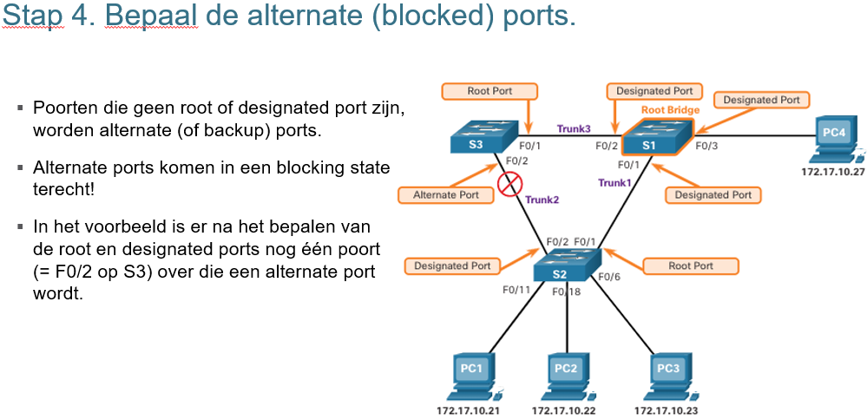

* STP convergence requires three timers, as follows:
  + Hello Timer -The hello time is the interval between BPDUs. The default is 2 seconds but can be modified to between 1 and 10 seconds.
  + Forward Delay Timer -The forward delay is the time that is spent in the listening and learning state. The default is 15 seconds but can be modified to between 4 and 30 seconds.
  + Max Age Timer -The max age is the maximum length of time that a switch waits before attempting to change the STP topology. The default is 20 seconds but can be modified to between 6 and 40 seconds.
  + Note: The default times can be changed on the root bridge, which dictates the value of these timers for the STP domain.
* STP facilitates the logical loop-free path throughout the broadcast domain. The spanning tree is determined through the information learned by the exchange of the BPDU frames between the interconnected switches. If a switch port transitions directly from the blocking state to the forwarding state without information about the full topology during the transition, the port can temporarily create a data loop. For this reason, STP has five ports states, four of which are operational port states as shown in the figure. The disabled state is considered non-operational.

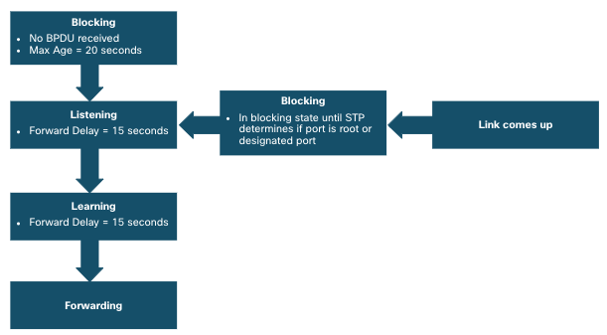

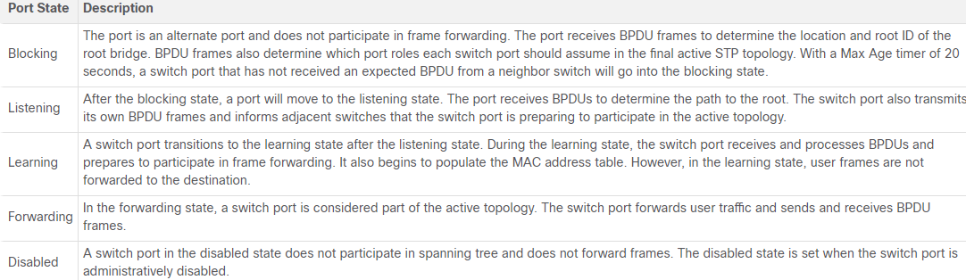

* Operational details of each port:

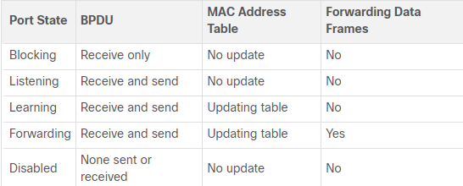

* Per-VLAN Spanning Tree:
  + STP can be configured to operate in an environment with multiple VLANs. In Per-VLAN Spanning Tree (PVST) versions of STP, there is a root bridge elected for each spanning tree instance. This makes it possible to have different root bridges for different sets of VLANs. STP operates a separate instance of STP for each individual VLAN. If all ports on all switches are members of VLAN 1, then there is only one spanning tree instance.

## Evolution of STP

* Different versions of STP:
  + Many professionals generically use spanning tree and STP to refer to the various implementations of spanning tree, such as Rapid Spanning Tree Protocol (RSTP) and Multiple Spanning Tree Protocol (MSTP). In order to communicate spanning tree concepts correctly, it is important to refer to the implementation or standard of spanning tree in context.
  + The latest IEEE documentation on spanning tree (IEEE-802-1D-2004) says, "STP has now been superseded by the Rapid Spanning Tree Protocol (RSTP)."The IEEE uses "STP" to refer to the original implementation of spanning tree and "RSTP" to describe the version of spanning tree specified in IEEE-802.1D-2004.
  + Because the two protocols share much of the same terminology and methods for the loop-free path, the primary focus will be on the current standard and the Cisco proprietary implementations of STP and RSTP.
  + Cisco switches running IOS 15.0 or later, run PVST+ by default. This version incorporates many of the specifications of IEEE 802.1D-2004, such as alternate ports in place of the former non-designated ports. Switches must be explicitly configured for rapid spanning tree mode in order to run the rapid spanning tree protocol.

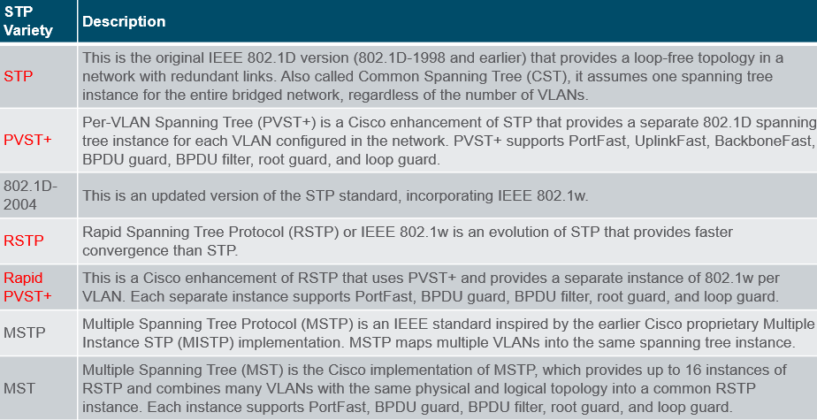

* RSTP concepts:
  + RSTP (IEEE 802.1w) supersedes the original 802.1D while retaining backward compatibility. The 802.1w STP terminology remains primarily the same as the original IEEE 802.1D STP terminology. Most parameters have been left unchanged. Users that are familiar with the original STP standard can easily configure RSTP. The same spanning tree algorithm is used for both STP and RSTP to determine port roles and topology.
  + RSTP increases the speed of the recalculation of the spanning tree when the Layer 2 network topology changes. RSTP can achieve much faster convergence in a properly configured network, sometimes in as little as a few hundred milliseconds. If a port is configured to be an alternate port it can immediately change to a forwarding state without waiting for the network to converge.
  + Note: Rapid PVST+ is the Cisco implementation of RSTP on a per-VLAN basis. With Rapid PVST+ an independent instance of RSTP runs for each VLAN.
* RSTP Port States and Port Roles:
  + There are only three port states in RSTP that correspond to the three possible operational states in STP. The 802.1D disabled, blocking, and listening states are merged into a unique 802.1w discarding state.
  + Root ports and designated ports are the same for both STP and RSTP. However, there are two RSTP port roles that correspond to the blocking state of STP. In STP, a blocked port is defined as not being the designated or root port. RSTP has two port roles for this purpose.
  + The alternate port has an alternate path to the root bridge. The backup port is a backup to a shared medium, such as a hub. A backup port is less common because hubs are now considered legacy devices.

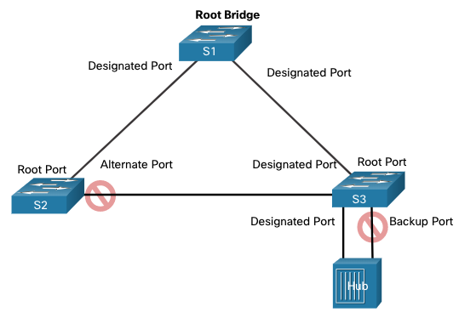

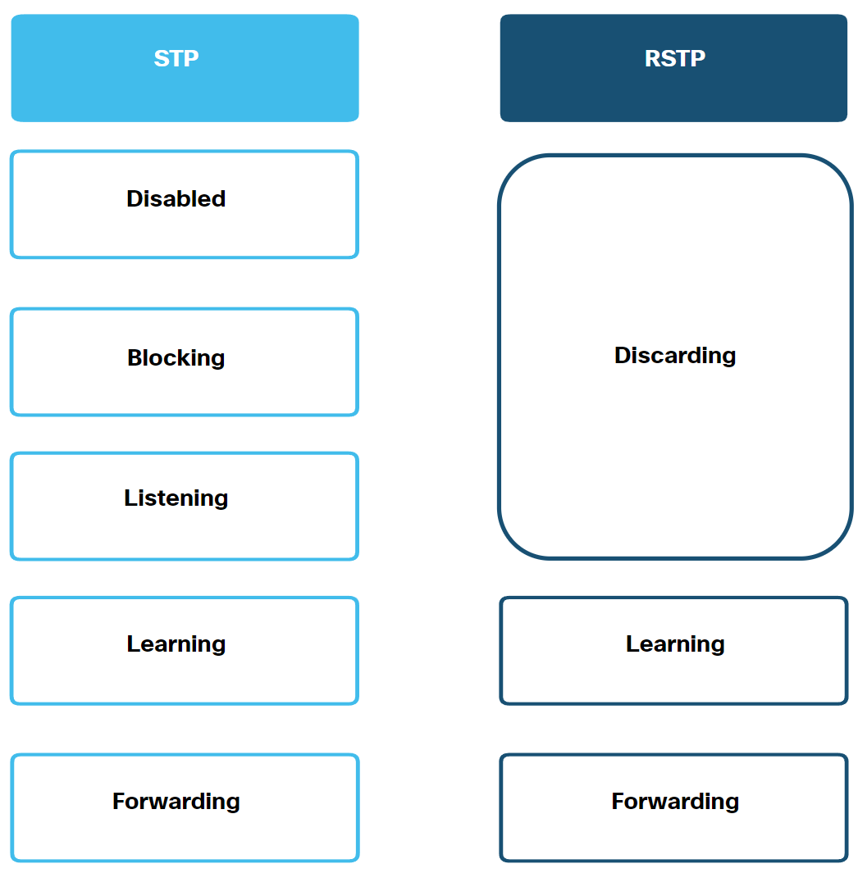

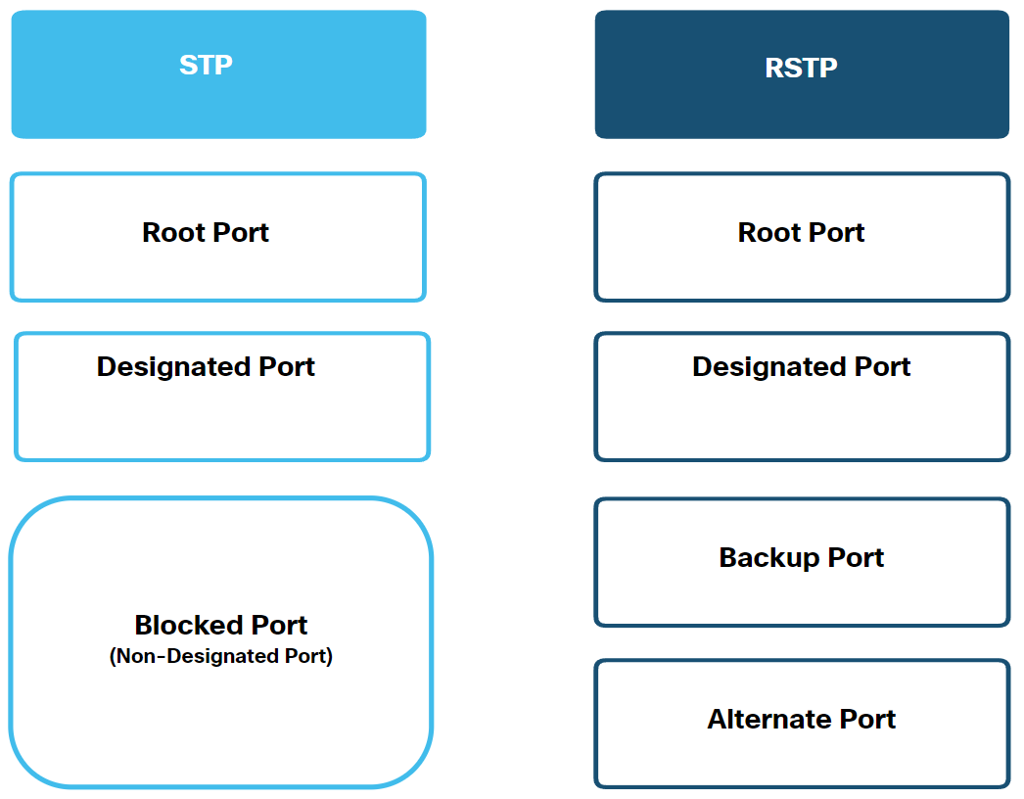

* PortFast and BPDU Guard:
  + When a device is connected to a switch port or when a switch powers up, the switch port goes through both the listening and learning states, each time waiting for the Forward Delay timer to expire. This delay is 15 seconds for each state for a total of 30 seconds. This can present a problem for DHCP clients trying to discover a DHCP server because the DHCP process may timeout. The result is that an IPv4 client will not receive a valid IPv4 address.
    - Note: Although this may occur with clients sending ICMPv6 Router Solicitation messages, the router will continue to send ICMPv6 Router Advertisement messages so the device will know how to obtain its address information.
  + When a switch port is configured with PortFast, that port transitions from blocking to forwarding state immediately, avoiding the 30 second delay. You can use PortFast on access ports to allow devices connected to these ports to access the network immediately. PortFast should only be used on access ports. If you enable PortFast on a port connecting to another switch, you risk creating a spanning tree loop.
  + A PortFast-enabled switch port should never receive BPDUs because that would indicate that switch is connected to the port, potentially causing a spanning tree loop. Cisco switches support a feature called BPDU guard. When enabled, it immediately puts the switch port in an errdisabled (error-disabled) state upon receipt of any BPDU. This protects against potential loops by effectively shutting down the port. The administrator must manually put the interface back into service.
* Alternatives to STP:
  + Over the years, organizations required greater resiliency and availability in the LAN. Ethernet LANs went from a few interconnected switches connected to a single router, to a sophisticated hierarchical network design including access, distribution and core layer switches.
  + Depending on the implementation, Layer 2 may include not only the access layer, but also the distribution or even the core layers. These designs may include hundreds of switches, with hundreds or even thousands of VLANs. STP has adapted to the added redundancy and complexity with enhancements, as part of RSTP and MSTP.
  + An important aspect to network design is fast and predictable convergence when there is a failure or change in the topology. Spanning tree does not offer the same efficiencies and predictabilities provided by routing protocols at Layer 3.
  + Layer 3 routing allows for redundant paths and loops in the topology, without blocking ports. For this reason, some environments are transitioning to Layer 3 everywhere except where devices connect to the access layer switch. In other words, the connections between access layer switches and distribution switches would be Layer 3 instead of Layer 2.

# EtherChannel

## EtherChannel Operation

* Link Aggregation:
  + There are scenarios in which more bandwidth or redundancy between devices is needed than what can be provided by a single link. Multiple links could be connected between devices to increase bandwidth. However, Spanning Tree Protocol (STP) block redundant links to prevent switching loops.
  + A link aggregation technology is needed that allows redundant links between devices that will not be blocked by STP. That technology is known as EtherChannel.
  + EtherChannel is a link aggregation technology that groups multiple physical Ethernet links together into one single logical link. It is used to provide fault-tolerance, load sharing, increased bandwidth, and redundancy between switches, routers, and servers.
  + EtherChannel technology makes it possible to combine the number of physical links between the switches to increase the overall speed of switch-to-switch communication.
* EtherChannel technology was originally developed by Cisco as a LAN switch-to-switch technique of grouping several Fast Ethernet or Gigabit Ethernet ports into one logical channel. When an EtherChannel is configured, the resulting virtual interface is called a port channel. The physical interfaces are bundled together into a port channel interface.

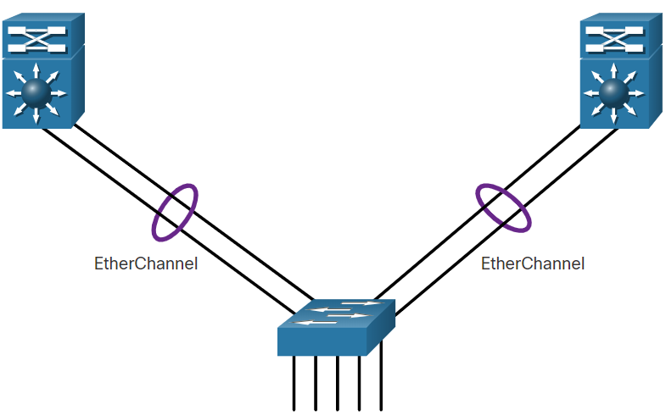

* Advantages of EtherChannel:
  + Most configuration tasks can be done on the EtherChannel interface instead of on each individual port, ensuring configuration consistency throughout the links.
  + EtherChannel relies on existing switch ports. There is no need to upgrade the link to a faster and more expensive connection to have more bandwidth.
  + Load balancing takes place between links that are part of the same EtherChannel. Depending on the hardware platform, one or more load-balancing methods can be implemented. These methods include source MAC and destination MAC load balancing, or source IP and destination IP load balancing, across the physical links.
  + EtherChannel creates an aggregation that is seen as one logical link. When several EtherChannel bundles exist between two switches, STP may block one of the bundles to prevent switching loops. When STP blocks one of the redundant links, it blocks the entire EtherChannel. This blocks all the ports belonging to that EtherChannel link. Where there is only one EtherChannel link, all physical links in the EtherChannel are active because STP sees only one (logical) link.
  + EtherChannel provides redundancy because the overall link is seen as one logical connection. Additionally, the loss of one physical link within the channel does not create a change in the topology. Therefore, a spanning tree recalculation is not required. Assuming at least one physical link is present; the EtherChannel remains functional, even if its overall throughput decreases because of a lost link within the EtherChannel.
* Implementation restrictions:
  + Interface types cannot be mixed. For example, Fast Ethernet and Gigabit Ethernet cannot be mixed within a single EtherChannel.
  + Currently each EtherChannel can consist of up to eight compatibly-configured Ethernet ports. EtherChannel provides full-duplex bandwidth up to 800 Mbps (Fast EtherChannel) or 8 Gbps (Gigabit EtherChannel) between one switch and another switch or host.
  + The Cisco Catalyst 2960 Layer 2 switch currently supports up to six EtherChannels. However, as new IOSs are developed and platforms change, some cards and platforms may support increased numbers of ports within an EtherChannel link, as well as support an increased number of Gigabit EtherChannels.
  + The individual EtherChannel group member port configuration must be consistent on both devices. If the physical ports of one side are configured as trunks, the physical ports of the other side must also be configured as trunks within the same native VLAN. Additionally, all ports in each EtherChannel link must be configured as Layer 2 ports.
  + Each EtherChannel has a logical port channel interface, as shown in the figure. A configuration applied to the port channel interface affects all physical interfaces that are assigned to that interface.

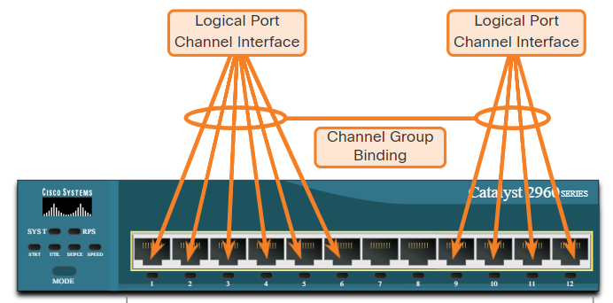

* AutoNegotiation Protocols:
  + EtherChannels can be formed through negotiation using one of two protocols, Port Aggregation Protocol (PAgP) or Link Aggregation Control Protocol (LACP). These protocols allow ports with similar characteristics to form a channel through dynamic negotiation with adjoining switches.
  + Note: It is also possible to configure a static or unconditional EtherChannel without PAgP or LACP.
* PAgP Operation:
  + PAgP (pronounced “Pag - P”) is a Cisco-proprietary protocol that aids in the automatic creation of EtherChannel links. When an EtherChannel link is configured using PAgP, PAgP packets are sent between EtherChannel-capable ports to negotiate the forming of a channel. When PAgP identifies matched Ethernet links, it groups the links into an EtherChannel. The EtherChannel is then added to the spanning tree as a single port.
  + When enabled, PAgP also manages the EtherChannel. PAgP packets are sent every 30 seconds. PAgP checks for configuration consistency and manages link additions and failures between two switches. It ensures that when an EtherChannel is created, all ports have the same type of configuration.
  + Note: In EtherChannel, it is mandatory that all ports have the same speed, duplex setting, and VLAN information. Any port-channel modification after the creation of the channel also changes the aggregated channel ports.
  + PAgP helps create the EtherChannel link by detecting the configuration of each side and ensuring that links are compatible so that the EtherChannel link can be enabled when needed. The modes for PAgP as follows:
    - On - This mode forces the interface to channel without PAgP. Interfaces configured in the on mode do not exchange PAgP packets.
    - PAgP desirable - This PAgP mode places an interface in an active negotiating state in which the interface initiates negotiations with other interfaces by sending PAgP packets.
    - PAgP auto - This PAgP mode places an interface in a passive negotiating state in which the interface responds to the PAgP packets that it receives but does not initiate PAgP negotiation.
  + The modes must be compatible on each side. If one side is configured to be in auto mode, it is placed in a passive state, waiting for the other side to initiate the EtherChannel negotiation. If the other side is also set to auto, the negotiation never starts and the EtherChannel does not form. If all modes are disabled by using the no command, or if no mode is configured, then the EtherChannel is disabled.
  + The on mode manually places the interface in an EtherChannel, without any negotiation. It works only if the other side is also set to on. If the other side is set to negotiate parameters through PAgP, no EtherChannel forms, because the side that is set to on mode does not negotiate.
  + No negotiation between the two switches means there is no checking to make sure that all the links in the EtherChannel are terminating on the other side, or that there is PAgP compatibility on the other switch.

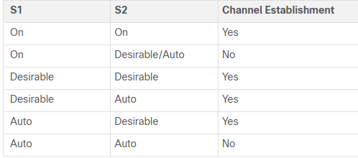

* LACP Operation:
  + LACP is part of an IEEE specification (802.3ad) that allows several physical ports to be bundled to form a single logical channel. LACP allows a switch to negotiate an automatic bundle by sending LACP packets to the other switch. It performs a function similar to PAgP with Cisco EtherChannel. Because LACP is an IEEE standard, it can be used to facilitate EtherChannels in multivendor environments. On Cisco devices, both protocols are supported.
  + LACP provides the same negotiation benefits as PAgP. LACP helps create the EtherChannel link by detecting the configuration of each side and making sure that they are compatible so that the EtherChannel link can be enabled when needed. The modes for LACP are as follows:
    - On - This mode forces the interface to channel without LACP. Interfaces configured in the on mode do not exchange LACP packets.
    - LACP active - This LACP mode places a port in an active negotiating state. In this state, the port initiates negotiations with other ports by sending LACP packets.
    - LACP passive - This LACP mode places a port in a passive negotiating state. In this state, the port responds to the LACP packets that it receives but does not initiate LACP packet negotiation.
  + Just as with PAgP, modes must be compatible on both sides for the EtherChannel link to form. The on mode is repeated, because it creates the EtherChannel configuration unconditionally, without PAgP or LACP dynamic negotiation.
  + LACP allows for eight active links, and also eight standby links. A standby link will become active should one of the current active links fail.

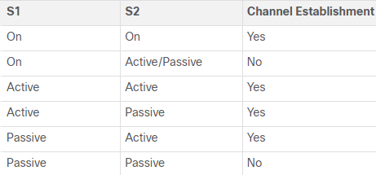

## Configure EtherChannel

* The following guidelines and restrictions are useful for configuring EtherChannel:
  + EtherChannel support - All Ethernet interfaces must support EtherChannel with no requirement that interfaces be physically contiguous.
  + Speed and duplex - Configure all interfaces in an EtherChannel to operate at the same speed and in the same duplex mode.
  + VLAN match - All interfaces in the EtherChannel bundle must be assigned to the same VLAN or be configured as a trunk.
  + Range of VLANs - An EtherChannel supports the same allowed range of VLANs on all the interfaces in a trunking EtherChannel. If the allowed range of VLANs is not the same, the interfaces do not form an EtherChannel, even when they are set to auto or desirable mode.
* If these settings must be changed, configure them in port channel interface configuration mode. Any configuration that is applied to the port channel interface also affects individual interfaces. However, configurations that are applied to the individual interfaces do not affect the port channel interface. Therefore, making configuration changes to an interface that is part of an EtherChannel link may cause interface compatibility issues.
* The port channel can be configured in access mode, trunk mode (most common), or on a routed port.
* Example:

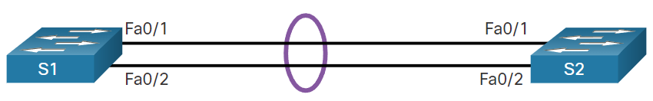

* Configuration of the example:
  1. Specify the interfaces that compose the EtherChannel group using the interface range interface global configuration mode command. The range keyword allows you to select several interfaces and configure them all together.
  2. Create the port channel interface with the channel-group identifier mode active command in interface range configuration mode. The identifier specifies a channel group number. The mode active keywords identify this as an LACP EtherChannel configuration.
  3. To change Layer 2 settings on the port channel interface, enter port channel interface configuration mode using the interface port-channel command, followed by the interface identifier. In the example, S1 is configured with an LACP EtherChannel. The port channel is configured as a trunk interface with the allowed VLANs specified.

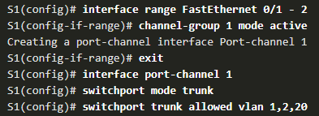

## Verify and Troubleshoot EtherChannel

* As always, when you configure devices in your network, you must verify your configuration. If there are problems, you will also need to be able to troubleshoot and fix them. There are a number of commands to verify an EtherChannel configuration:
  + The **show interfaces port-channel** command displays the general status of the port channel interface.
  + The **show etherchannel summary** command displays one line of information per port channel.
  + The **show etherchannel port-channel** command displays information about a specific port channel interface.
  + The **show interfaces etherchannel** command can provide information about the role of a physical member interface of the EtherChannel.
* Common issues with EtherChannel Configurations:
  + All interfaces within an EtherChannel must have the same configuration of speed and duplex mode, native and allowed VLANs on trunks, and access VLAN on access ports. Ensuring these configurations will significantly reduce network problems related to EtherChannel. Common EtherChannel issues include the following:
    - Assigned ports in the EtherChannel are not part of the same VLAN, or not configured as trunks. Ports with different native VLANs cannot form an EtherChannel.
    - Trunking was configured on some of the ports that make up the EtherChannel, but not all of them. It is not recommended that you configure trunking mode on individual ports that make up the EtherChannel. When configuring a trunk on an EtherChannel, verify the trunking mode on the EtherChannel.
    - If the allowed range of VLANs is not the same, the ports do not form an EtherChannel even when PAgP is set to the auto or desirable mode.
    - The dynamic negotiation options for PAgP and LACP are not compatibly configured on both ends of the EtherChannel.
  + Note: It is easy to confuse PAgP or LACP with DTP, because they are all protocols used to automate behavior on trunk links. PAgP and LACP are used for link aggregation (EtherChannel). DTP is used for automating the creation of trunk links. When an EtherChannel trunk is configured, typically EtherChannel (PAgP or LACP) is configured first and then DTP.
* Troubleshoot EtherChannel:
  + Step 1. View the EtherChannel Summary Information: The output of the **show etherchannel summary** command indicates that the EtherChannel is down.

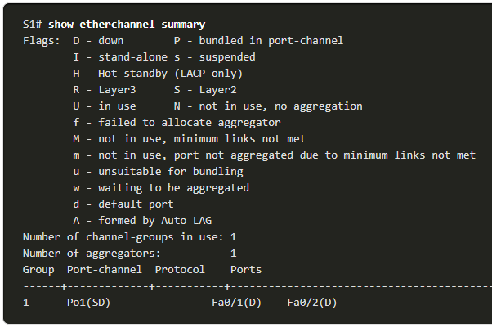

* + Step 2. View Port Channel Configuration: In the **show run | begin interface port-channel**output, more detailed output indicates that there are incompatible PAgP modes configured on S1 and S2.

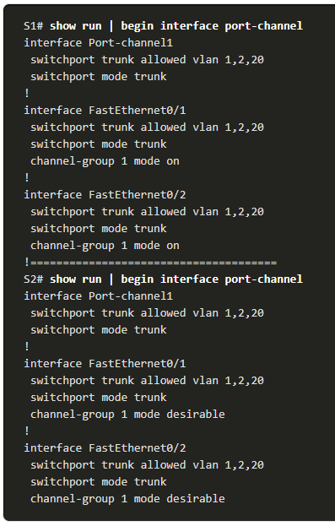

* + Step 3: Correct the Misconfiguration: To correct the issue, the PAgP mode on the EtherChannel is changed to desirable.

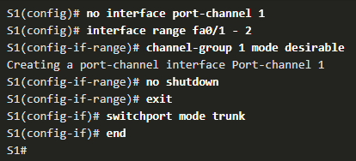

* + - Note: EtherChannel and STP must interoperate. For this reason, the order in which EtherChannel-related commands are entered is important, which is why you see interface Port-Channel 1 removed and then re-added with the channel-group command, as opposed to directly changed. If one tries to change the configuration directly, STP errors cause the associated ports to go into blocking or errdisabled state.
  + Step 4. Verify EtherChannel is Operational: The EtherChannel is now active as verified by the output of the **show etherchannel summary** command.

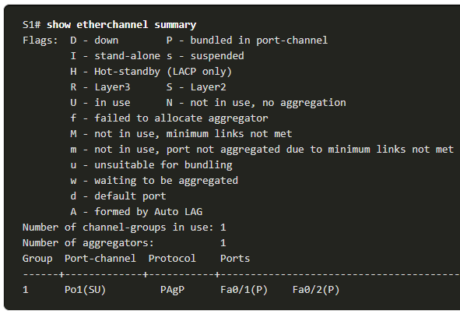

# DHCPv4

## DHCPv4 Concepts

* DHCPv4 Server and Client
  + Dynamic Host Configuration Protocol v4 (DHCPv4) assigns IPv4 addresses and other network configuration information dynamically. Because desktop clients typically make up the bulk of network nodes, DHCPv4 is an extremely useful and timesaving tool for network administrators.
  + A dedicated DHCPv4 server is scalable and relatively easy to manage. However, in a small branch or SOHO location, a Cisco router can be configured to provide DHCPv4 services without the need for a dedicated server. Cisco IOS software supports an optional, full-featured DHCPv4 server.
  + The DHCPv4 server dynamically assigns, or leases, an IPv4 address from a pool of addresses for a limited period of time chosen by the server, or until the client no longer needs the address.
  + Clients lease the information from the server for an administratively defined period. Administrators configure DHCPv4 servers to set the leases to time out at different intervals. The lease is typically anywhere from 24 hours to a week or more. When the lease expires, the client must ask for another address, although the client is typically reassigned the same address.
* DHCPv4 Operation:
  + DHCPv4 works in a client/server mode. When a client communicates with a DHCPv4 server, the server assigns or leases an IPv4 address to that client.
  + The client connects to the network with that leased IPv4 address until the lease expires. The client must contact the DHCP server periodically to extend the lease.
  + This lease mechanism ensures that clients that move or power off do not keep addresses that they no longer need.
  + When a lease expires, the DHCP server returns the address to the pool where it can be reallocated as necessary.
* When the client boots (or otherwise wants to join a network), it begins a four-step process to obtain a lease:

1. DHCP Discover (DHCPDISCOVER):
   * + The client starts the process using a broadcast DHCPDISCOVER message with its own MAC address to discover available DHCPv4 servers. Because the client has no valid IPv4 information at bootup, it uses Layer 2 and Layer 3 broadcast addresses to communicate with the server. The purpose of the DHCPDISCOVER message is to find DHCPv4 servers on the network.
2. DHCP Offer (DHCPOFFER):
   * + When the DHCPv4 server receives a DHCPDISCOVER message, it reserves an available IPv4 address to lease to the client. The server also creates an ARP entry consisting of the MAC address of the requesting client and the leased IPv4 address of the client. The DHCPv4 server sends the binding DHCPOFFER message to the requesting client.
3. DHCP Request (DHCPREQUEST):
   * + When the client receives the DHCPOFFER from the server, it sends back a DHCPREQUEST message. This message is used for both lease origination and lease renewal. When used for lease origination, the DHCPREQUEST serves as a binding acceptance notice to the selected server for the parameters it has offered and an implicit decline to any other servers that may have provided the client a binding offer.
     + Many enterprise networks use multiple DHCPv4 servers. The DHCPREQUEST message is sent in the form of a broadcast to inform this DHCPv4 server and any other DHCPv4 servers about the accepted offer.
4. DHCP Acknowledgment (DHCPACK):
   * + On receiving the DHCPREQUEST message, the server may verify the lease information with an ICMP ping to that address to ensure it is not being used already, it will create a new ARP entry for the client lease, and reply with a DHCPACK message. The DHCPACK message is a duplicate of the DHCPOFFER, except for a change in the message type field. When the client receives the DHCPACK message, it logs the configuration information and may perform an ARP lookup for the assigned address. If there is no reply to the ARP, the client knows that the IPv4 address is valid and starts using it as its own.

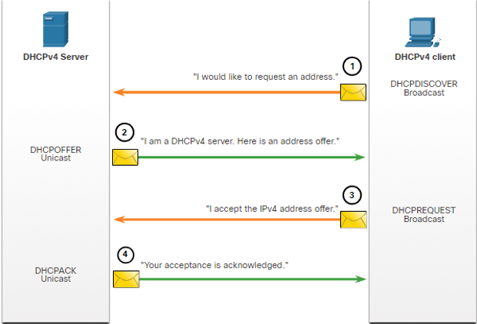

* Steps to Renew a Lease:
  + Prior to lease expiration, the client begins a two-step process to renew the lease with the DHCPv4 server, as shown in the figure:

1. DHCP Request (DHCPREQUEST)

* + Before the lease expires, the client sends a DHCPREQUEST message directly to the DHCPv4 server that originally offered the IPv4 address. If a DHCPACK is not received within a specified amount of time, the client broadcasts another DHCPREQUEST so that one of the other DHCPv4 servers can extend the lease.

2. DHCP Acknowledgment (DHCPACK)

* + On receiving the DHCPREQUEST message, the server verifies the lease information by returning a DHCPACK.

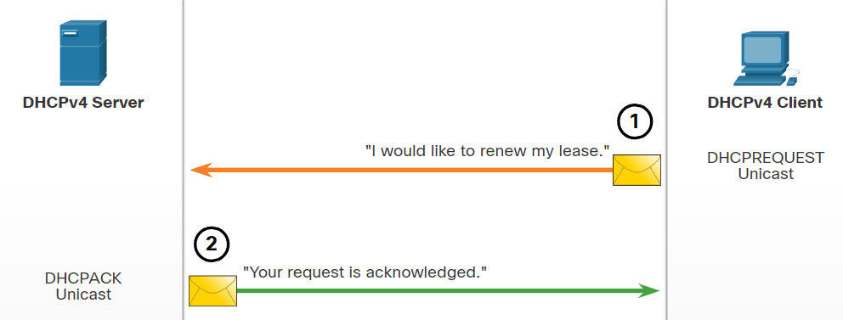

* + Note: These messages (primarily the DHCPOFFER and DHCPACK) can be sent as unicast or broadcast according to IETF RFC 2131.

## Configure a Cisco IOS DHCPv4 Server

* Steps to Configure a Cisco IOS DHCPv4 Server
  1. Exclude IPv4 addresses.
     + The router functioning as the DHCPv4 server assigns all IPv4 addresses in a DHCPv4 address pool unless it is configured to exclude specific addresses. Typically, some IPv4 addresses in a pool are assigned to network devices that require static address assignments. Therefore, these IPv4 addresses should not be assigned to other devices. The command syntax to exclude IPv4 addresses is the following:



* + - A single address or a range of addresses can be excluded by specifying the low-address and high-address of the range. Excluded addresses should be those addresses that are assigned to routers, servers, printers, and other devices that have been, or will be, manually configured. You can also enter the command multiple times.
  1. Define a DHCPv4 pool name.
     + Configuring a DHCPv4 server involves defining a pool of addresses to assign.
     + As shown in the example, the ip dhcp pool pool-name command creates a pool with the specified name and puts the router in DHCPv4 configuration mode, which is identified by the prompt Router(dhcp-config)#.

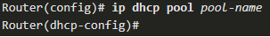

* 1. Configure the DHCPv4 pool.
     + The address pool and default gateway router must be configured. Use the network statement to define the range of available addresses. Use the default-router command to define the default gateway router. Typically, the gateway is the LAN interface of the router closest to the client devices. One gateway is required, but you can list up to eight addresses if there are multiple gateways.
     + The default lease value is one day.

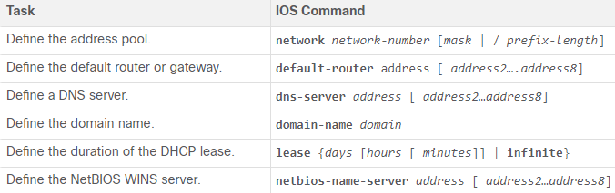

* DHCPv4 Verification Commands:

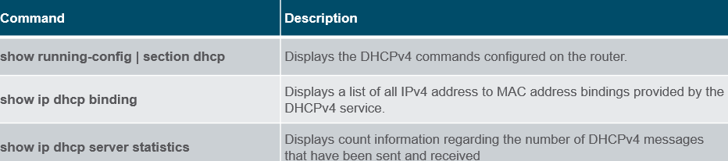

* Verify DHCPv4 is Operational:
  + Verify the DHCPv4 Configuration: As shown in the example, the **show running-config | section dhcp** command output displays the DHCPv4 commands configured on R1. The | section parameter displays only the commands associated with DHCPv4 configuration.

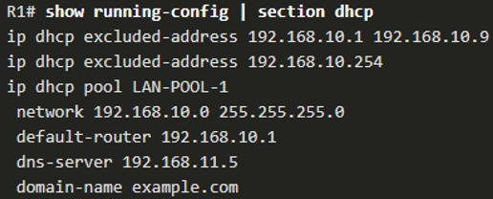

* + Verify DHCPv4 Bindings: As shown in the example, the operation of DHCPv4 can be verified using the **show ip dhcp binding** command. This command displays a list of all IPv4 address to MAC address bindings that have been provided by the DHCPv4 service.

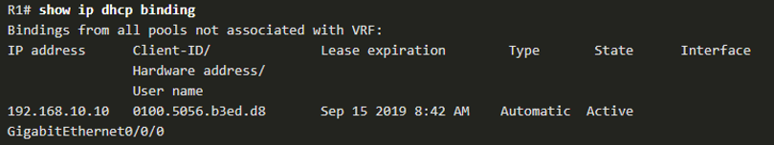

* + Verify DHCPv4 Statistics: The output of the **show ip dhcp server statistics** is used to verify that messages are being received or sent by the router. This command displays count information regarding the number of DHCPv4 messages that have been sent and received.

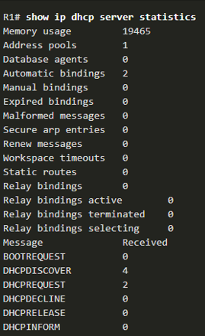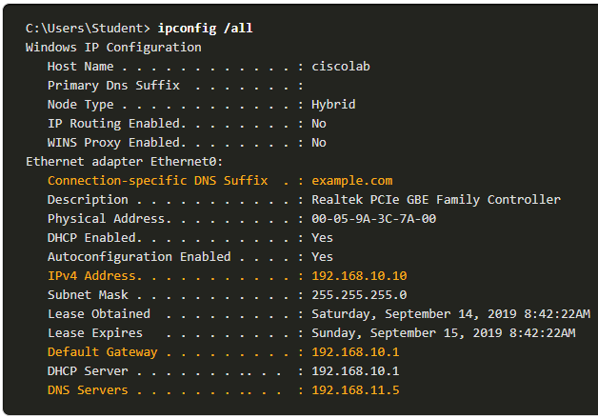

* + Verify DHCPv4 Client Received IPv4 Addressing: The **ipconfig /all** command, when issued on PC1, displays the TCP/IP parameters, as shown in the example. Because PC1 was connected to the network segment 192.168.10.0/24, it automatically received a DNS suffix, IPv4 address, subnet mask, default gateway, and DNS server address from that pool. No DHCP-specific router interface configuration is required: if a PC is connected to a network segment that has a DHCPv4 pool available, the PC can obtain an IPv4 address from the appropriate pool automatically.
* Disable the Cisco IOS DHCPv4 Server
  + The DHCPv4 service is enabled by default. To disable the service, use the no service dhcp global configuration mode command. Use the service dhcp global configuration mode command to re-enable the DHCPv4 server process, as shown in the example. Enabling the service has no effect if the parameters are not configured.
  + Note: Clearing the DHCP bindings or stopping and restarting the DHCP service may result in duplicate IP addresses being temporarily assigned on the network.

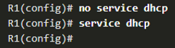

* DHCPv4 Relay:
  + In a complex hierarchical network, enterprise servers are usually located centrally. These servers may provide DHCP, DNS, TFTP, and FTP services for the network. Network clients are not typically on the same subnet as those servers. In order to locate the servers and receive services, clients often use broadcast messages.
  + In the figure, PC1 is attempting to acquire an IPv4 address from a DHCPv4 server using a broadcast message. In this scenario, R1 is not configured as a DHCPv4 server and does not forward the broadcast. Because the DHCPv4 server is located on a different network, PC1 cannot receive an IP address using DHCP. R1 must be configured to relay DHCPv4 messages to the DHCPv4 server.

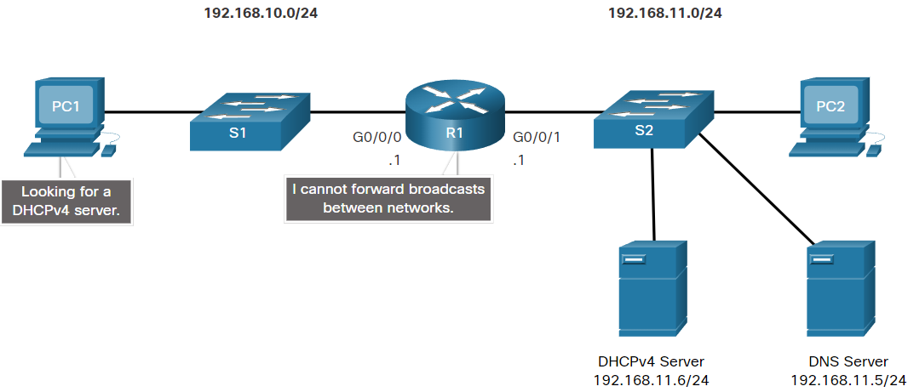

* + Configure R1 with the **ip helper-address address *interface*** configuration command. This will cause R1 to relay DHCPv4 broadcasts to the DHCPv4 server. As shown in the example, the interface on R1 receiving the broadcast from PC1 is configured to relay DHCPv4 address to the DHCPv4 server at 192.168.11.6.
  + When R1 has been configured as a DHCPv4 relay agent, it accepts broadcast requests for the DHCPv4 service and then forwards those requests as a unicast to the IPv4 address 192.168.11.6. The network administrator can use **the show ip interface** command to verify the configuration.

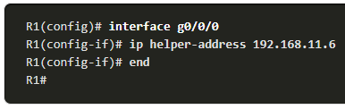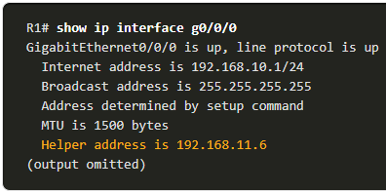

* + DHCPv4 is not the only service that the router can be configured to relay. By default, the ip helper-address command forwards the following eight UDP services:
    - Port 37: Time
    - Port 49: TACACS
    - Port 53: DNS
    - Port 67: DHCP/BOOTP server
    - Port 68: DHCP/BOOTP client
    - Port 69: TFTP
    - Port 137: NetBIOS name service
    - Port 138: NetBIOS datagram service

## Configure a DHCPv4 Client

* Cisco Router as a DHCPv4 Client
  + There are scenarios where you might have access to a DHCP server through your ISP. In these instances, you can configure a Cisco IOS router as a DHCPv4 client.
  + Sometimes, Cisco routers in a small office or home office (SOHO) and branch sites have to be configured as DHCPv4 clients in a similar manner to client computers. The method used depends on the ISP. However, in its simplest configuration, the Ethernet interface is used to connect to a cable or DSL modem.
  + To configure an Ethernet interface as a DHCP client, use the **ip address dhcp interface** configuration mode command.
  + In the figure, assume that an ISP has been configured to provide select customers with IP addresses from the 209.165.201.0/27 network range after the G0/0/1 interface is configured with the **ip address dhcp** command.

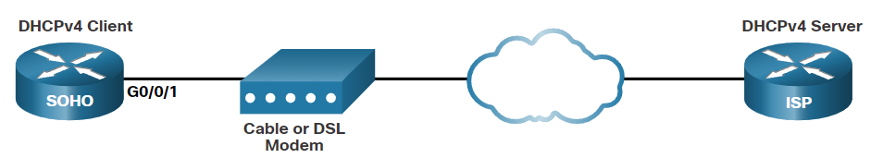

* Configuration example:
  + To configure an Ethernet interface as a DHCP client, use the **ip address dhcp** interface configuration mode command, as shown in the example. This configuration assumes that the ISP has been configured to provide select customers with IPv4 addressing information.
  + The **show ip interface g0/1** command confirms that the interface is up and that the address was allocated by a DHCPv4 server.

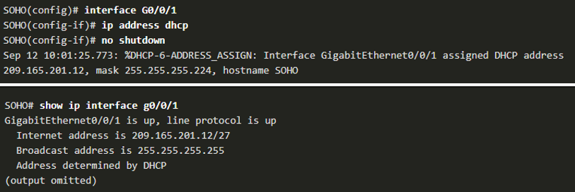

* Home Router as a DHCPv4 Client
  + Home routers are typically already set to receive IPv4 addressing information automatically from the ISP. This is so that customers can easily set up the router and connect to the internet.
  + For example, the figure shows the default WAN setup page for a Packet Tracer wireless router. Notice that the internet connection type is set to Automatic Configuration - DHCP. This selection is used when the router is connected to a DSL or cable modem and acts as a DHCPv4 client, requesting an IPv4 address from the ISP.
  + Various manufacturers of home routers will have a similar setup.

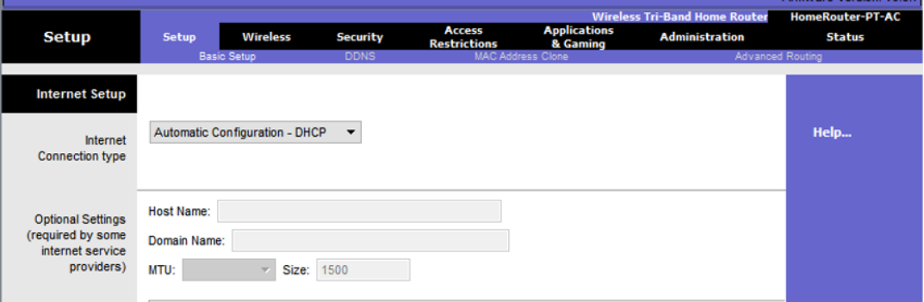

# SLAAC and DHCPv6

## IPv6 GUA Assignment

* IPv6 host configuration:
  + On a router, an IPv6 global unicast address (GUA) is manually configured using the **ipv6 address *ipv6-address/prefix-length*** interface configuration command.
  + A Windows host can also be manually configured with an IPv6 GUA address configuration, as shown in the figure.
  + However, manually entering an IPv6 GUA can be time consuming and somewhat error prone.
  + Therefore, most Windows host are enabled to dynamically acquire an IPv6 GUA configuration.

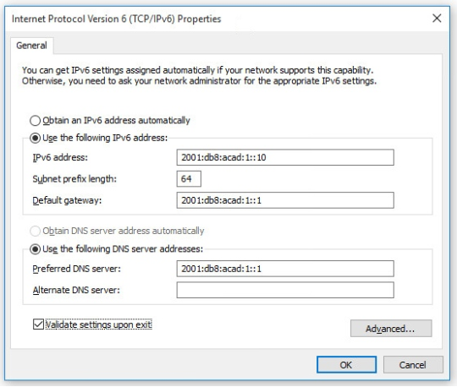

* IPv6 Host Link-Local Address:
  + If automatic IPv6 addressing is selected, the host will use an Internet Control Message Protocol version 6 (ICMPv6) Router Advertisement (RA) message to help it autoconfigure an IPv6 configuration.
  + The IPv6 link-local address is automatically created by the host when it boots and the Ethernet interface is active.
  + The interface did not create an IPv6 GUA in the output because the network segment did not have a router to provide network configuration instructions for the host.
  + **Note:** The "%" and number at the end of the link-local address is known as a Zone ID or Scope ID and is used by the OS to associate the LLA with a specific interface.

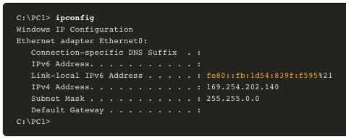

* IPv6 GUA Assignment:
  + By default, an IPv6-enabled router periodically send ICMPv6 RAs which simplifies how a host can dynamically create or acquire its IPv6 configuration.
  + A host can dynamically be assigned a GUA using stateless and stateful services.
  + All stateless and stateful methods in this module use ICMPv6 RA messages to suggest to the host how to create or acquire its IPv6 configuration.
  + Although host operating systems follow the suggestion of the RA, the actual decision is ultimately up to the host

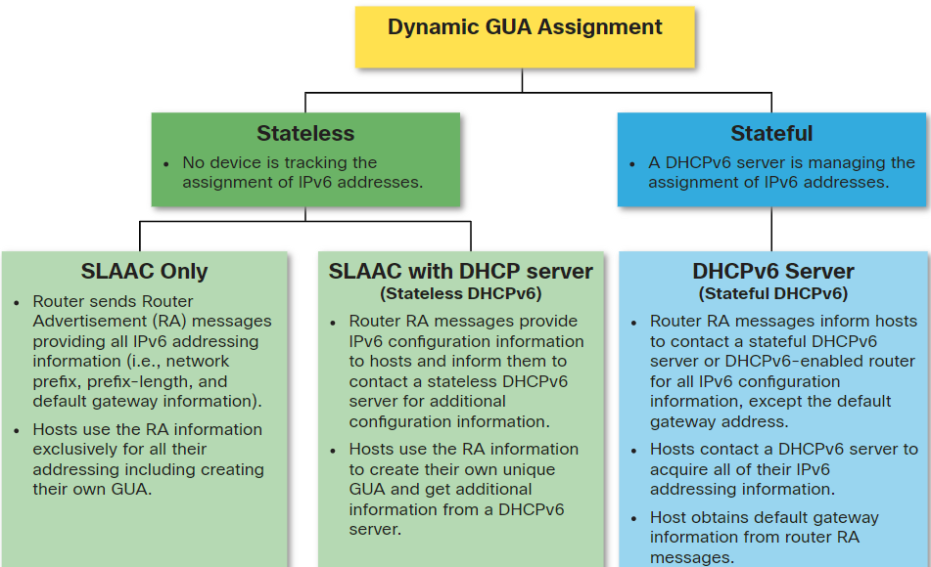

* Three RA Message Flags
  + How a client obtains an IPv6 GUA depends on settings in the RA message.
  + An ICMPv6 RA message includes the following three flags:
    - A flag - The Address Autoconfiguration flag signifies to use Stateless Address Autoconfiguration (SLAAC) to create an IPv6 GUA
    - O flag - The Other Configuration flag signifies that additional information is available from a stateless DHCPv6 server.
    - M flag - The Managed Address Configuration flag signifies to use a stateful DHCPv6 server to obtain an IPv6 GUA.
  + Using different combinations of the A, O and M flags, RA messages inform the host about the dynamic options available.

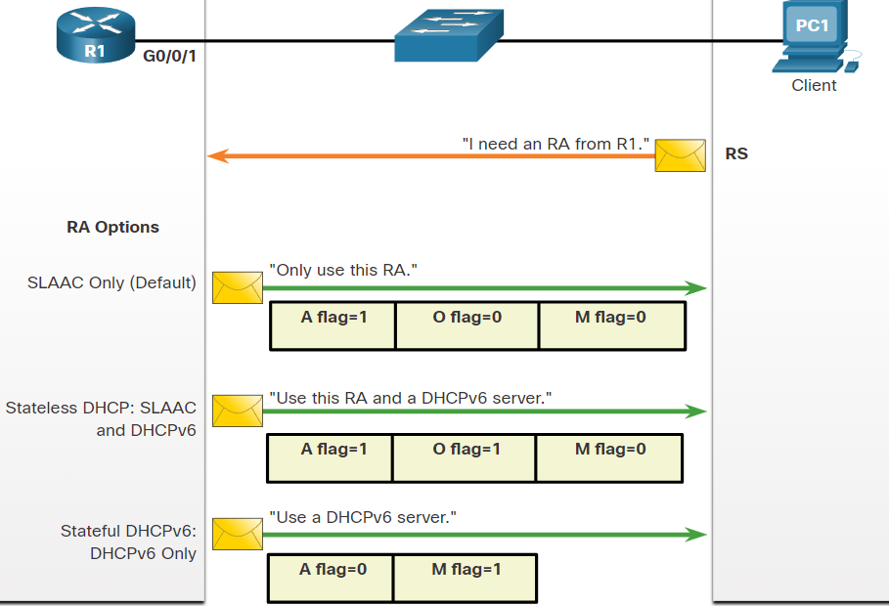

## SLAAC

* SLAAC Overview
  + Not every network has access to a DHCPv6 server but every device in an IPv6 network needs a GUA. The SLAAC method enables hosts to create their own unique IPv6 global unicast address without the services of a DHCPv6 server.
  + SLAAC is a stateless service which means there is no server that maintains network address information to know which IPv6 addresses are being used and which ones are available.
  + SLAAC sends periodic ICMPv6 RA messages (i.e., every 200 seconds) providing addressing and other configuration information for hosts to autoconfigure their IPv6 address based on the information in the RA.
  + A host can also send a Router Solicitation (RS) message requesting an RA.
  + SLAAC can be deployed as SLAAC only, or SLAAC with DHCPv6.
* Enabling SLAAC:
  + R1 G0/0/1 has been configured with the indicated IPv6 GUA and link-local addresses.

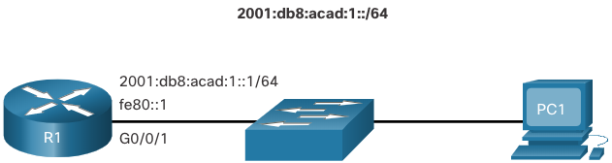

* + The R1 G0/0/01 IPv6 addresses include:
    - Link-local IPv6 address - fe80::1
    - GUA / subnet - 2001:db8:acad:1::1, 2001:db8:acad:1::/64
    - IPv6 all-nodes group - ff02::1
  + Although the router interface has an IPv6 configuration, it is still not yet enabled to send RAs containing address configuration information to hosts using SLAAC.
    - To enable the sending of RA messages, a router must join the IPv6 all-routers group using the **ipv6 unicast-routing** global config command.

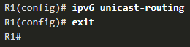

* + The IPv6 all-routers group responds to the IPv6 multicast address ff02::2.
    - The **show ipv6 interface** command verifies that R1 has joined the IPv6 all-routers group (i.e., ff02::2).
    - R1 will now begin to send RA messages every 200 seconds to the IPv6 all-nodes multicast address ff02::1.

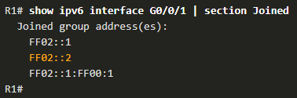

* SLAAC Only Method:
  + The SLAAC only method is enabled by default when the ipv6 unicast-routing command is configured. All enabled Ethernet interfaces with an IPv6 GUA configured will start sending RA messages with the A flag set to 1, and the O and M flags set to 0
  + The A = 1 flag suggests to the client that it create its own IPv6 GUA using the prefix advertised in the RA. The client can create its own Interface ID using either Extended Unique Identifier method (EUI-64) or have it randomly generated.
  + The O =0 and M=0 flags instruct the client to use the information in the RA message exclusively. The RA includes the prefix, prefix-length, DNS server, MTU, and default gateway information. There is no further information available from a DHCPv6 server.

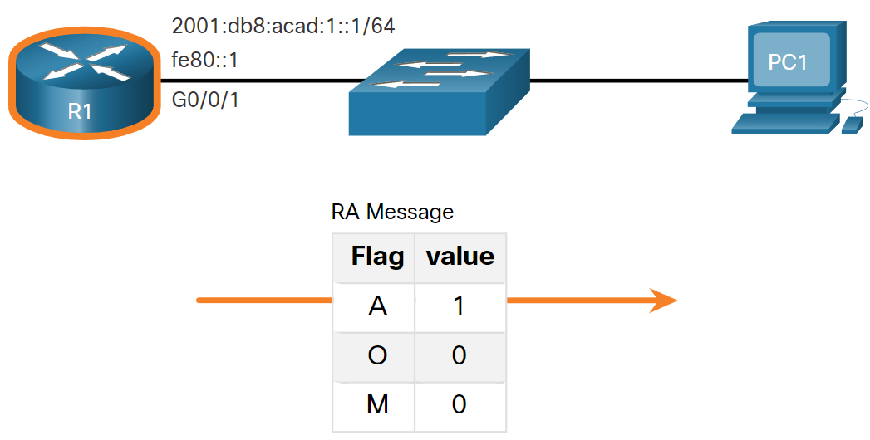

* + The default gateway address is the source IPv6 address of the RA message, which is the LLA for R1. The default gateway can only be obtained automatically from the RA message. A DHCPv6 server does not provide this information.
* ICMPv6 RS Messages:
  + A router sends RA messages every 200 seconds. However, it will also send an RA message if it receives an RS message from a host.
  + IPv6 enabled hosts wishing to obtain IPv6 addressing information send an RS message to the IPv6 all-routers multicast address of ff02::2.

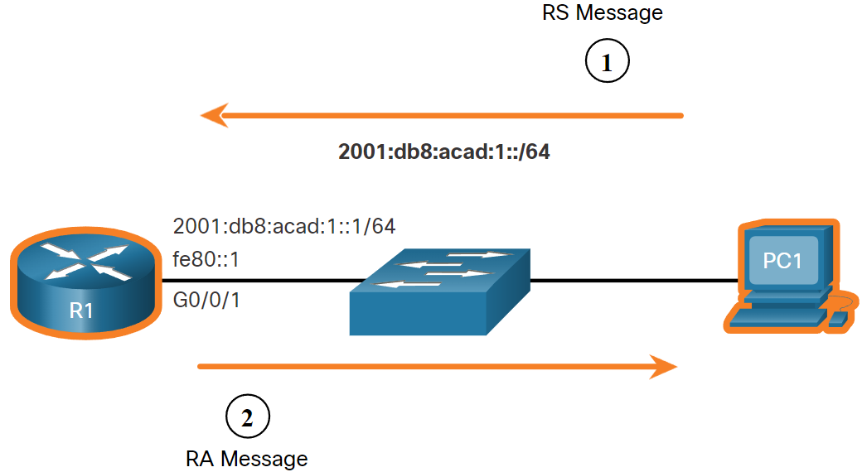

* Host Process to Generate Interface ID:
  + Using SLAAC, a host typically acquires its 64-bit IPv6 subnet information from the router RA. However, it must generate the remainder 64-bit interface identifier (ID) using one of two methods:
    - Randomly generated - The 64-bit interface ID is randomly generated by the client operating system. This is the method now used by Windows 10 hosts.
    - EUI-64 - The host creates an interface ID using its 48-bit MAC address. The host inserts the hex value of fffe in the middle of the address, and flips the seventh bit of the interface ID. This changes the value of the second hexadecimal digit of the interface ID. Some operating systems default to the randomly generated interface ID instead of the EUI-64 method, due to privacy concerns. This is because the Ethernet MAC address of the host is used by EUI-64 to create the interface ID.
* Duplicate Address Detection:
  + The previous process enables the host to create an IPv6 address. However, there is no guarantee that the address is unique on the network.
  + A SLAAC host may use the following Duplicate Address Detection (DAD) process to ensure that the IPv6 GUA is unique.
    - The host sends an ICMPv6 Neighbor Solicitation (NS) message with a specially constructed solicited-node multicast address containing the last 24 bits of IPv6 address of the host.
    - If no other devices respond with a Neighbor Advertisement (NA) message, then the address is virtually guaranteed to be unique and can be used by the host.
    - If an NA is received by the host, then the address is not unique, and the host must generate a new interface ID to use.
  + Note: DAD is really not required because a 64-bit interface ID provides 18 quintillion possibilities. Therefore, the chance of a duplicate address is remote. However, the Internet Engineering Task Force (IETF) recommends that DAD is used. Therefore, most operating systems perform DAD on all IPv6 unicast addresses, regardless of how the address is configured.

## DHCPv6

* DHCPv6 Operation Steps:
  + Stateless DHCPv6 uses parts of SLAAC to ensure that all the necessary information is supplied to the host. Stateful DHCPv6 does not require SLAAC.
  + The host begins the DHCPv6 client/server communications after stateless DHCPv6 or stateful DHCPv6 is indicated in the RA.
  + The steps for DHCPv6 operations are as follows:
    - The host sends an RS message.
    - The router responds with an RA message.
    - The host sends a DHCPv6 SOLICIT message.
      * The client, now a DHCPv6 client, needs to locate a DHCPv6 server and sends a DHCPv6 SOLICIT message to the reserved IPv6 multicast all-DHCPv6-servers address of ff02::1:2. This multicast address has link-local scope, which means routers do not forward the messages to other networks.
    - The DHCPv6 server responds with an ADVERTISE message.
      * One or more DHCPv6 servers respond with a DHCPv6 ADVERTISE unicast message. The ADVERTISE message informs the DHCPv6 client that the server is available for DHCPv6 service
    - The host responds to the DHCPv6 server.
      * The PC1 response depends on whether it is using stateful or stateless DHCPv6:
        + Stateless DHCPv6 client - The client creates an IPv6 address using the prefix in the RA message and a self-generated Interface ID. The client then sends a DHCPv6 INFORMATION-REQUEST message to the DHCPv6 server requesting additional configuration parameters (e.g., DNS server address).
        + Stateful DHCPv6 client - The client sends a DHCPv6 REQUEST message to the DHCPv6 server to obtain all necessary IPv6 configuration parameters.
    - The DHCPv6 server sends a REPLY message.
      * The server sends a DHCPv6 REPLY unicast message to the client. The content of the message varies depending on if it is replying to a REQUEST or INFORMATION-REQUEST message.
      * Note: The client will use the source IPv6 Link-local address of the RA as its default gateway address. A DHCPv6 server does not provide this information.

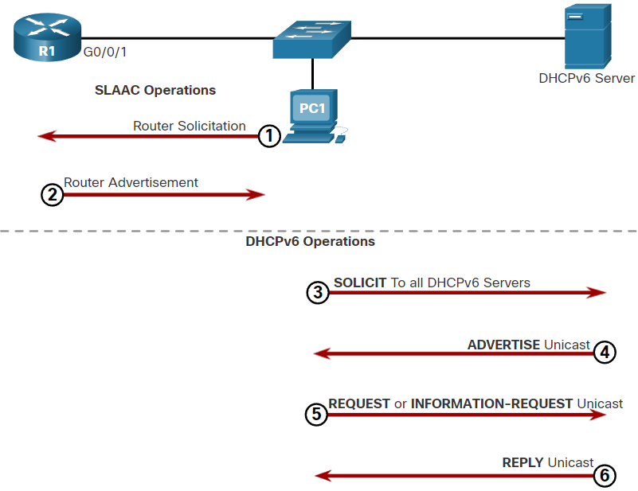

* Stateless DHCPv6 Operation:
  + The stateless DHCPv6 server is only providing information that is identical for all devices on the network such as the IPv6 address of a DNS server.
  + This process is known as stateless DHCPv6 because the server is not maintaining any client state information (i.e., a list of available and allocated IPv6 addresses). The stateless DHCPv6 server is only providing configuration parameters for clients, not IPv6 addresses.

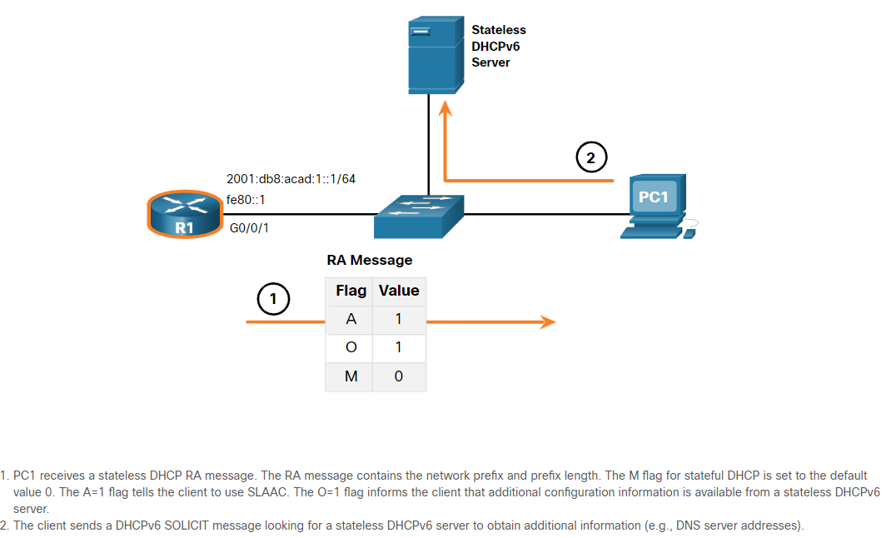

* Enable Stateless DHCPv6 on an Interface:
  + Stateless DHCPv6 is enabled on a router interface using the **ipv6 nd other-config-flag** interface configuration command. This sets the O flag to 1.
  + Note: You can use **the no ipv6 nd other-config-flag** to reset the interface to the default SLAAC only option (O flag = 0).

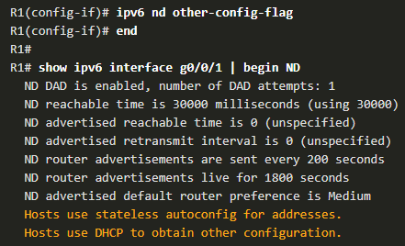

* + The highlighted output confirms the RA will tell receiving hosts to use stateless autoconfigure (A flag = 1) and contact a DHCPv6 server to obtain another configuration information (O flag = 1).
* Stateful DHCPv6 Operation:
  + In this case, the RA message tells the client to obtain all addressing information from a stateful DHCPv6 server, except the default gateway address which is the source IPv6 link-local address of the RA.
  + This is known as stateful DHCPv6 because the DHCPv6 server maintains IPv6 state information. This is similar to a DHCPv4 server allocating addresses for IPv4.

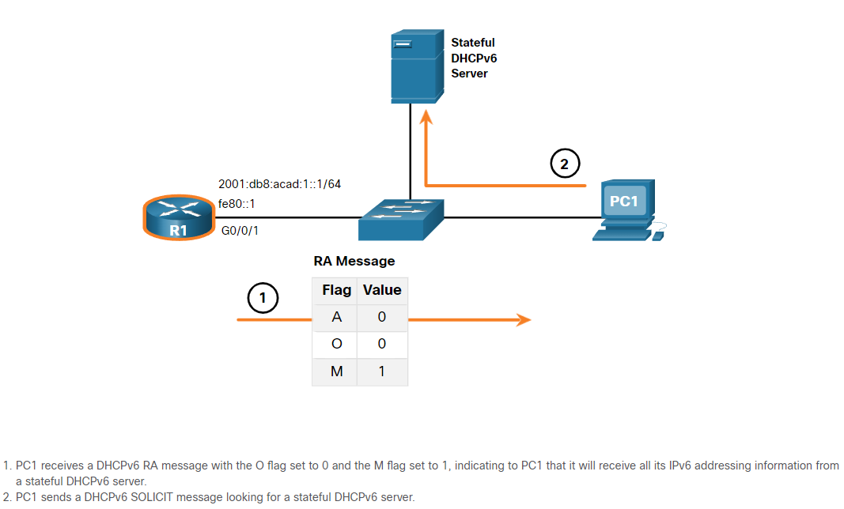

* Enable Stateful DHCPv6 on an Interface:
  + Stateful DHCPv6 is enabled on a router interface using the **ipv6 nd managed-config-flag** interface configuration command. This sets the M flag to 1. The **ipv6 nd prefix default no-autoconfig** interface command disables SLAAC by setting the A flag to 0.

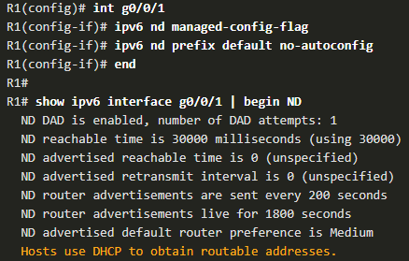

* + The highlighted output in the example confirms that the RA will tell the host to obtain all IPv6 configuration information from a DHCPv6 server (M flag = 1).

## Configure DHCPv6 Server

* DHCPv6 Router Roles:
  + Cisco IOS routers are powerful devices. In smaller networks, you do not have to have separate devices to have a DHCPv6 server, client, or relay agent. A Cisco IOS router can be configured to provide DHCPv6 server services.
  + Specifically, it can be configured to be one of the following:
    - DHCPv6 Server - Router provides stateless or stateful DHCPv6 services.
    - DHCPv6 Client - Router interface acquires an IPv6 IP configuration from a DHCPv6 server.
    - DHCPv6 Relay Agent - Router provides DHCPv6 forwarding services when the client and the server are located on different networks.
* Configure a Stateless DHCPv6 Server:
  + The stateless DHCPv6 server option requires that the router advertise the IPv6 network addressing information in RA messages. However, the client must contact a DHCPv6 server for more information.
  + There are five steps to configure and verify a router as a stateless DHCPv6 server:
    1. Enable IPv6 routing using the **ipv6 unicast-routing** command.
       - Although it is not necessary for the router to be a stateless DHCPv6 server, it is required for the router to source ICMPv6 RA messages.



* + 1. Define a DHCPv6 pool name using **the ipv6 dhcp pool *POOL-NAME*** global config command.
       - Note: The pool name does not have to be uppercase. However, using an uppercase name makes it easier to see in a configuration.

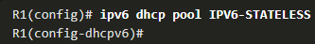

* + 1. Configure the DHCPv6 pool with options. Common options **include dns-server *X:X:X:X:X:X:X:X***and **domain-name *name***.

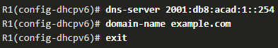

* + 1. Bind the interface to the pool using the **ipv6 dhcp server *POOL-NAME*** interface config command.
       - The router responds to stateless DHCPv6 requests on this interface with the information contained in the pool. The O flag needs to be manually changed from 0 to 1 using the interface command ipv6 nd other-config-flag. RA messages sent on this interface indicate that additional information is available from a stateless DHCPv6 server. The A flag is 1 by default, telling clients to use SLAAC to create their own GUA.

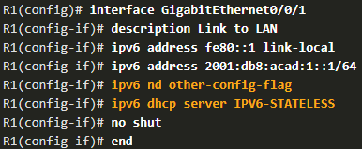

* + 1. Verify that the hosts have received IPv6 addressing information using the **ipconfig /all** command.

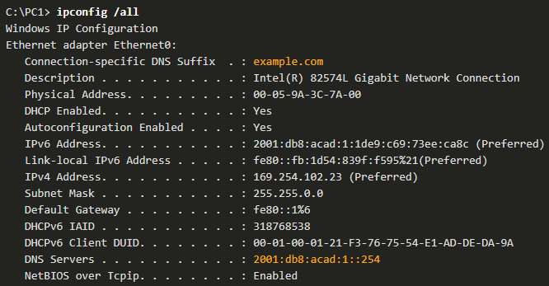

* Configure a Stateless DHCPv6 Client:
  + A router can also be a DHCPv6 client and get an IPv6 configuration from a DHCPv6 server, such as a router functioning as a DHCPv6 server.
    1. Enable IPv6 routing using the **ipv6 unicast-routing** command.



* + 1. Configure the client router to create an LLA. An IPv6 link-local address is created on a router interface when a global unicast address is configured, or without a GUA using the **ipv6 enable** interface configuration command. Cisco IOS uses EUI-64 to create the Interface ID.

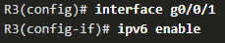

* + 1. Configure the client router to use SLAAC using the **ipv6 address autoconfig** command.

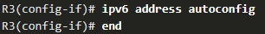

* + 1. Verify that the client router is assigned a GUA using the **show ipv6 interface brief** command.

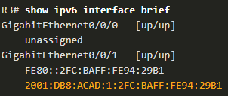

* + 1. Verify that the client router received other necessary DHCPv6 information. The **show ipv6 dhcp interface g0/0/1** command confirms DHCP option information, such as DNS server and domain name, have been received by the client.

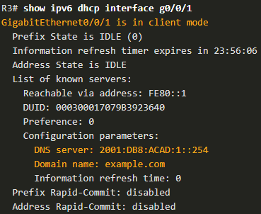

* Configure a Stateful DHCPv6 Server:
  + The stateful DHCP server option requires that the IPv6 enabled router tells the host to contact a DHCPv6 server to obtain all necessary IPv6 network addressing information.
  + There are five steps to configure and verify a router as a stateful DHCPv6 server:
    1. Enable IPv6 routing using the **ipv6 unicast-routing** command.



* + 1. Define a DHCPv6 pool name using the **ipv6 dhcp pool** ***POOL-NAME*** global config command.

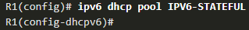

* + 1. Configure the DHCPv6 pool with options. Common options include the **address prefix** command, domain name, DHS server IP address, and more.
       - The address prefix command is used to indicate the pool of addresses to be allocated by the server.

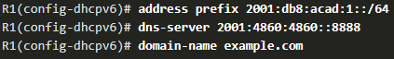

* + 1. Bind the interface to the pool using the**ipv6 dhcp server*****POOL-NAME***interface config command.
       - Manually change the M flag from 0 to 1 using the interface command **ipv6 nd managed-config-flag**.
       - Manually change the A flag from 1 to 0 using the **ipv6 nd prefix default no-autoconfig** interface command to inform the client to not to use SLAAC to create a GUA.
       - The **ipv6 dhcp server** command binds the DHCPv6 pool to the interface. R1 will now respond with the information contained in the pool when it receives stateful DHCPv6 requests on this interface.

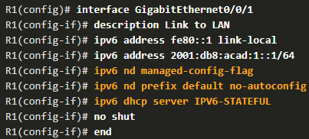

* + 1. Verify that the hosts have received IPv6 addressing information using the **ipconfig /all** command.

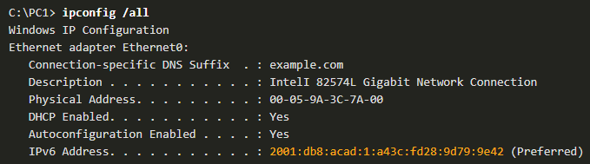

* Configure a Stateful DHCPv6 Client:
  + A router can also be a DHCPv6 client. The client router needs to have ipv6 unicast-routing enabled and an IPv6 link-local address to send and receive IPv6 messages.
  + There are five steps to configure and verify a router as a stateless DHCPv6 client.
    1. Enable IPv6 routing using the **ipv6 unicast-routing** command.



* + 1. Configure the client router to create an LLA. An IPv6 link-local address is created on a router interface when a global unicast address is configured, or without a GUA using the **ipv6 enable** interface configuration command. Cisco IOS uses EUI-64 to create an Interface ID.

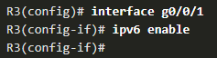

* + 1. Configure the client router to use DHCPv6 using the **ipv6 address dhcp** interface config command.

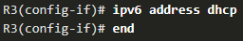

* + 1. Verify that the client router is assigned a GUA using the **show ipv6 interface brief** command.

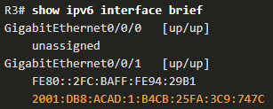

* + 1. Verify that the client router received other necessary DHCPv6 information using the **show ipv6 dhcp interface g0/0/1** command.

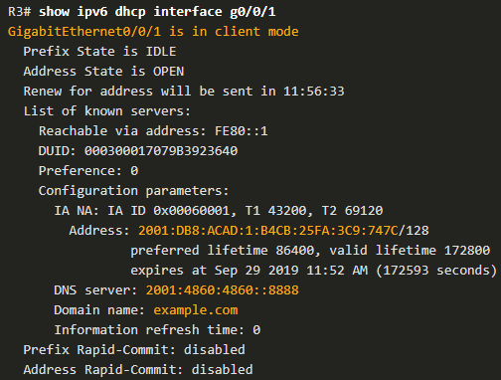

* DHCPv6 Server Verification Commands:
  + The **show ipv6 dhcp pool** command verifies the name of the DHCPv6 pool and its parameters. The command also identifies the number of active clients.

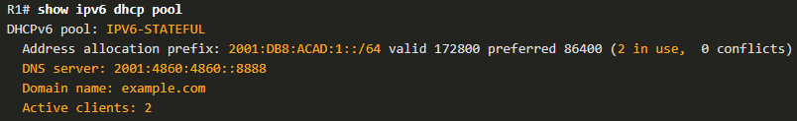

* + - When a router is providing stateful DHCPv6 services, it also maintains a database of assigned IPv6 addresses.
  + Use the **show ipv6 dhcp binding** command output to display the IPv6 link-local address of the client and the global unicast address assigned by the server.
    - This information is maintained by a stateful DHCPv6 server.
    - A stateless DHCPv6 server would not maintain this information.

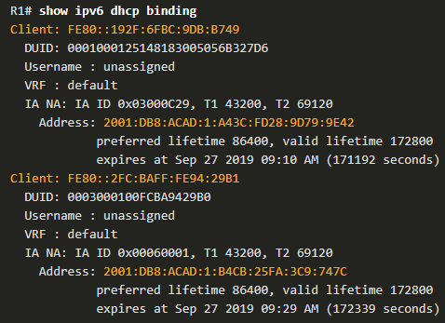

* Configure a DHCPv6 Relay Agent:
  + If the DHCPv6 server is located on a different network than the client, then the IPv6 router can be configured as a DHCPv6 relay agent. The configuration of a DHCPv6 relay agent is similar to the configuration of an IPv4 router as a DHCPv4 relay.
  + This command is configured on the interface facing the DHCPv6 clients and specifies the DHCPv6 server address and egress interface to reach the server, as shown in the output. The egress interface is only required when the next-hop address is an LLA.

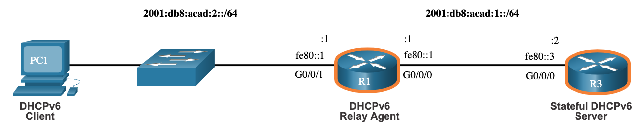

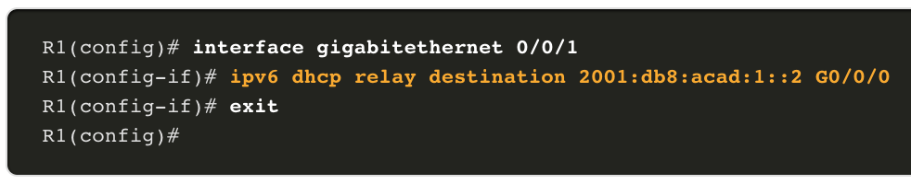

* Verify the DHCPv6 Relay Agent:
  + Verify that the DHCPv6 relay agent is operational with the **show ipv6 dhcp interface** (on R1) and **show ipv6 dhcp binding** (on R3) commands.

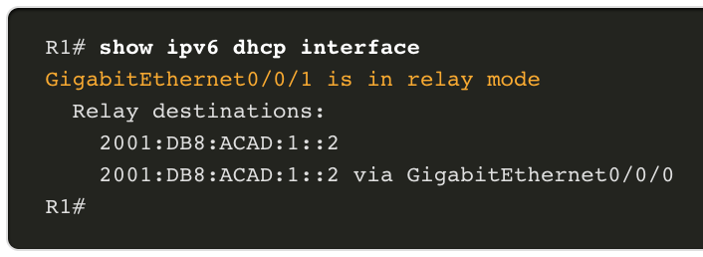

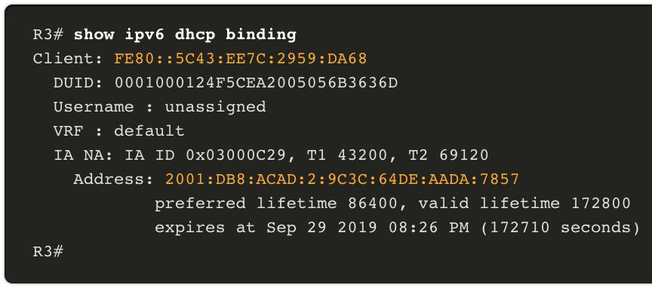

* + Verify Windows hosts received IPv6 addressing information with the **ipconfig /all** command.

# FHRP Concepts

## First Hop Redundancy Protocols

* Default Gateway Limitations:
  + End devices are typically configured with a single default gateway IPv4 address.
  + If the default gateway router interface fails, LAN hosts lose outside LAN connectivity.
  + This occurs even if a redundant router or Layer 3 switch that could serve as a default gateway exists.
  + Note: IPv6 devices receive their default gateway address dynamically from the ICMPv6 Router Advertisement. However, IPv6 devices benefit with a faster failover to the new default gateway when using FHRP.
* First hop redundancy protocols (FHRPs) are mechanisms that provide alternate default gateways in switched networks where two or more routers are connected to the same VLANs.
* Router Redundancy:
  + One way to prevent a single point of failure at the default gateway is to implement a virtual router. To implement this type of router redundancy, multiple routers are configured to work together to present the illusion of a single router to the hosts on the LAN. By sharing an IP address and a MAC address, two or more routers can act as a single virtual router.
  + The IPv4 address of the virtual router is configured as the default gateway for the workstations on a specific IPv4 segment.
  + When frames are sent from host devices to the default gateway, the hosts use ARP to resolve the MAC address that is associated with the IPv4 address of the default gateway. The ARP resolution returns the MAC address of the virtual router. Frames that are sent to the MAC address of the virtual router can then be physically processed by the currently active router within the virtual router group.
  + A protocol is used to identify two or more routers as the devices that are responsible for processing frames that are sent to the MAC or IP address of a single virtual router. Host devices send traffic to the address of the virtual router. The physical router that forwards this traffic is transparent to the host devices.
  + A redundancy protocol provides the mechanism for determining which router should take the active role in forwarding traffic. It also determines when the forwarding role must be taken over by a standby router. The transition from one forwarding router to another is transparent to the end devices.
  + The ability of a network to dynamically recover from the failure of a device acting as a default gateway is known as first-hop redundancy.
* Steps for Router Failover:
  + When the active router fails, the redundancy protocol transitions the standby router to the new active router role, as shown in the figure. These are the steps that take place when the active router fails:
    1. The standby router stops seeing Hello messages from the forwarding router.
    2. The standby router assumes the role of the forwarding router.
    3. Because the new forwarding router assumes both the IPv4 and MAC addresses of the virtual router, the host devices see no disruption in service.

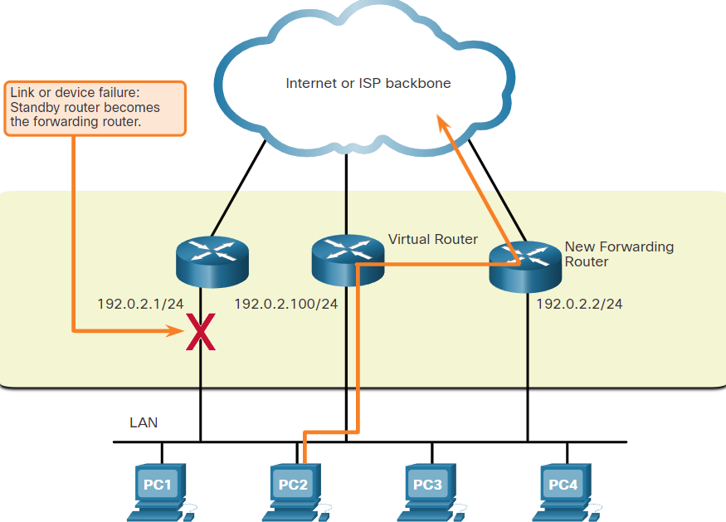

* 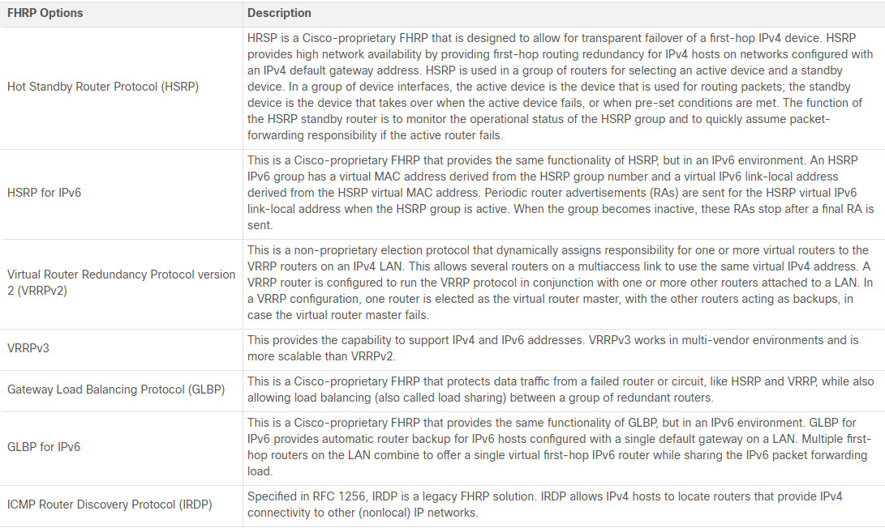FHRP Options:

## HSRP

* Overview:
  + Cisco provides HSRP and HSRP for IPv6 as a way to avoid losing outside network access if your default router fails. HSRP is a Cisco-proprietary FHRP that is designed to allow for transparent failover of a first-hop IP device.
  + HSRP ensures high network availability by providing first-hop routing redundancy for IP hosts on networks configured with an IP default gateway address. HSRP is used in a group of routers for selecting an active device and a standby device. In a group of device interfaces, the active device is the device that is used for routing packets; the standby device is the device that takes over when the active device fails, or when pre-set conditions are met. The function of the HSRP standby router is to monitor the operational status of the HSRP group and to quickly assume packet-forwarding responsibility if the active router fails.
* HSRP Priority:
  + The role of the active and standby routers is determined during the HSRP election process. By default, the router with the numerically highest IPv4 address is elected as the active router. However, it is always better to control how your network will operate under normal conditions rather than leaving it to chance.
  + HSRP priority can be used to determine the active router.
  + The router with the highest HSRP priority will become the active router.
  + By default, the HSRP priority is 100.
  + If the priorities are equal, the router with the numerically highest IPv4 address is elected as the active router.
  + To configure a router to be the active router, use the **standby priority** interface command. The range of the HSRP priority is 0 to 255.
* HSRP Preemption:
  + By default, after a router becomes the active router, it will remain the active router even if another router comes online with a higher HSRP priority.
  + To force a new HSRP election process to take place when a higher priority router comes online, preemption must be enabled using the **standby preempt** interface command. Preemption is the ability of an HSRP router to trigger the re-election process. With preemption enabled, a router that comes online with a higher HSRP priority will assume the role of the active router.
  + Preemption only allows a router to become the active router if it has a higher priority. A router enabled for preemption, with equal priority but a higher IPv4 address will not preempt an active router.
  + Note: With preemption disabled, the router that boots up first will become the active router if there are no other routers online during the election process.

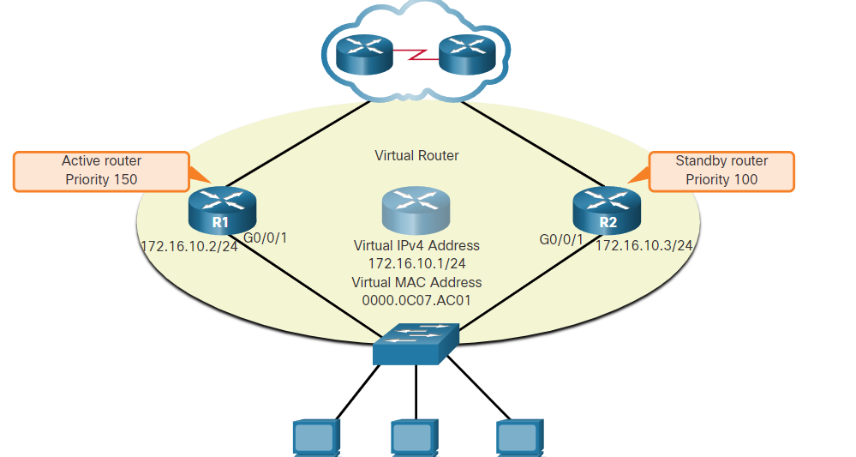

* HSRP States and Timers:
  + The active and standby HSRP routers send hello packets to the HSRP group multicast address every 3 seconds by default. The standby router will become active if it does not receive a hello message from the active router after 10 seconds. You can lower these timer settings to speed up the failover or preemption. However, to avoid increased CPU usage and unnecessary standby state changes, do not set the hello timer below 1 second or the hold timer below 4 seconds.

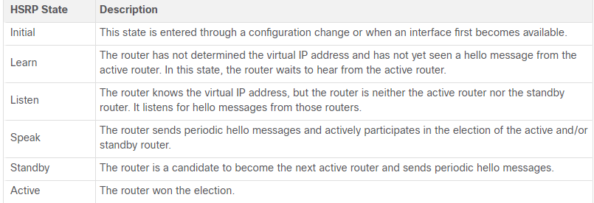

# LAN Security Concepts

## Endpoint Security

* Network Attacks Today:
  + The news media commonly covers attacks on enterprise networks. Simply search the internet for “latest network attacks” to find up-to-date information on current attacks. Most likely, these attacks will involve one or more of the following:
    - Distributed Denial of Service (DDoS) – This is a coordinated attack from many devices, called zombies, with the intention of degrading or halting public access to an organization’s website and resources.
    - Data Breach – This is an attack in which an organization’s data servers or hosts are compromised to steal confidential information.
    - Malware – This is an attack in which an organization’s hosts are infected with malicious software that cause a variety of problems. For example, ransomware such as WannaCry encrypts the data on a host and locks access to it until a ransom is paid.
* Network Security Devices:
  + Various network security devices are required to protect the network perimeter from outside access. These devices could include the following:
    - Virtual Private Network (VPN) enabled router - provides a secure connection to remote users across a public network and into the enterprise network. VPN services can be integrated into the firewall.
    - Next-Generation Firewall (NGFW) - provides stateful packet inspection, application visibility and control, a next-generation intrusion prevention system (NGIPS), advanced malware protection (AMP), and URL filtering.
    - Network Access Control (NAC) - includes authentication, authorization, and accounting (AAA) services. In larger enterprises, these services might be incorporated into an appliance that can manage access policies across a wide variety of users and device types. The Cisco Identity Services Engine (ISE) is an example of a NAC device.
* Endpoint Protection:
  + LAN devices such as switches, wireless LAN controllers (WLCs), and other access point (AP) devices interconnect endpoints. Most of these devices are susceptible to the LAN-related attacks. But many attacks can also originate from inside the network. If an internal host is infiltrated, it can become a starting point for a threat actor to gain access to critical system devices, such as servers and sensitive data.
  + Endpoints are hosts which commonly consist of laptops, desktops, servers, and IP phones, as well as employee-owned devices that are typically referred to as bring your own devices (BYODs).
  + Endpoints are particularly susceptible to malware-related attacks that originate through email or web browsing.
  + These endpoints have typically used traditional host-based security features, such as antivirus/antimalware, host-based firewalls, and host-based intrusion prevention systems (HIPSs).
  + However, today endpoints are best protected by a combination of NAC, host-based AMP software, an email security appliance (ESA), and a web security appliance (WSA).
  + Advanced Malware Protection (AMP) products include endpoint solutions such as Cisco AMP for Endpoints.
* Cisco Email Security Appliance:
  + Content security appliances include fine-grained control over email and web browsing for an organization’s users.
  + The Cisco ESA is a device that is designed to monitor Simple Mail Transfer Protocol (SMTP). The Cisco ESA is constantly updated by real-time feeds from the Cisco Talos, which detects and correlates threats and solutions by using a worldwide database monitoring system. This threat intelligence data is pulled by the Cisco ESA every three to five minutes. These are some of the functions of the Cisco ESA:
    - Block known threats.
    - Remediate against stealth malware that evaded initial detection.
    - Discard emails with bad links.
    - Block access to newly infected sites.
    - Encrypt content in outgoing email to prevent data loss.

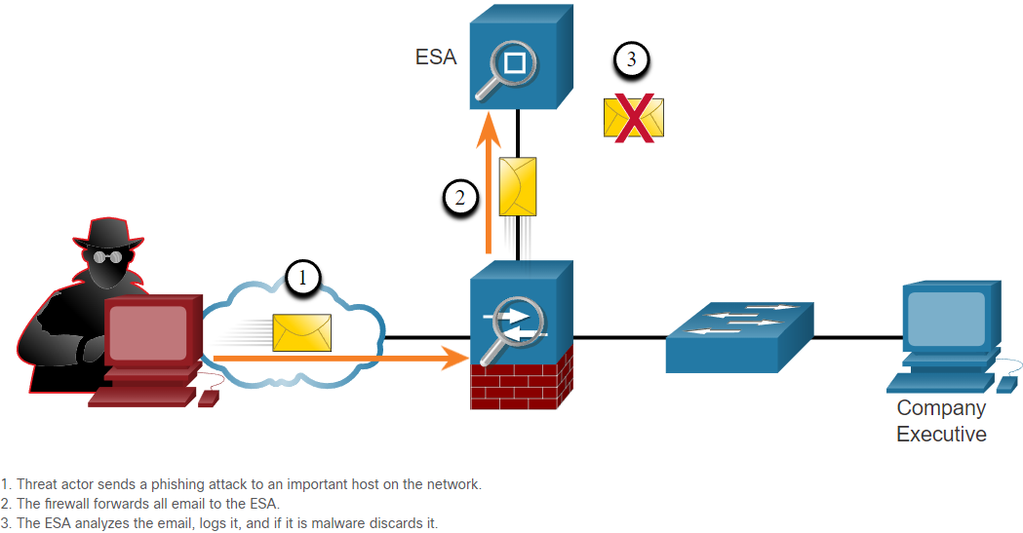

* Cisco Web Security Appliance:
  + The Cisco Web Security Appliance (WSA) is a mitigation technology for web-based threats. It helps organizations address the challenges of securing and controlling web traffic.
  + The Cisco WSA combines advanced malware protection, application visibility and control, acceptable use policy controls, and reporting.
  + Cisco WSA provides complete control over how users access the internet. Certain features and applications, such as chat, messaging, video and audio, can be allowed, restricted with time and bandwidth limits, or blocked, according to the organization’s requirements.
  + The WSA can perform blacklisting of URLs, URL-filtering, malware scanning, URL categorization, Web application filtering, and encryption and decryption of web traffic.

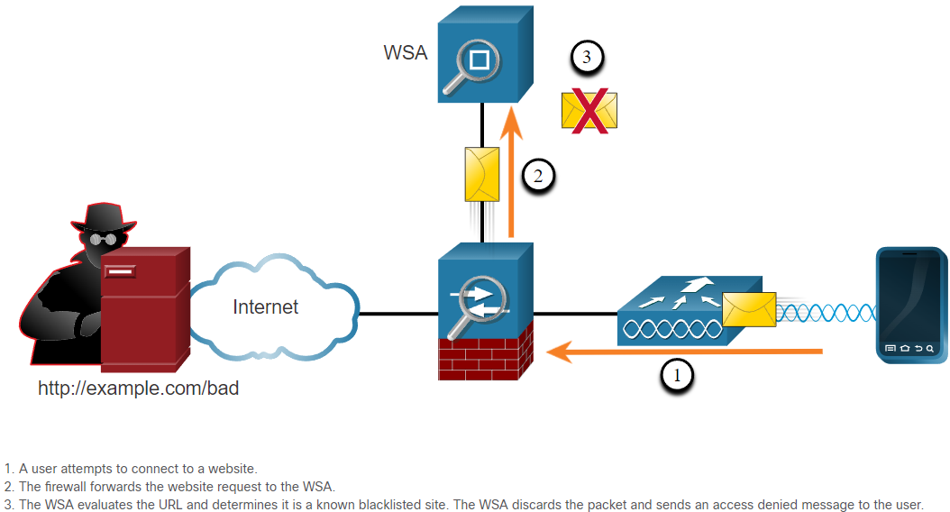

## Access Control

* Authentication with a Local Password:
  + Many types of authentication can be performed on networking devices, and each method offers varying levels of security.
  + The simplest method of remote access authentication is to configure a login and password combination on console, vty lines, and aux ports.

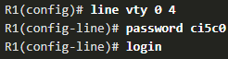

* + - This method provides no accountability and the password is sent in plaintext.
  + SSH is a more secure form of remote access:
    - It requires a username and a password, both of which are encrypted during transmission.
    - The username and password can be authenticated by the local database method.
    - It provides more accountability because the username is recorded when a user logs in.

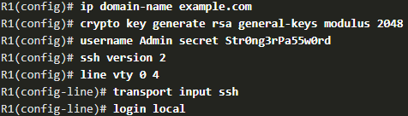

* The local database method has some limitations:
  + User accounts must be configured locally on each device. In a large enterprise environment with multiple routers and switches to manage, it can take time to implement and change local databases on each device.
  + The local database configuration provides no fallback authentication method. For example, what if the administrator forgets the username and password for that device? With no backup method available for authentication, password recovery becomes the only option.
  + A better solution is to have all devices refer to the same database of usernames and passwords from a central server.
* AAA Components:
  + AAA stands for Authentication, Authorization, and Accounting, and provides the primary framework to set up access control on a network device.
  + AAA is a way to control who is permitted to access a network (authenticate), what they can do while they are there (authorize), and to audit what actions they performed while accessing the network (accounting).
* Authentication:
  + Local AAA Authentication:
    - Method stores usernames and passwords locally in a network device (e.g., Cisco router).
    - Users authenticate against the local database.
    - Local AAA is ideal for small networks.

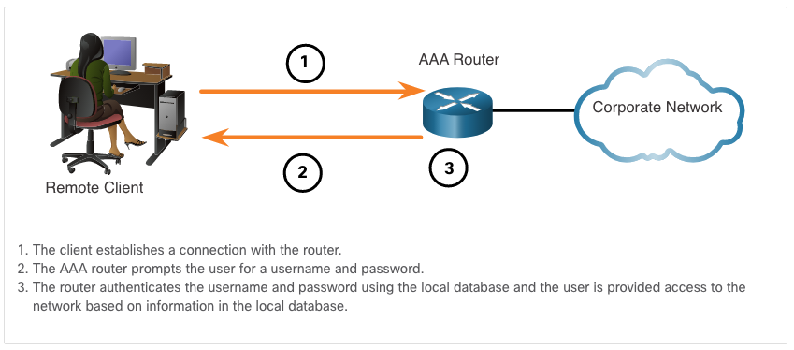

* + Server-Based AAA Authentication:
    - With the server-based method, the router accesses a central AAA server.
    - The AAA server contains the usernames and password for all users.
    - The router uses either the Remote Authentication Dial-In User Service (RADIUS) or Terminal Access Controller Access Control System (TACACS+) protocols to communicate with the AAA server.
    - When there are multiple routers and switches, server-based AAA is more appropriate.

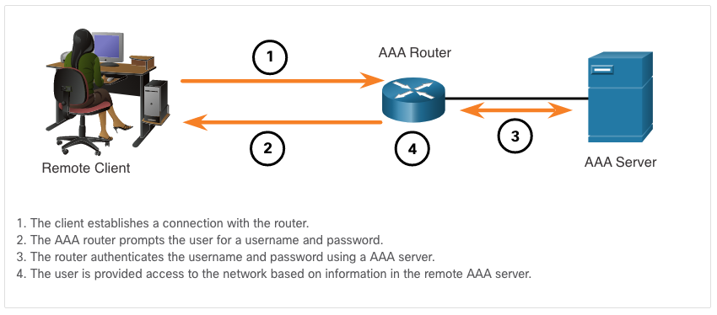

* Authorization:
  + AAA authorization is automatic and does not require users to perform additional steps after authentication.
  + Authorization governs what users can and cannot do on the network after they are authenticated.
  + Authorization uses a set of attributes that describes the user’s access to the network. These attributes are used by the AAA server to determine privileges and restrictions for that user.

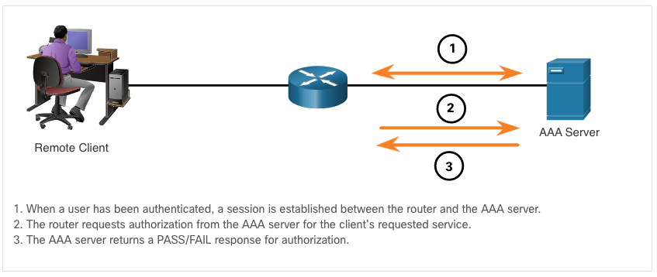

* Accounting:
  + AAA accounting collects and reports usage data. This data can be used for such purposes as auditing or billing. The collected data might include the start and stop connection times, executed commands, number of packets, and number of bytes.
  + A primary use of accounting is to combine it with AAA authentication.
    - The AAA server keeps a detailed log of exactly what the authenticated user does on the device, as shown in the figure. This includes all EXEC and configuration commands issued by the user.
    - The log contains numerous data fields, including the username, the date and time, and the actual command that was entered by the user. This information is useful when troubleshooting devices. It also provides evidence for when individuals perform malicious acts.

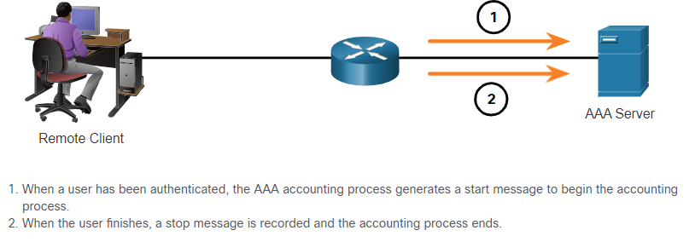

* 802.1X:
  + The IEEE 802.1X standard is a port-based access control and authentication protocol. This protocol restricts unauthorized workstations from connecting to a LAN through publicly accessible switch ports. The authentication server authenticates each workstation that is connected to a switch port before making available any services offered by the switch or the LAN.
  + With 802.1X port-based authentication, the devices in the network have specific roles:
    - Client (Supplicant) - This is a device running 802.1X-compliant client software, which is available for wired or wireless devices.
    - Switch (Authenticator) –The switch acts as an intermediary between the client and the authentication server. It requests identifying information from the client, verifies that information with the authentication server, and relays a response to the client. Another device that could act as authenticator is a wireless access point.
    - Authentication server –The server validates the identity of the client and notifies the switch or wireless access point that the client is or is not authorized to access the LAN and switch services.

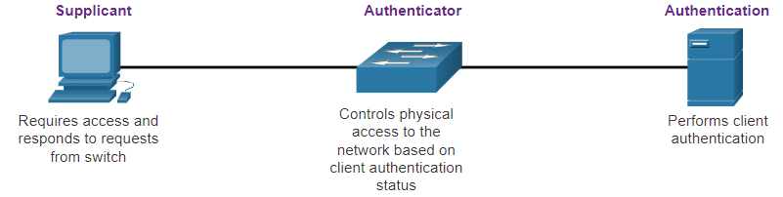

## Layer 2 Security Threats

* Layer 2 Vulnerabilities:
  + Recall that the OSI reference model is divided into seven layers which work independently of each other. The figure shows the function of each layer and the core elements that can be exploited.
  + Network administrators routinely implement security solutions to protect the elements in Layer 3 up through Layer 7. They use VPNs, firewalls, and IPS devices to protect these elements. However, if Layer 2 is compromised, then all the layers above it are also affected. For example, if a threat actor with access to the internal network captured Layer 2 frames, then all the security implemented on the layers above would be useless. The threat actor could cause a lot of damage on the Layer 2 LAN networking infrastructure.

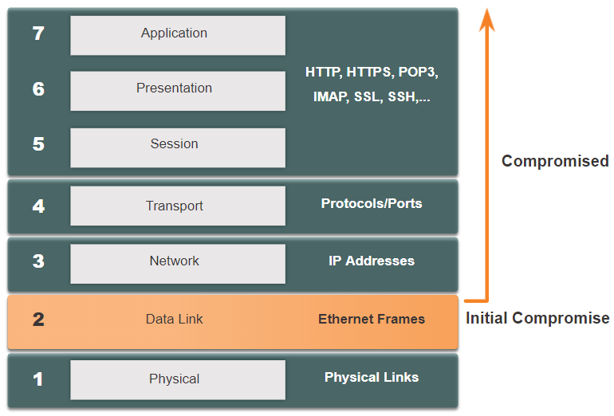

* Switch Attack Categories:
  + Security is only as strong as the weakest link in the system, and Layer 2 is considered to be that weak link. This is because LANs were traditionally under the administrative control of a single organization. We inherently trusted all persons and devices connected to our LAN. Today, with BYOD and more sophisticated attacks, our LANs have become more vulnerable to penetration.

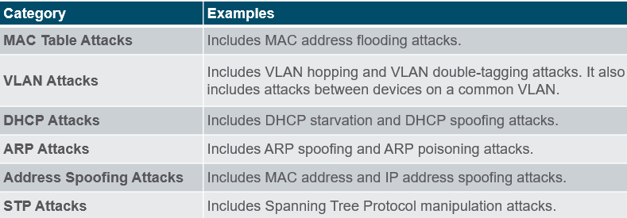

* Switch Attack Mitigation Techniques:

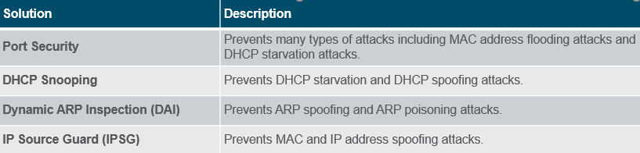

* + These Layer 2 solutions will not be effective if the management protocols are not secured. The following strategies are recommended:
    - Always use secure variants of management protocols such as SSH, Secure Copy Protocol (SCP), Secure FTP (SFTP), and Secure Socket Layer/Transport Layer Security (SSL/TLS).
    - Consider using out-of-band management network to manage devices.
    - Use a dedicated management VLAN where nothing but management traffic resides.
    - Use ACLs to filter unwanted access.

## MAC Address Table Attack

* Switch Operation Review:
  + Recall that to make forwarding decisions, a **Layer 2 LAN switch** builds a table based on the source MAC addresses in received frames. This is called a MAC address table. MAC address tables are stored in memory and are used to forward frames more efficiently.

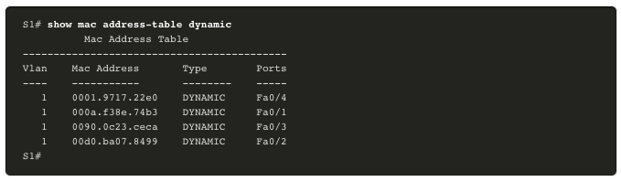

* MAC Address Table Flooding:
  + All MAC tables have a fixed size and consequently, a switch can run out of resources in which to store MAC addresses. MAC address flooding attacks take advantage of this limitation by bombarding the switch with fake source MAC addresses until the switch MAC address table is full.
  + When this occurs, the switch treats the frame as an unknown unicast and begins to flood all incoming traffic out all ports on the same VLAN without referencing the MAC table. This condition now allows a threat actor to capture all of the frames sent from one host to another on the local LAN or local VLAN.
  + Note: Traffic is flooded only within the local LAN or VLAN. The threat actor can only capture traffic within the local LAN or VLAN to which the threat actor is connected.

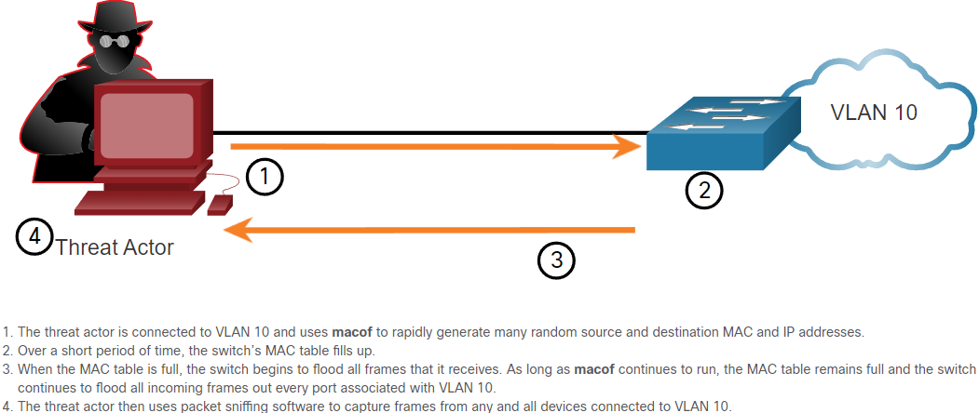

* + If the threat actor stops macof from running or is discovered and stopped, the switch eventually ages out the older MAC address entries from the table and begins to act like a switch again.
* MAC Address Table Attack Mitigation:
  + What makes tools such as macof so dangerous is that an attacker can create a MAC table overflow attack very quickly. For instance, a Catalyst 6500 switch can store 132,000 MAC addresses in its MAC address table. A tool such as macof can flood a switch with up to 8,000 bogus frames per second; creating a MAC address table overflow attack in a matter of a few seconds.
  + Another reason why these attack tools are dangerous is because they not only affect the local switch, they can also affect other connected Layer 2 switches. When the MAC address table of a switch is full, it starts flooding out all ports including those connected to other Layer 2 switches.
  + To mitigate MAC address table overflow attacks, network administrators must implement port security. Port security will only allow a specified number of source MAC addresses to be learned on the port. Port security is further discussed in another module.

## LAN Attacks

* VLAN Hopping Attacks:
  + A VLAN hopping attack enables traffic from one VLAN to be seen by another VLAN without the aid of a router. In a basic VLAN hopping attack, the threat actor configures a host to act like a switch to take advantage of the automatic trunking port feature enabled by default on most switch ports.
  + The threat actor configures the host to spoof 802.1Q signaling and Cisco-proprietary Dynamic Trunking Protocol (DTP) signaling to trunk with the connecting switch. If successful, the switch establishes a trunk link with the host, as shown in the figure. Now the threat actor can access all the VLANs on the switch. The threat actor can send and receive traffic on any VLAN, effectively hopping between VLANs.

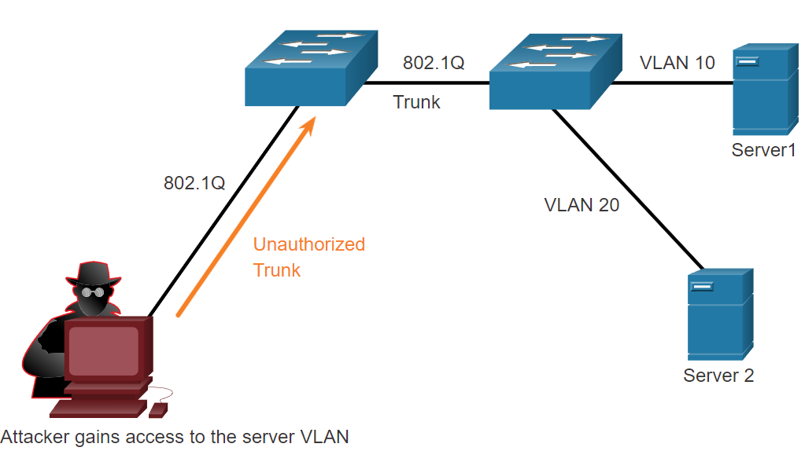

* VLAN Double-Tagging Attacks:
  + A threat actor in specific situations could embed a hidden 802.1Q tag inside the frame that already has an 802.1Q tag. This tag allows the frame to go to a VLAN that the original 802.1Q tag did not specify.
  1. The threat actor sends a double-tagged 802.1Q frame to the switch. The outer header has the VLAN tag of the threat actor, which is the same as the native VLAN of the trunk port.
  2. The frame arrives on the first switch, which looks at the first 4-byte 802.1Q tag. The switch sees that the frame is destined for the native VLAN. The switch forwards the packet out all native VLAN ports after stripping the VLAN tag. The frame is not retagged because it is part of the native VLAN. At this point, the inner VLAN tag is still intact and has not been inspected by the first switch.
  3. The frame arrives at the second switch which has no knowledge that it was supposed to be for the native VLAN. Native VLAN traffic is not tagged by the sending switch as specified in the 802.1Q specification. The second switch looks only at the inner 802.1Q tag that the threat actor inserted and sees that the frame is destined the target VLAN. The second switch sends the frame on to the target or floods it, depending on whether there is an existing MAC address table entry for the target.

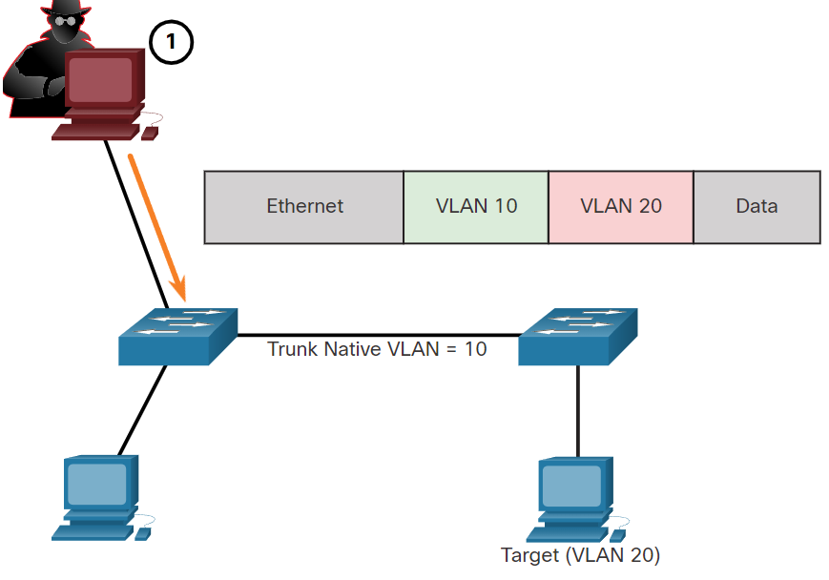

* + A VLAN double-tagging attack is unidirectional and works only when the attacker is connected to a port residing in the same VLAN as the native VLAN of the trunk port. The idea is that double tagging allows the attacker to send data to hosts or servers on a VLAN that otherwise would be blocked by some type of access control configuration. Presumably the return traffic will also be permitted, thus giving the attacker the ability to communicate with devices on the normally blocked VLAN.
  + VLAN Attack Mitigation - VLAN hopping and VLAN double-tagging attacks can be prevented by implementing the following trunk security guidelines, as discussed in a previous module:
    - Disable trunking on all access ports.
    - Disable auto trunking on trunk links so that trunks must be manually enabled.
    - Be sure that the native VLAN is only used for trunk links.
* DHCP Attacks:
  + DHCP Starvation Attack
    - The goal of the DHCP Starvation attack is to create a DoS for connecting clients. DHCP starvation attacks require an attack tool such as Gobbler.
    - Gobbler has the ability to look at the entire scope of leasable IP addresses and tries to lease them all. Specifically, it creates DHCP discovery messages with bogus MAC addresses.
  + DHCP Spoofing Attack
    - A DHCP spoofing attack occurs when a rogue DHCP server is connected to the network and provides false IP configuration parameters to legitimate clients. A rogue server can provide a variety of misleading information:
      * Wrong default gateway - The rogue server provides an invalid gateway or the IP address of its host to create a man-in-the-middle attack. This may go entirely undetected as the intruder intercepts the data flow through the network.
      * Wrong DNS server - The rogue server provides an incorrect DNS server address pointing the user to a nefarious website.
      * Wrong IP address - The rogue server provides an invalid IP address effectively creating a DoS attack on the DHCP client.
  + Both attacks are mitigated by implementing DHCP snooping.
* ARP Attacks:
  + Hosts broadcast ARP Requests to determine the MAC address of a host with a destination IP address. All hosts on the subnet receive and process the ARP Request. The host with the matching IP address in the ARP Request sends an ARP Reply.
  + A client can send an unsolicited (= not asked for) ARP Reply called a “gratuitous ARP”. Other hosts on the subnet store the MAC address and IP address contained in the gratuitous ARP in their ARP tables.
  + An attacker can send a gratuitous ARP message containing a spoofed MAC address to a switch, and the switch would update its MAC table accordingly. In a typical attack, a threat actor sends unsolicited ARP Replies to other hosts on the subnet with the MAC Address of the threat actor and the IP address of the default gateway, effectively setting up a man-in-the-middle attack.
  + There are many tools available on the internet to create ARP man-in-the-middle attacks.
  + IPv6 uses ICMPv6 Neighbor Discovery Protocol for Layer 2 address resolution. IPv6 includes strategies to mitigate Neighbor Advertisement spoofing, similar to the way IPv4 prevents a spoofed ARP Reply.
  + ARP spoofing and ARP poisoning are mitigated by implementing Dynamic ARP Inspection (DAI).

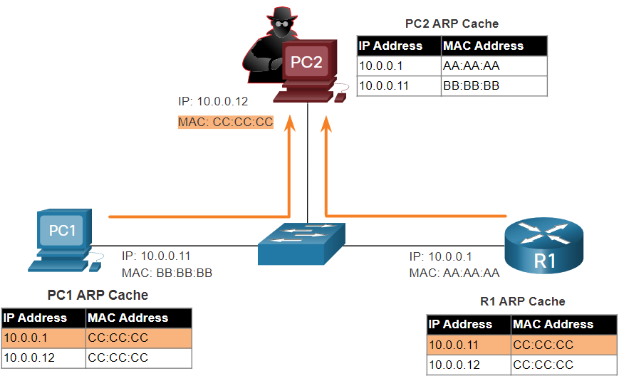

* Address Spoofing Attacks:
  + IP address spoofing is when a threat actor hijacks a valid IP address of another device on the subnet or uses a random IP address. IP address spoofing is difficult to mitigate, especially when it is used inside a subnet in which the IP belongs.
  + MAC address spoofing attacks occur when the threat actors alter the MAC address of their host to match another known MAC address of a target host. The switch overwrites the current MAC table entry and assigns the MAC address to the new port. It then inadvertently forwards frames destined for the target host to the attacking host.
  + When the target host sends traffic, the switch will correct the error, realigning the MAC address to the original port. To stop the switch from returning the port assignment to its correct state, the threat actor can create a program or script that will constantly send frames to the switch so that the switch maintains the incorrect or spoofed information.
  + There is no security mechanism at Layer 2 that allows a switch to verify the source of MAC addresses, which is what makes it so vulnerable to spoofing.
  + IP and MAC address spoofing can be mitigated by implementing IP Source Guard (IPSG).

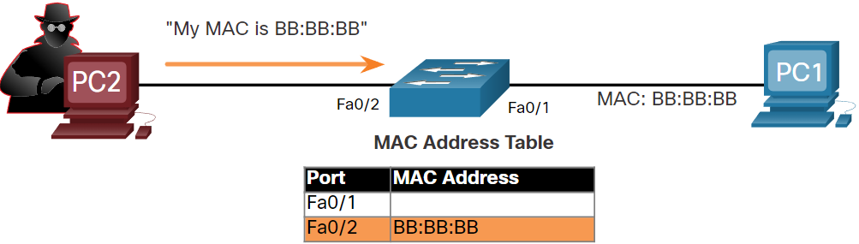

* STP Attack:
  + Network attackers can manipulate the Spanning Tree Protocol (STP) to conduct an attack by spoofing the root bridge and changing the topology of a network. Attackers can then capture all traffic for the immediate switched domain.
  + To conduct an STP manipulation attack, the attacking host broadcasts STP bridge protocol data units (BPDUs) containing configuration and topology changes that will force spanning-tree recalculations. The BPDUs sent by the attacking host announce a lower bridge priority in an attempt to be elected as the root bridge.
  + This STP attack is mitigated by implementing BPDU Guard on all access ports. BPDU Guard is discussed in more detail later in the course.

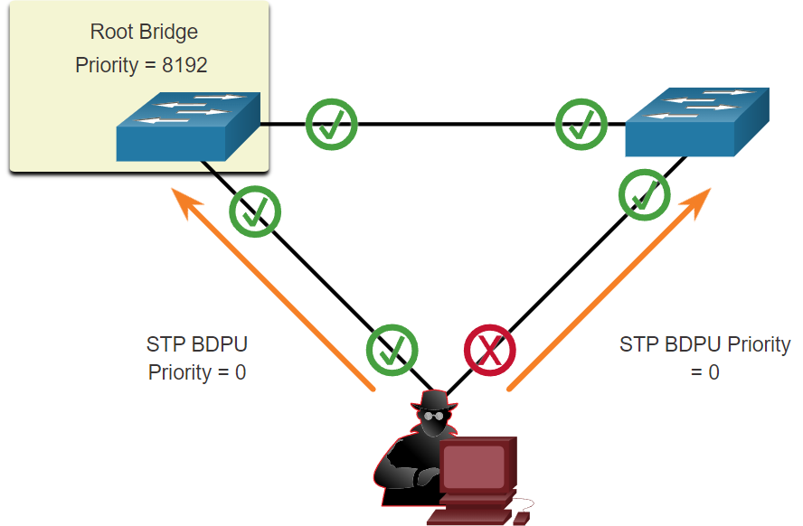 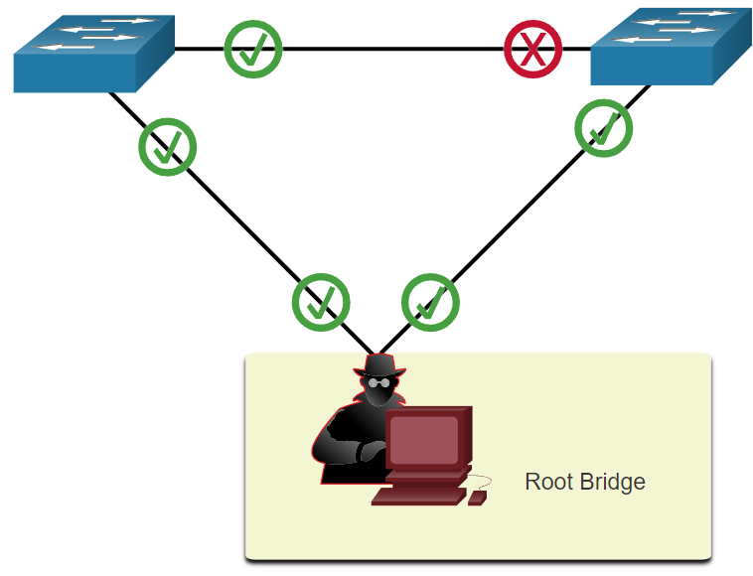

* CDP Reconnaissance:
  + The Cisco Discovery Protocol (CDP) is a proprietary Layer 2 link discovery protocol. It is enabled on all Cisco devices by default. CDP can automatically discover other CDP-enabled devices and help auto-configure their connection. Network administrators also use CDP to help configure and troubleshoot network devices. CDP information is sent out CDP-enabled ports in periodic, unencrypted, unauthenticated broadcasts. CDP information includes the IP address of the device, IOS software version, platform, capabilities, and the native VLAN. The device receiving the CDP message updates its CDP database.
  + To mitigate the exploitation of CDP, limit the use of CDP on devices or ports. For example, disable CDP on edge ports that connect to untrusted devices.
    - To disable CDP globally on a device, use the **no cdp run** global configuration mode command. To enable CDP globally, use the **cdp run** global configuration command.
    - To disable CDP on a port, use the **no cdp enable** interface configuration command. To enable CDP on a port, use the **cdp enable** interface configuration command.
  + Note: Link Layer Discovery Protocol (LLDP) is also vulnerable to reconnaissance attacks. Configure **no lldp run** to disable LLDP globally. To disable LLDP on the interface, configure **no lldp transmit** and **no lldp receive**.

# Switch Security Configuration

## Implement Port Security

* Secure Unused Ports:
  + Layer 2 attacks are some of the easiest for hackers to deploy but these threats can also be mitigated with some common Layer 2 solutions.
  + All switch ports (interfaces) should be secured before the switch is deployed for production use. How a port is secured depends on its function.
  + A simple method that many administrators use to help secure the network from unauthorized access is to disable all unused ports on a switch. Navigate to each unused port and issue the Cisco IOS **shutdown** command. If a port must be reactivated at a later time, it can be enabled with the **no shutdown** command.
  + To configure a range of ports, use the **interface range** command. (for shutting down multiple interfaces at once)
* Mitigate MAC Address Table Attacks:
  + The simplest and most effective method to prevent MAC address table overflow attacks is to enable port security.
  + Port security limits the number of valid MAC addresses allowed on a port. It allows an administrator to manually configure MAC addresses for a port or to permit the switch to dynamically learn a limited number of MAC addresses. When a port configured with port security receives a frame, the source MAC address of the frame is compared to the list of secure source MAC addresses that were manually configured or dynamically learned on the port.
  + By limiting the number of permitted MAC addresses on a port to one, port security can be used to control unauthorized access to the network.
* Enable Port Security:
  + Port security is enabled with the **switchport port-security** interface configuration command.
  + Notice in the example, the **switchport port-security** command was rejected. This is because port security can only be configured on manually configured access ports or manually configured trunk ports. By default, Layer 2 switch ports are set to dynamic auto (trunking on). Therefore, in the example, the port is configured with the **switchport mode access** interface configuration command.

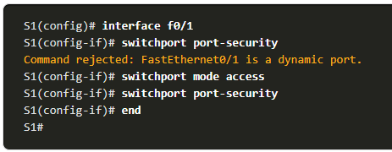

* + Use the **show port-security interface** command to display the current port security settings for FastEthernet 0/1.

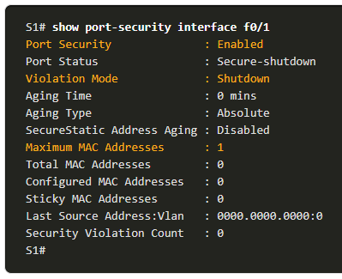

* + Notice how port security is enabled, the violation mode is shutdown, and how the maximum number of MAC addresses is 1.
  + If a device is connected to the port, the switch will automatically add the device’s MAC address as a secure MAC. In this example, no device is connected to the port.
  + Note: If an active port is configured with the switchport port-security command and more than one device is connected to that port, the port will transition to the error-disabled state.
  + After port security is enabled, other port security specifics can be configured
* Limit and Learn MAC Addresses:
  + To set the maximum number of MAC addresses allowed on a port, use the following command:



* + The default port security value is 1.
  + The maximum number of secure MAC addresses that can be configured depends the switch and the IOS.
  + In this example, the maximum is 8192.

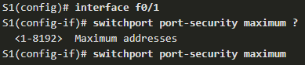

* + The switch can be configured to learn about MAC addresses on a secure port in one of three ways:
  1. Manually Configured: The administrator manually configures a static MAC address(es) by using the following command for each secure MAC address on the port:



* 1. Dynamically Learned: When the **switchport port-security** command is entered, the current source MAC for the device connected to the port is automatically secured but is not added to the running configuration. If the switch is rebooted, the port will have to re-learn the device’s MAC address.
  2. Dynamically Learned – Sticky: The administrator can enable the switch to dynamically learn the MAC address and “stick” them to the running configuration by using the following command:



* + Saving the running configuration will commit the dynamically learned MAC address to NVRAM.
  + The example (next page) demonstrates a complete port security configuration for FastEthernet 0/1.
  + The administrator specifies a maximum of 4 MAC addresses, manually configures one secure MAC address, and then configures the port to dynamically learn additional secure MAC addresses up to the 4 secure MAC address maximum.
  + Use the **show port-security interface** and the **show port-security address** command to verify the configuration.

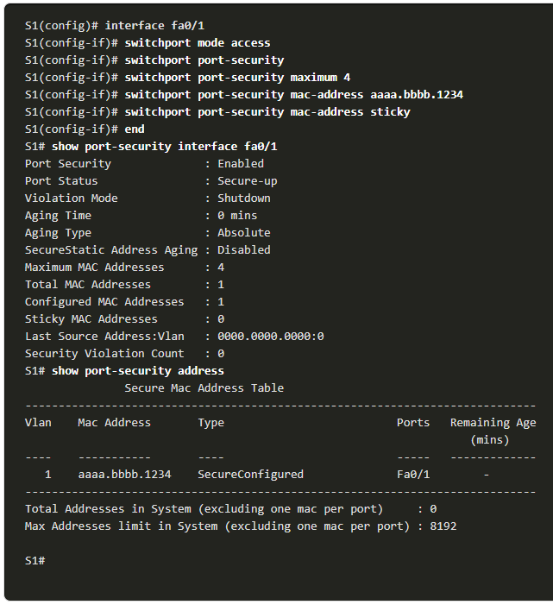

* Port Security Aging:
  + Port security aging can be used to set the aging time for static and dynamic secure addresses on a port and two types of aging are supported per port:
    - Absolute - The secure addresses on the port are deleted after the specified aging time.
    - Inactivity - The secure addresses on the port are deleted if they are inactive for a specified time.
  + Use aging to remove secure MAC addresses on a secure port without manually deleting the existing secure MAC addresses.
  + Aging of statically configured secure addresses can be enabled or disabled on a per-port basis.
  + Use the **switchport port-security aging** command to enable or disable static aging for the secure port, or to set the aging time or type.



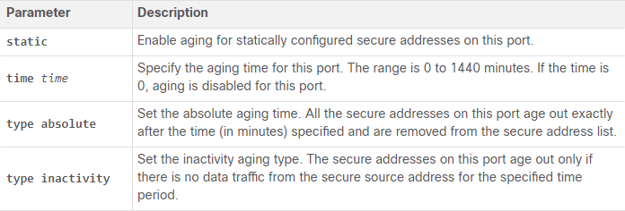

* + Example:

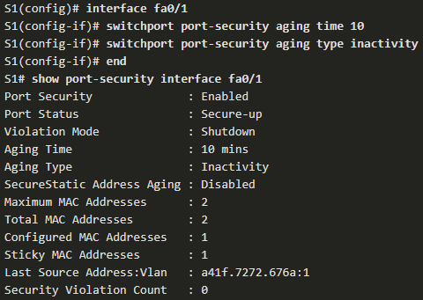

* Port Security Violation Modes:
  + If the MAC address of a device attached to a port differs from the list of secure addresses, then a port violation occurs and the port enters the error-disabled state.
  + To set the port security violation mode, use the following command:



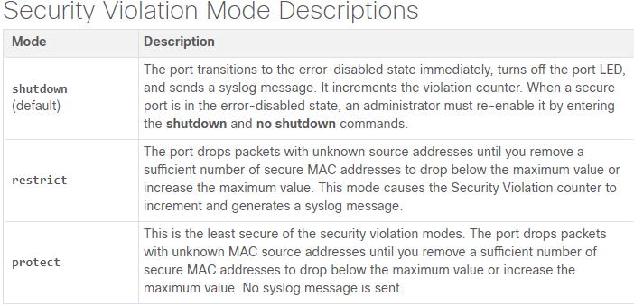

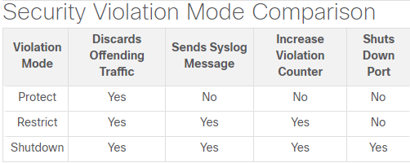

* + Example:

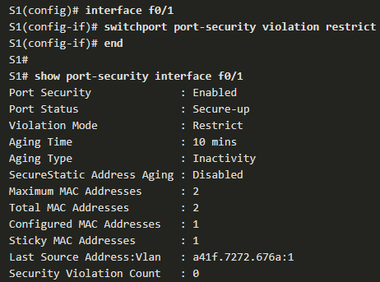

* Ports in error-disabled State:
  + When a port is shutdown and placed in the error-disabled state, no traffic is sent or received on that port.
  + A series of port security related messages display on the console, as shown in the following example.

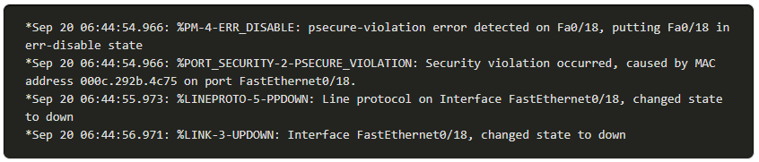

* + Note: The port protocol and link status are changed to down and the port LED is turned off.

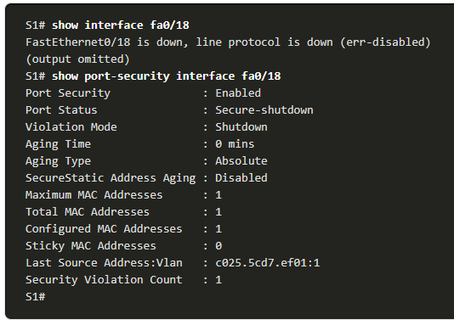

* + In the example, the show interface command identifies the port status as err-disabled. The output of the **show port-security interface** command now shows the port status as secure-shutdown. The Security Violation counter increments by 1.
  + The administrator should determine what caused the security violation. If an unauthorized device is connected to a secure port, the security threat is eliminated before re-enabling the port.
  + To re-enable the port, first use the **shutdown** command, then, use the **no shutdown** command.
* Verify Port Security:
  + After configuring port security on a switch, check each interface to verify that the port security is set correctly, and check to ensure that the static MAC addresses have been configured correctly.
  + Port Security for All Interfaces:
    - To display port security settings for the switch, use the show port-security command.
    - The example indicates that all 24 interfaces are configured with the switchport port-security command because the maximum allowed is 1 and the violation mode is shutdown.
    - No devices are connected, therefore, the CurrentAddr (Count) is 0 for each interface.

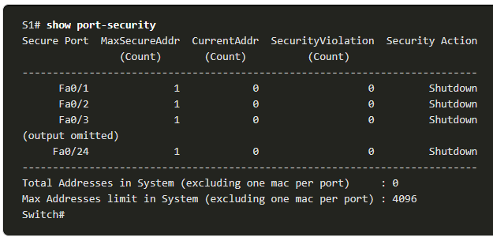

* + Port Security for a Specific Interface:
    - Use the show port-security interface command to view details for a specific interface

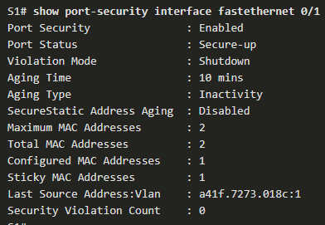

* + Verify Learned MAC Addresses:
    - To verify that MAC addresses are “sticking” to the configuration, use the show run command as shown in the example for FastEthernet 0/19.

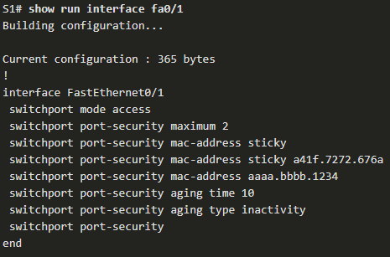

* + Verify Secure MAC Addresses:
    - To display all secure MAC addresses that are manually configured or dynamically learned on all switch interfaces, use the show port-security address command as shown in the example.

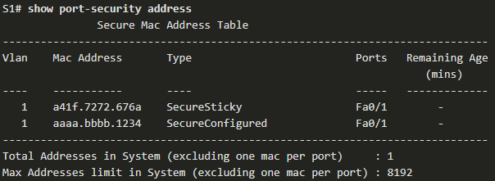

## Mitigate VLAN Attacks

* VLAN Attacks Review
  + A VLAN hopping attack can be launched in one of three ways:
    - Spoofing DTP messages from the attacking host to cause the switch to enter trunking mode. From here, the attacker can send traffic tagged with the target VLAN, and the switch then delivers the packets to the destination.
    - Introducing a rogue switch and enabling trunking. The attacker can then access all the VLANs on the victim switch from the rogue switch.
    - Another type of VLAN hopping attack is a double-tagging (or double-encapsulated) attack. This attack takes advantage of the way hardware on most switches operate
* Steps to Mitigate VLAN Hopping Attacks:
  1. Disable DTP (auto trunking) negotiations on non-trunking ports by using the **switchport mode access** interface configuration command.
  2. Disable unused ports and put them in an unused VLAN.
  3. Manually enable the trunk link on a trunking port by using the **switchport mode trunk** command.
  4. Disable DTP (auto trunking) negotiations on trunking ports by using the **switchport nonegotiate** command.
  5. Set the native VLAN to a VLAN other than VLAN 1 by using the **switchport trunk native vlan** *vlan_number* command and don't use the native VLAN as a data VLAN.

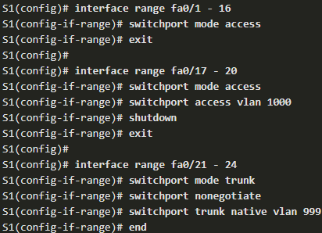

## Mitigate DHCP Attacks

* DHCP Attack Review:
  + DHCP Starvation attack:
    - The goal of a DHCP starvation attack is to an attack tool such as Gobbler to create a Denial of Service (DoS) for connecting clients. Recall that DHCP starvation attacks can be effectively mitigated by using port security because Gobbler uses a unique source MAC address for each DHCP request sent.
  + DHCP Spoofing attack:
    - Mitigating DHCP spoofing attacks requires more protection. Gobbler could be configured to use the actual interface MAC address as the source Ethernet address, but specify a different Ethernet address in the DHCP payload. This would render port security ineffective because the source MAC address would be legitimate.
  + DHCP spoofing attacks can be mitigated by using DHCP snooping on trusted ports.
* DHCP Snooping:
  + DHCP snooping does not rely on source MAC addresses. Instead, DHCP snooping determines whether DHCP messages are from an administratively configured trusted or untrusted source. It then filters DHCP messages and rate-limits DHCP traffic from untrusted sources.
  + Devices under your administrative control, such as switches, routers, and servers, are trusted sources.
  + Any device beyond the firewall or outside your network is an untrusted source. In addition, all access ports are generally treated as untrusted sources.

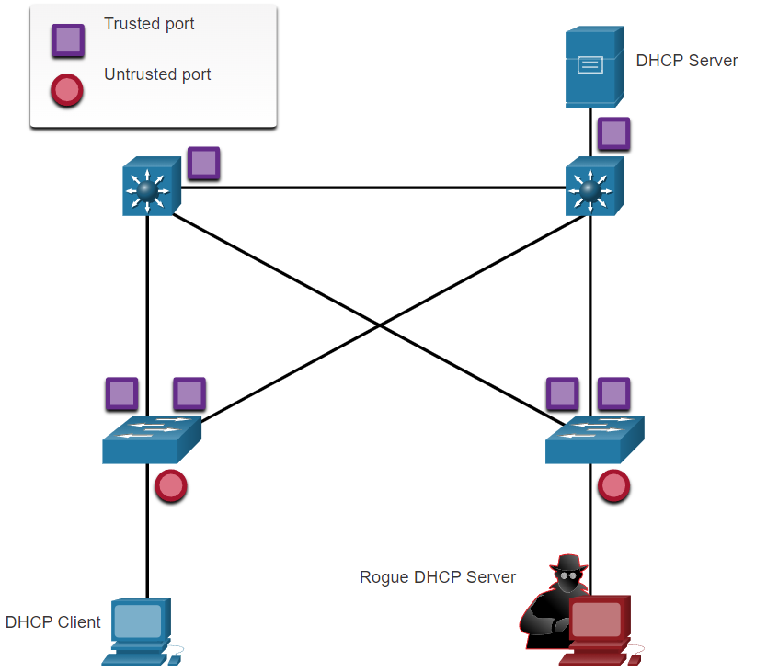

* + All interfaces are treated as untrusted by default. Trusted interfaces are typically trunk links and ports directly connected to a legitimate DHCP server. These interfaces must be explicitly configured as trusted.
  + A DHCP table is built that includes the source MAC address of a device on an untrusted port and the IP address assigned by the DHCP server to that device. The MAC address and IP address are bound together. Therefore, this table is called the DHCP snooping binding table.
* Steps to Implement DHCP Snooping:
  1. Enable DHCP snooping by using the **ip dhcp snooping** global configuration command.
  2. On trusted ports, use the **ip dhcp snooping trust** interface configuration command.
  3. On untrusted interfaces, limit the number of DHCP discovery messages that can be received using the **ip dhcp snooping limit rate** ***packets-per-second***interface configuration command.
  4. Enable DHCP snooping by VLAN, or by a range of VLANs, by using the **ip dhcp snooping** ***vlan*** global configuration command.
* DHCP Snooping Configuration Example:

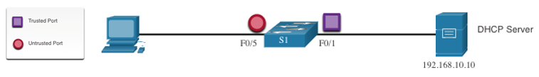

* + DHCP snooping is first enabled on S1.
  + The upstream interface to the DHCP server is explicitly trusted.
  + F0/5 to F0/24 are untrusted and are, therefore, rate limited to six packets per second.
  + Finally, DHCP snooping is enabled on VLANS 5, 10, 50, 51, and 52.

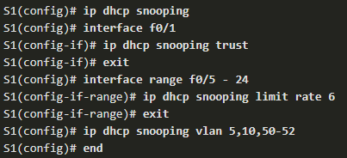

* + Use the **show ip dhcp snooping** privileged EXEC command to verify DHCP snooping settings.
  + Use the **show ip dhcp snooping binding** command to view the clients that have received DHCP information.
  + Note: DHCP snooping is also required by Dynamic ARP Inspection (DAI).

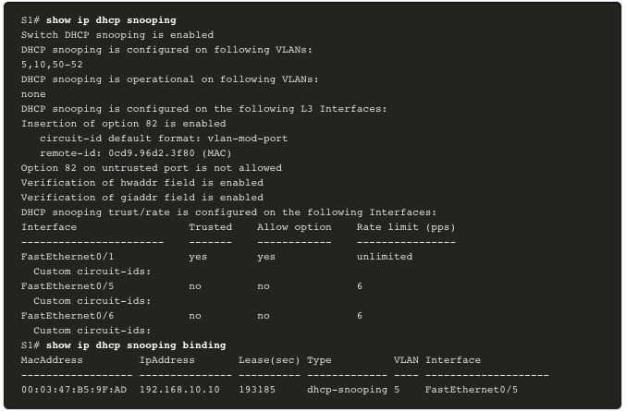

## Mitigate ARP Attacks

* Dynamic ARP Inspection:
  + In a typical ARP attack, a threat actor can send unsolicited ARP replies to other hosts on the subnet with the MAC Address of the threat actor and the IP address of the default gateway. To prevent ARP spoofing and the resulting ARP poisoning, a switch must ensure that only valid ARP Requests and Replies are relayed.
  + Dynamic ARP inspection (DAI) requires DHCP snooping and helps prevent ARP attacks by:
    - Not relaying invalid or gratuitous ARP Replies out to other ports in the same VLAN.
    - Intercepting all ARP Requests and Replies on untrusted ports.
    - Verifying each intercepted packet for a valid IP-to-MAC binding.
    - Dropping and logging ARP Replies coming from invalid sources to prevent ARP poisoning.
    - Error-disabling the interface if the configured DAI number of ARP packets is exceeded.
* DAI Implementation Guidelines:
  + Enable DHCP snooping globally.
  + Enable DHCP snooping on selected VLANs.
  + Enable DAI on selected VLANs.
  + Configure trusted interfaces for DHCP snooping and ARP inspection.
  + It is generally advisable to configure all access switch ports as untrusted and to configure all uplink ports that are connected to other switches as trusted.

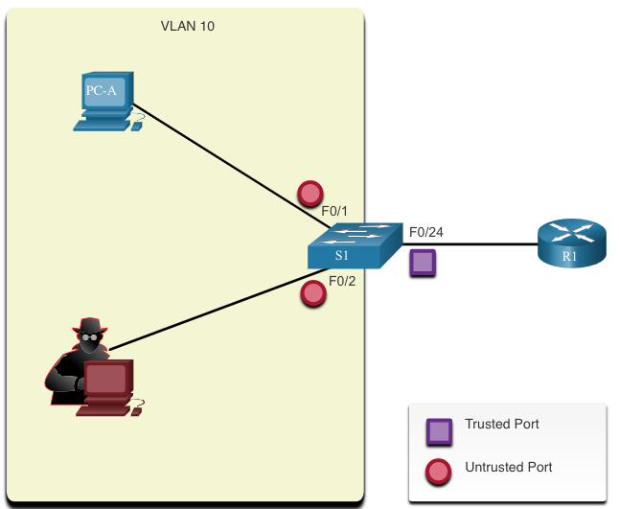

* DAI Configuration Example:
  + In the previous topology, S1 is connecting two users on VLAN 10.
  + DAI will be configured to mitigate against ARP spoofing and ARP poisoning attacks.
  + DHCP snooping is enabled because DAI requires the DHCP snooping binding table to operate.
  + Next, DHCP snooping and ARP inspection are enabled for the PCs on VLAN10.
  + The uplink port to the router is trusted, and therefore, is configured as trusted for DHCP snooping and ARP inspection.

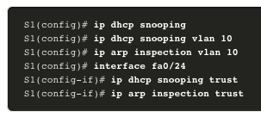

* + DAI can also be configured to check for both destination or source MAC and IP addresses:
    - Destination MAC - Checks the destination MAC address in the Ethernet header against the target MAC address in ARP body.
    - Source MAC - Checks the source MAC address in the Ethernet header against the sender MAC address in the ARP body.
    - IP address - Checks the ARP body for invalid and unexpected IP addresses including addresses 0.0.0.0, 255.255.255.255, and all IP multicast addresses.
  + The **ip arp inspection validate** {[**src-mac**] [**dst-mac**] [**ip**]} global configuration command is used to configure DAI to drop ARP packets when the IP addresses are invalid.
  + It can be used when the MAC addresses in the body of the ARP packets do not match the addresses that are specified in the Ethernet header.
  + Notice in the following example how only one command can be configured.
  + Therefore, entering multiple **ip arp inspection validate** commands overwrites the previous command.
  + To include more than one validation method, enter them on the same command line as shown in the output

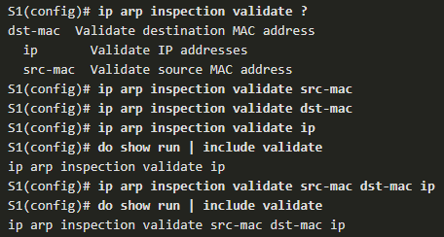

## Mitigate STP Attacks

* PortFast and BPDU Guard:
  + Recall that network attackers can manipulate the Spanning Tree Protocol (STP) to conduct an attack by spoofing the root bridge and changing the topology of a network. To mitigate STP attacks, use PortFast and Bridge Protocol Data Unit (BPDU) Guard
  + PortFast:
    - PortFast immediately brings a port to the forwarding state from a blocking state, bypassing the listening and learning states.
    - Apply to all end-user access ports.
  + BPDU Guard:
    - BPDU guard immediately error disables a port that receives a BPDU.
    - Like PortFast, BPDU guard should only be configured on interfaces attached to end devices.
* Configure PortFast:
  + PortFast bypasses the STP listening and learning states to minimize the time that access ports must wait for STP to converge. If PortFast is enabled on a port connecting to another switch, there is a risk of creating a spanning-tree loop.
  + PortFast can be enabled:
    - On an interface– Use the **spanning-tree portfast** interface configuration command.
    - **G**lobally – Use the **spanning-tree portfast default** global configuration command to enable PortFast on all access ports.
  + To verify whether PortFast is enabled globally you can use either the:
    - **show running-config | begin span** command
    - **show spanning-tree summary** command
  + To verify if PortFast is enabled an interface, use the show **running-config interface *type/number*** command.
  + The **show spanning-tree interface *type/number*** **detail** command can also be used for verification.

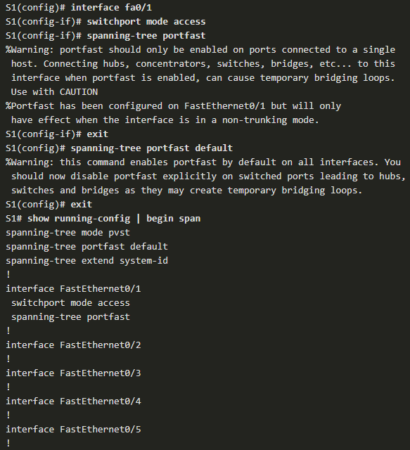

* Configure BPDU Guard:
  + An access port could receive an unexpected BPDUs accidentally or because a user connected an unauthorized switch to the access port.
  + If a BPDU is received on a BPDU Guard enabled access port, the port is put into error-disabled state.
  + This means the port is shut down and must be manually re-enabled or automatically recovered through the **errdisable recovery cause psecure_violation** global command.
  + BPDU Guard can be enabled:
    - On an interface– Use the **spanning-tree bpduguard enable** interface configuration command.
    - Globally – Use the **spanning-tree portfast bpduguard default** global configuration command to enable BPDU Guard on all PortFast-enabled ports.
  + To display information about the state of spanning tree, use the **show spanning-tree summary** command.

